
Gazette | Agricultural and  Veterinary Chemicals
APVMA Special Gazette, 14 January 2021
Published by the Australian Pesticides and Veterinary Medicines Authority
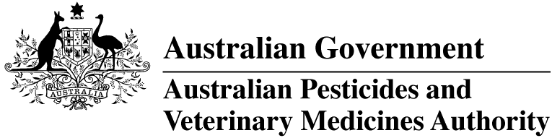
The Agricultural and Veterinary Chemical Code Act 1994 (the Act) commenced on 15 March 1995. The Agricultural and Veterinary Chemicals Code (the Agvet Code) scheduled to the Act requires notices to be published in the Gazette containing details of the registration of agricultural and veterinary chemical products and other approvals granted by the Australian Pesticides and Veterinary Medicines Authority. The Agvet Code and related legislation also requires certain other notices to be published in the Gazette. A reference to Agvet Codes in this publication is a reference to the Agvet Code in each state and territory jurisdiction.
ISSN 1837-7629
© Commonwealth of Australia 2021
This work is copyright. Apart from any use as permitted under the Copyright Act 1968, no part may be reproduced by any process without prior written permission from the Australian Pesticides and Veterinary Medicines Authority. Requests and inquiries concerning reproduction and rights should be addressed to:
Assistant Director, Communications
Australian Pesticides and Veterinary Medicines Authority
GPO Box 3262
Sydney NSW 2001
Email: communications@apvma.gov.au
Website: apvma.gov.au
General Information
The APVMA (Australian Pesticides and Veterinary Medicines Authority) Gazette is published fortnightly and contains details of the registration of agricultural and veterinary chemicals products and other approvals granted by the APVMA, notices as required by the Agricultural and Veterinary Chemicals Code (the Agvet Code) and related legislation and a range of regulatory material issued by the APVMA.
Pursuant to section 8J(1) of the Agvet Code, the APVMA has decided that it is unnecessary to publish details of applications made for the purpose of notifying minor variations to registration details. The APVMA will however report notifications activity in quarterly statistical reports.
Distribution and subscription
The APVMA Gazette is published in electronic format only and is available from the APVMA website.
If you would like to subscribe to receive email notification when a new edition is published, please complete the subscription form.
APVMA Contacts
For enquiries regarding the publishing and distribution of the APVMA Gazette: Telephone: +61 2 6770 2300.
For enquiries on the APVMA Gazette content, please refer to the individual APVMA contacts listed under each notice.
CONTENTS
Levy payment for the 2019–20 financial year 4

Levy payment for the 2019–20 financial year
In accordance with section 6(1)(d) of the Agricultural and Veterinary Chemical Products (Collection of Levy) Act 1994 (Collection of Levy Act), the Australian Pesticides and Veterinary Medicines Authority (APVMA) makes the following direction in respect of the amount of levy payable by the liable person under section 16 of the Collection of Levy Act for the 2019–20 financial year.
PAYMENT BY INSTALMENT
For the purposes of section 6(1)(d) of the Collection of Levy Act, the APVMA directs that the amount of levy payable as assessed under section 16 of the Collection of Levy Act and notified to the liable person in the Notice of Assessment for the 2019–20 financial year may be paid by instalments as follows:
Date | Amount of Levy to be paid
15 January 2021 | No less than 50% of the amount of levy payable as assessed in the Notice of Assessment for the 2019–20 financial year
15 June 2021 | The balance of the amount of levy payable as assessed in the Notice of Assessment for the 2019–20 financial year
The APVMA directs that the amount of levy that would be required to be paid by the due date as specified in the Notice of Assessment for the 2019–20 financial year is taken to have been paid by that date if the levy is paid in instalments as set out above.
APVMA Contact
For any enquiries or further information about this matter, please contact:
Finance
Australian Pesticides and Veterinary Medicines Authority
GPO Box 3262
Sydney NSW 2001
Phone: +61 2 6770 2300
Email: finance@apvma.gov.au

