

Spray drift risk assessment manual
Stage one
JULY 2019

© Australian Pesticides and Veterinary Medicines Authority 2019
Ownership of intellectual property rights in this publication
Unless otherwise noted, copyright (and any other intellectual property rights, if any) in this publication is owned by the Australian Pesticides and Veterinary Medicines Authority (APVMA).
Creative Commons licence
With the exception of the Coat of Arms and other elements specifically identified, this publication is licensed under a Creative Commons Attribution 4.0 Australia Licence. This is a standard form agreement that allows you to copy, distribute, transmit and adapt this publication provided that you attribute the work.

A summary of the licence terms is available from www.creativecommons.org/licenses/by/3.0/au/deed.en. The full licence terms are available from www.creativecommons.org/licenses/by/3.0/au/legalcode.
The APVMA’s preference is that you attribute this publication (and any approved material sourced from it) using the following wording:
Source: Licensed from the Australian Pesticides and Veterinary Medicines Authority (APVMA) under a Creative Commons Attribution 4.0 Australia Licence.
In referencing this document the Australian Pesticides and Veterinary Medicines Authority should be cited as the author, publisher and copyright owner.
Cover image: iStockphoto (www.istockphoto.com)
iStockphoto images are not covered by this Creative Commons licence.
Use of the Coat of Arms
The terms under which the Coat of Arms can be used are set out on the Department of the Prime Minister and Cabinet website.
Disclaimer
The material in or linking from this report may contain the views or recommendations of third parties. Third party material does not necessarily reflect the views of the APVMA, or indicate a commitment to a particular course of action. There may be links in this document that will transfer you to external websites. The APVMA does not have responsibility for these websites, nor does linking to or from this document constitute any form of endorsement. The APVMA is not responsible for any errors, omissions or matters of interpretation in any third-party information contained within this document.
Comments and enquiries regarding copyright:
Assistant Director, Communications
Australian Pesticides and Veterinary Medicines Authority
PO Box 6182
KINGSTON ACT 2604 Australia
Telephone: +61 2 6770 2300
Email: communications@apvma.gov.au.
This publication is available from the APVMA website.

Contents
Background 6
1 General information 9
1.1 Introduction 9
1.2 Legislative basis 9
2 spray drift risk assessment overview 10
2.1 Buffer zones 12
Calculating buffer zone distances 12
Buffer zones and sensitive areas 13
2.2 Products and use patterns not requiring a spray drift risk assessment 15
3 Regulatory acceptable levels 17
3.1 Establishment of RALs 17
Bystander areas 18
Natural aquatic areas 22
Pollinator areas 22
Vegetation areas 23
Determination of livestock area RAL 24
3.2 Expression of RALs as fraction of applied rate 24
3.3 RALs for combination products and mandatory tank-mixes 25
4 Deposition curves 28
4.1 Standard deposition curves 28
Boom sprayers 28
Vertical sprayers 30
Aircraft 31
4.2 Custom deposition curves 33
Field trials 33
Modelling 34
4.3 Averaged deposition curves 35
5 Use instructions 36
5.1 Standard instructions 36
General instructions 37
Boom sprayers 37
Vertical sprayers 38
Aircraft 38
Different application equipment types for different crop/situation use patterns 39
5.2 Custom instructions 40
6 Spray drift risk assessment tool (SDRAT) 41
6.1 Buffer zone rounding 41
6.2 Mandatory tank mixes 41
7 Spray drift management tool (SDMT) 43
7.1 SDMT overview 43
Tank-mixing 45
7.2 Fraction of applied rate factors 45
Application rate 46
Water depth 46
Optical spot spraying technologies 46
Vegetative and artificial spray drift barriers 46
7.3 Alternative deposition curves 47
Addition of custom deposition curves 47
Additional SDMT deposition curves 47
8 Case studies 49
8.1 Case study one: Herbicide applied by air and ground boom 49
8.2 Case study two: Insecticide applied by vertical sprayer and ground boom 51
Appendix A: Droplet size distributions (DSDS) 54
Appendix B: Evaluation of AGDISP ground model 56
Abbreviations 58
Glossary 59
Reference 64

List of tables
Table 1: Types of sensitive areas 13
Table 2: List of RAL units and conversion factors 18
Table 3: Bystander area RAL units and default values 20
Table 4: Pollinator area RAL units and default values 23
Table 5: Water rates for different crops 25
Table 6: Variables used in equation 10 and equation 11 26
Table 7: Spray quality weightings to be used between AI and FF droplet size distributions 29
Table 8: Terminology equivalence between German ‘basic drift values’ and APVMA vertical sprayer standard deposition curves 30
Table 9: Buffer zone rounding 41
Table 10: Example calculation of an adjusted active concentration for a tank mix 42
Table 11: Example calculation of worst-case buffer zones for a tank mix 42
Table 12: Regulatory acceptable levels for Herbicide One 49
Table 13: Regulatory acceptable levels for Insecticide One 51
Table 14: Summary droplet size statistics for the reference nozzles used to establish standard deposition curves 55

Background
The possibility of off-target spray drift accompanying the application of pesticides is a concern both to the community and the agricultural industry, for whom it is a constant challenge to find ways to minimise off target drift more effectively. The APVMA is responsible for ensuring that off-target pesticide spray drift does not harm human health, the environment or Australia’s international trade. The potential for off-target drift to cause harm must be considered by the APVMA.
In July 2008, the APVMA released a revised version of the policy document ‘APVMA Operating Principles in Relation to Spray Drift Risk’ and then in March 2010, implemented regulations requiring new pesticide products seeking registration to be assessed for their potential risk of spray drift as part of the registration process. This included the development of an Operational Notice, which is in effect a form of code/manual. Label instructions for new products now have to include statements that describe mandatory no-spray (buffer) zones where applicable.
The APVMA’s current approach for addressing the risk of spray drift has a number of limitations, including lack of flexibility and ability to adopt newer systems/technologies to reduce the risk of spray drift. Assessment is based around worst case scenarios and provides no incentive for spray applicators to adopt best practice, new technology and/or operations that will limit spray drift. There is also some concern that the APVMA’s current approach to spray drift and labelling requirements has become a deterrent to the inclusion of some types of spray applications and uses on approved labels.
The APVMA therefore began a project in 2013 to develop a new spray drift regulatory framework that will enable more reasonable buffer zones to be set. The intention of this new approach was to provide a set of publicly available online tools on the APVMA website for calculating spray drift and setting buffers that can be used by:
- APVMA Risk Managers to set spray drift label requirements when processing a product application for registration
- prospective registrants to enable them to predict the likely restraints that may be required on the use of their product
- external or APVMA scientific reviewers that are making recommendations on appropriate risk mitigation to the APVMA Risk Managers
- industry to help select the most appropriate set of parameters for conducting spray operations in order to minimise drift and required buffers. This will greatly aid the adoption of new technology/best practice by industry.
Various sectors of industry, largely coordinated through the National Working Party on Pesticide Application (NWPPA), have generated information that has assisted or been incorporated into the APVMA’s new spray drift management approach and/or provided comment on elements of the new approach.
Consultation on the spray drift management approach was undertaken from 18 December 2017 to 30 March 2018, with consideration of comments received in preparation of this manual. During consultation it was proposed that the approach be introduced in two stages (figure 1). Stage one includes aspects up to establishing a product label or permit instructions. Stage two potentially involves an interactive spray drift management tool (SDMT) that would allow chemical users to refine the realistic worst-case risk assessments used in the standard assessment and recalculate buffer zone distances based on their own circumstances. Prior to introduction of stage two, an Excel-based SDMT will be used by the APVMA to put buffers relevant to the use of drift reducing technologies (DRTs) on labels or permits.
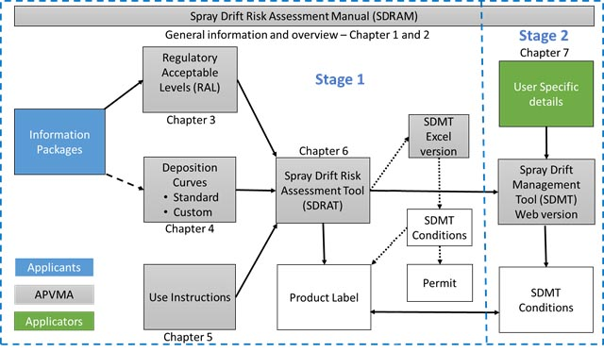
Figure 1: Overview of the staged approach to spray drift management
Under the new spray drift management approach, there are no changes to the current items and modules for registration applications. Applicants would continue to submit relevant information packages to allow the regulatory acceptable levels (RALs) to be determined. The method used to determine the RAL is described in section 3 of this spray drift risk assessment manual (SDRAM).
Standard deposition curves (outlined in section 4) will be used to determine buffer zones based on realistic worst case scenarios. Applicants will also have an option to provide information to determine custom deposition curves. The spray drift data guideline describes how spray drift information and data may be generated and submitted.
The approved RAL would be entered into the spray drift risk assessment tool (SDRAT) that is described in section 6 and the appropriate standard deposition curve selected. The SDRAT contains approved label instructions (section 5) and will be used to generate the label instructions, including buffer zones and spray drift restraints.
The spray drift management tool will in stage one be used by the APVMA to put buffers relevant to the use of DRTs on labels or permits. In the future its use may be expanded to allow users to reduce buffer zones where they are using DRTs to a greater extent than required by the approved label (or permit). Buffer zones and conditions can be recalculated according to, for example, the chemical user’s specific equipment, application rate and weather conditions that are relevant to their own circumstances.
Further consultation on the spray drift management approach—stage one was undertaken from 19 November 2018 to 8 March 2019, with consideration of comments received in preparation of this manual.
The APVMA’s proposed new spray drift management approach is outlined in the remainder of this manual. It will initially only apply to new chemistries and chemical reviews and may be extended to existing products on a priority basis. The manual covers stage one only and will be updated to include the interactive SDMT once stage two is finalised.

General information

Introduction
The APVMA conducts spray drift risk assessments in order to ensure that pesticide products can be used in a manner that will not adversely impact the health and safety of human beings or the environment and not unduly prejudice international trade.
Spray drift is defined by the APVMA as the movement of spray droplets of a pesticide outside of the application site during, or shortly after, application. It does not encompass off-target movement of a pesticide caused by runoff, volatilisation, erosion, or any other mechanism that occurs after spray droplets reach their intended target. Specific definitions for terminology used in this manual are listed in the glossary.
This manual applies to any spray drift risk assessment conducted during:
- the evaluation of an application to the APVMA:
- to register a new product or to approve a label
- to vary a registered product or approved label
- for a permit
- for addition of a custom deposition curve in the spray drift management tool (see section 7.3)
- the reconsideration of registered products or approved labels through the chemical review program
- for any other purpose in accordance with the provisions of the Agvet Code.

Legislative basis
The APVMA must comply with its governing legislation. When a decision is made, the following sections of the Agvet Code apply:
- 14—registration of a new product or approval of a label
- 29 or 29A—variation of a registered product or approved label
- 112—issuance of a permit
- 34 or 34(A)—reconsideration of registered products or approved labels.
The basis for all of these decisions, in regards to spray drift, is that the APVMA must be satisfied that certain statutory criteria are met, as defined by the following sections of the Agvet Code:
- 5A—safety
- 5C—trade
- 5D—labelling (with respect to how the product should be used in order to manage spray drift to satisfy the safety and trade criteria).

spray drift risk assessment overview
As part of the standard APVMA approach to risk analysis, there are two key regulatory science questions that need to be addressed in any spray drift risk assessment:
- does the product pose a hazard to an off-target area that requires protection?
- does the manner in which the product is applied result in exposure to an area requiring protection that is outside the target area?
These questions require the problem to be defined; specifically, what are the areas that require protection for the APVMA to be satisfied of the statutory criteria when making a decision? In order to formulate this, the statutory criteria are used to develop ‘sensitive areas’, which are representative of what requires protection so that an appropriate determination of the hazard can be made. The assessment of the hazard posed by a product results in the determination of a regulatory acceptable level (RAL). The maximum amount of spray drift exposure that is not expected to cause undue harm to a certain sensitive area is a RAL. The sensitive areas, and the process for determining RALs, are described in section 3.
Once a RAL is established, the possible risk must then be determined by assessing potential exposure. This is done by selecting the downwind deposition curve/s (ie the spray drift deposition pattern) relevant for the use pattern/s being assessed. Refer to section 4 for further details.
The hazard (RALs) and exposure (deposition curves) are then used to determine if a risk is posed, and if so what buffer zone distance is required. Buffer zones (also known as no-spray zones or setbacks) are areas where spraying does not take place between the downwind edge of the application site and an identified sensitive area. Refer to section 2.1 for an overview of buffer zones.
The implementation of risk management through use instructions is outlined in section 5. These instructions are included in the ‘relevant particulars’ on approved labels or in permit conditions that are established through the use of the spray drift risk assessment tool described in section 6. They also provide the basis for conditions on the use of the spray drift management tool as described in section 7.
Risk communication is routinely conducted on a product-by-product basis through interactions between the APVMA and applicants/holders of registrations. Specific communications on issues related to spray drift policy and procedure will be communicated via the APVMA website and emailed regulatory updates.
The SDRAT is used by the APVMA to conduct a risk assessment of the realistic worst-case scenario for the use of each product. The realistic worst-case is best summarised by considering the following assumptions for different equipment types:
- boom sprayers and aircraft
- standard equipment is set up and used in accordance with good agricultural practice (eg boom is kept as low to the ground as is safe and practical, or boom width is less than wing or rotor span)
- spray droplet size is assumed to be the smallest/finest that could be produced within each spray droplet size category; the spray droplet size category is the largest droplet size category supported under the efficacy criteria
- the highest application rate on the label for the use of that equipment type is used
- wind speed is between the lowest acceptable (ie three km/hr) and the highest acceptable (ie 20 km/hr), and no surface temperature inversion conditions are present at the time of application
- vertical sprayers
- standard equipment (axial-flow airblast sprayer) is set up and used in accordance with good agricultural practice (eg nozzles are not directed above the canopy, outermost side of sprayer is turned off when turning at end of rows and last row on either side of the block)
- the highest dilution rate and water rate associated with the largest crop on the label is used
- wind speed is between the lowest acceptable (ie three km/hr) and the highest acceptable (ie 20 km/hr), and no surface temperature inversion conditions are present at the time of application.
The SDMT, when adopted, will allow chemical users to refine these realistic worst-case risk assessments (based on, for example, the specific equipment, application rate and weather conditions that are relevant to their own circumstances) and can recalculate buffer zone distances accordingly.
The relationships between key sections in this manual are shown in figure 2 (refer to each section for further detail).
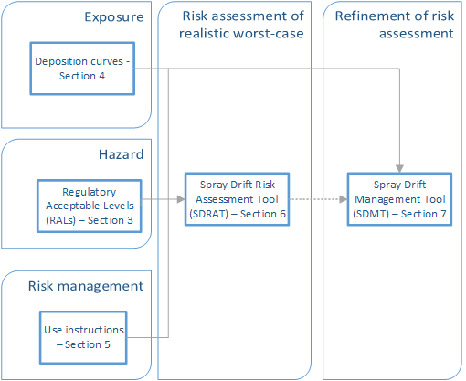
Figure 2: Relationship of key sections in this manual

Buffer zones
Spray drift can only travel with the direction of the wind, so buffer zones are always downwind and are not permanently fixed with respect to a target area.
All buffer zones on the label are mandatory. To comply with use instructions (see section 5), users must observe the required buffer zone distance (either on the product label or from the use of the spray drift management tool when it is available).

Calculating buffer zone distances
The information used to calculate a buffer zone is described throughout this manual and summarised in figure 3.
Figure 3: Information required to calculate buffer zones
A visual representation of how buffer zones are calculated is shown in figure 4. Here the horizontal black line is the RAL for a certain sensitive area and the orange line is the relevant deposition curve, which decreases in exposure with increasing distance downwind of the target area. In this example, a 15-metre buffer zone would be required for protection of the sensitive area.
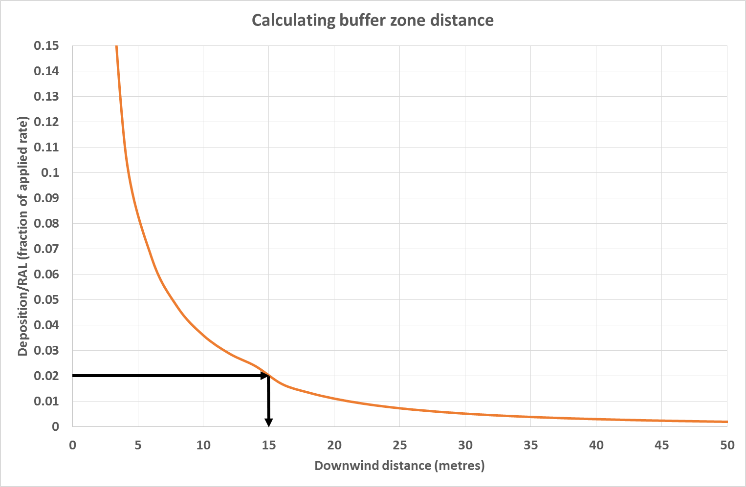
Figure 4: Visual representation of how buffer zone distances are calculated

Buffer zones and sensitive areas
Five different type of sensitive areas are considered in establishing relevant buffer zones and these are described in table 1.
Table 1: Types of sensitive areas
Sensitive area | Explanation
Bystander areas | ‘Bystander areas’ are locations where it is reasonably likely that ‘bystanders’ will be exposed to residues deposited on the ground from spray drift on a regular basis and for an extended period of time (ie several hours per day over a period of a month). Examples of these areas include: residential properties, schools, kindergartens, day care facilities, hospitals, aged care facilities, public or private parks or recreational areas, and areas where manual handling of soil or plants is required.
Natural aquatic areas | ‘Natural aquatic areas’ are where a ‘watercourse’ (as defined by the Commonwealth Water Act 2007) is present, with the following exceptions:  - artificial ‘watercourses’ used exclusively for agricultural or ornamental purposes, such as irrigation channels, flood irrigation areas, farm dams, ornamental ponds, golf course dams and those used for aquacultural production  - ‘watercourses’ that are dry at the time of pesticide application  - ‘watercourses’ that are commonly identified as ‘puddles’.  ‘Buffer zones’ established for the purpose of the ‘natural aquatic area’ may also be used as the basis for the protection of ‘aquacultural production’ but as the buffer zones for ‘natural aquatic areas’ are based on survival at a population or ecosystem level, they may not be sufficient if yield loss or replacement cost within an aquaculture operation is the issue.  It is not reasonable to expect that a chemical user can conduct a local area risk assessment of aquatic species (ie below the surface of water) and determine that no aquatic species sensitive to the chemical being used are present.
Pollinator areas | ‘Pollinator areas’ means managed bee hives. This only applies when the manager of those bee hives has provided notification regarding their location to the chemical user, or the person the chemical user is applying agricultural chemical product/s on behalf of, at least 48 hours prior to application of the agricultural chemical product/s. Whilst notification can be made directly (in writing or verbally), the use of the BeeConnected website or smartphone app is acceptable and recommended.
Vegetation areas | ‘Vegetation areas’ are where ‘native vegetation’, ‘agricultural crops’ or ‘landscaped gardens’ are present. It does not include vegetation that has been planted explicitly for purpose of a drift buffer. The RAL for vegetation areas is established on the basis that any area of vegetation will not be impacted at a habitat or ecosystem level (ie acceptable risk not nil risk). However, it is not possible to determine what an appropriate RAL would be for a particular area of vegetation or crop containing only certain species at certain growth stages.
Livestock areas | ‘Livestock areas’ are those where livestock are grazing. ‘Buffer zones’ for ‘livestock areas’ have been established to protect international trade. These ‘buffer zones’ are based on the Maximum Residue Limit (MRL) Standards of significant export markets for livestock commodities. When the chemical user also manages the livestock, or when neighbours communicate and work cooperatively, risk to livestock trade can be managed by moving livestock further away from the application site, and managing export slaughter intervals.
The compliance pathway for chemical users to protect sensitive areas when buffer zones are established is shown in figure 5.
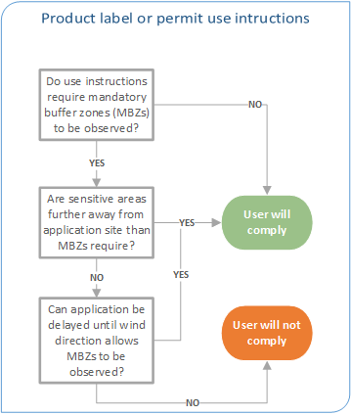
Figure 5: Compliance pathway for protecting sensitive areas

Products and use patterns not requiring a spray drift risk assessment
Spray drift risk assessments are required for agricultural chemical products (as defined by section 3 of the Agvet Code) if the way they are used poses a spray drift risk.
The following agricultural chemical product types do not require a spray drift risk assessment under any circumstance:
- antifouling products, antifoulants or antifouling paints
- dairy cleansers
- disinfectants
- fumigants
- household insecticides
- seed treatments
- swimming pool or spa chemicals
- vertebrate poisons
- veterinary chemicals
- wood preservatives or timber treatments.
Some products do not require a spray drift risk assessment when the proposed product label limits their use to:
- application below the surface of soil or water
- application with specialised equipment in cropping situations where the nozzles are orientated below the horizontal of the top of the crop canopy and spray is released at a height below the top of the crop canopy (eg drop nozzles used to direct the spray to the furrows between emerged crops, or small booms used to spray inter-row areas in tree and vine crops), but excluding sprayers where air is used to aid in the spray penetrating the canopy as these are defined as ‘vertical sprayers’ (eg air blast sprayers in orchards)
- home garden and domestic pest control use
- outdoor use when applied in a form other than a spray (eg granules, pheromone traps, non-sprayed invertebrate baits, a gel, a paste, cut stump painting, stem injection, weed wiper systems)
- post-harvest treatment of agricultural produce (including seed prior to sowing)
- preparing a poison bait for the control of vertebrate or invertebrate pests
- treatment of fertiliser prior to spreading
- use by single-nozzle application equipment (eg knapsack, hand sprayer)
- use indoors (eg protected growing situations).
If the proposed label of a product contains use patterns from the list above as well as use patterns that require a spray drift risk assessment, only those use patterns that are not listed above will be taken into account. For example, if a label had an application rate equivalent to 10 L/ha for a single-nozzle application only and a maximum application rate for a boom sprayer of 5 L/ha, then the spray drift risk assessment will be conducted on the 5 L/ha rate applied by a boom sprayer.
There may be uncommon and unusual circumstances in which the product types or use patterns listed above do pose a risk of off-target movement of pesticide prior to it reaching its intended target (eg dusts or small and/or low density granules). Although the risk assessment framework is conceptually similar to what is described in this section, there are significant differences in determining, for example, deposition curves and use instructions to mitigate risk, which will be unique for individual products and/or use patterns. It is expected that the number of products of concern for this type of off-target movement is considered to be very small.
Rather than add unnecessary complexity to this manual, identified risks will be managed on a case-by-case basis using this manual as a starting point. Applicants are encouraged to contact the APVMA prior to submitting an application through the pre-application assistance (PAA) process if they are concerned that their product or use pattern may be subject to this type of off-target movement.

Regulatory acceptable levels
The regulatory acceptable level (RAL) is the maximum amount of spray drift exposure that is not expected to cause undue harm to a certain sensitive area. The RAL is established after any required safety factor (also known as the uncertainty factor, level of concern, margin of exposure or assessment factor) is applied to the relevant level, which is determined through the assessment of information used for satisfying the statutory criteria (safety and trade) of the legislation.
All RALs are compared to a single spray drift event of a product only. While the consideration of multiple applications is important for risk assessments within an application site, the same cannot be said for spray drift. The probability of spraying occurring in the same location under the same worst-case conditions (ie at the highest wind speed allowed and applied in a manner most prone to spray drift) is low. Therefore, multiple applications are not considered relevant for spray drift risk assessment purposes due to the low probability of spray drift resulting in accumulation from multiple applications outside the target area.

Establishment of RALs
All RALs are established by the APVMA assessment areas as part of their standard assessment processes as described in the APVMA Module Descriptors. No additional information is needed to conduct a spray drift risk assessment compared to what is already needed to assess hazards for other risk pathways, as described in the APVMA data guidelines:
- environment (part 7)
- occupational health and safety (part 6)
- overseas trade (part 5B)
- toxicology (part 3).
Applicants can choose to submit information such as higher tier studies that can be considered for refinement of risk assessments to establish a less conservative RAL (which remains adequately protective) compared to lower tier studies only. Any higher tier study could also be applied in other risk assessments, not just spray drift.
An outline of how RALs are established is explained below in relation to how existing risk assessment methodologies are modified for spray drift risk assessment purposes. The intention of the APVMA is to publish risk assessment manuals (where internationally recognised manuals are not available or appropriate in accordance with Australian Government policy) for each assessment area. These manuals will provide specific information about the establishment of RALs for spray drift risk assessment purposes (as well as all other risk assessment methodologies).
It is important to note that RALs are always expressed relative to the amount of active constituent in a product, not the amount of the product. That is, when studies conducted to determine RALs use the product instead of an active constituent, the data must be expressed on an active constituent basis.
When combination toxicity is determined to be of concern, RALs will be established with formulation or tank-mix data when available. When formulation or tank-mix data are not available, the concentration addition approach will be used, as discussed in section 3.3.
The units of a RAL depend on the sensitive area being protected. RAL units are expressed as the amount of active constituent per unit area (bystander, pollinator or vegetation areas), unit volume (natural aquatic areas), or unit mass (livestock areas). Further details are listed in table 2 including the conversion (multiplication) factors that are required to express RALs in units of g ac/ha. This conversion allows a fraction of the application rate to be calculated, for consistency with deposition curves (see section 3.2). Further details are provided in the following sub-sections.
Table 2: List of RAL units and conversion factors
Sensitive area | Units | Conversion factor
Bystander areas | mg ac/cm² | 100,000
Natural aquatic areas | µg ac/L | 1.5
Pollinator areas | kg ac/ha | 1,000
Vegetation areas | g ac/ha | 1 (ie not required)
Livestock areas | mg ac/kg | 3

Bystander areas
Bystanders may be contacted by spray drift in two ways, either directly by the spray cloud, or, through repeat exposure to deposited residues on the ground. This approach is based on that adopted by the US EPA (2014).
Available tools used to predict spray drift are only capable of reliably determining deposition on the ground (ie a horizontal surface), which is not relevant for direct contact of bystanders with the spray cloud (ie a vertical surface). As it is not possible to reliably estimate exposure through direct contact by the spray cloud, use instructions (see section 5) for all products will prohibit any use that causes a bystander to be contacted by the spray cloud.
Repeat exposure to deposited residues on the ground is akin to risk assessments that determine re-entry periods for applications to turf so this risk assessment approach forms the basis for the determination of the RAL for bystanders. The highest concern for this type of exposure is that of an infant/toddler who may be exposed from repeat dermal and oral (hand-to-mouth actions of infants/toddlers) exposure while in a backyard over an extended period of time.

Determination of bystander area RAL
The formula used to determine if a re-entry period is required after applications to turf is shown in equation 1. The variables in this formula and any default values are explained in table 3.
Equation 1: Exposure of infants after application to turf
$$Exposure=\frac{\left(Dermal adsorption\right)+\left(Oral adsorption\right)}{Body Weight}$$
$$Exposure=\frac{\left(AR×DepR×Ac×DA×TC×ET\right)+\left(AR×DepR ×Ac×B×SAo×FQ×ETo\right)}{BW}$$
$$If, Exposure≤ \frac{NOAEL}{MoE} risk is acceptable and a re˗entry period is not required$$
$$If, Exposure> \frac{NOAEL}{MoE} risk is unacceptable and a re˗entry period must be established$$
For applications to turf, the application rate (AR) is the level of active constituent deposited in the target area. When considering exposure of an off-target area through spray drift (which varies according to the way the product is applied as well as the application rate), this value is equivalent to the level of active constituent that can be deposited outside the target area and not pose an unacceptable risk (ie the bystander RAL).
This formula also normally has an additional variable to account for dissipation of residues over time. Dissipation is not relevant to spray drift because it is unreasonable to expect that a re-entry period can be implemented outside the target area.
As ‘Exposure’ is equal to, or less than, the NOAEL divided by the MoE, the following substitutions can be made to this formula which can then be converted to calculate the RAL, as shown in equation 2:
- AR ≡ RAL, which becomes the unknown in the formula
- Exposure ≡ NOAEL/MoE, which become known variables in the formula.
Equation 2: Conversion of application to turf formula to determine bystander area RAL
$$\frac{NOAEL}{MoE}=\frac{\left(RAL ×DepR ×Ac×DA ×TC ×ET\right)+\left(RAL ×DepR ×Ac ×B ×SAo×FQ×ETo\right)}{BW}$$
$$\left(\frac{NOAEL}{MoE}\right)×BW=\left(RAL×DepR×Ac×DA×TC×ET\right)+\left(RAL×DepR×Ac×B×SAo×FQ×ETo\right)$$
$$\left(\frac{NOEL}{MoE}\right)×BW=RAL×\left((DepR×Ac×DA×TC×ET)+(DepR×Ac×B×SAo×FQ×ETo)\right)$$
$$RAL=\frac{\left(\frac{NOAEL}{MoE}\right)×BW}{\left((DepR×Ac×DA×TC×ET)+(DepR×Ac×B×SAo×FQ×ETo)\right)}$$
Table 3: Bystander area RAL units and default values
Variable |  | Units | Default value | Comment
AR | Application rate | mg ac/cm² | - | Deposition on turf calculated from the application rate for the use pattern on the label.
B | Oral bioavailability | fraction | 1.0–DA | Estimates of oral bioavailability are usually determined from PK studies with oral dosing. In the absence of pesticide-specific data, suitable surrogate data using a valid scientific argument, such as ‘read across’ would be acceptable.
BW | Bodyweight | kg | 11 (1–2 year olds)  OR  15 (2–3 year olds) | EnHealth (2012) recommends a bodyweight value for 1–2 year old children of 11 kg, and for 2–3 year olds of 15 kg.
DA | Dermal absorption factor | fraction | 1.0 | In the absence of product-specific data, suitable surrogate data using a valid scientific argument, such as ‘read across’ can be used.
DepR | Deposited Residue | fraction | Combined as 0.05 | Together, these factors constitute a transferable residue factor (DepR x Ac).  EnHealth (2012) states that default for the accessibility of organics on surfaces is 100% (1.0), and 0.01% (0.0001) for inorganics, and that the default values are to be used 'only when other reasonable information is not available'. On the basis that most agricultural chemicals are organics, the default Ac is 1.0.  The default value for the DepR is 0.05, which is consistent with upper limits of US EPA (1997), so it is considered to be derived from 'reasonable information'.  Therefore, without additional information, a default transferable residue factor of 0.05 for turf is used.
Ac | Accessibility factor | fraction | Combined as 0.05
ET | Exposure time per day | hours per day | 1.1 (1–2 year olds)  OR  1 (2–3 year olds) | For time spent playing on turf, EnHealth (2012) recommends using the mean values of 1.1 (95th percentile of 2 hours) and 1 hour (95th percentile of 2 hours) for infants (1–<2 years) and toddlers (2–<3 years) respectively.
ETo | Duration of hand-to-mouth actions per day | hours per day | 1.1 (1–2 year olds)  OR  1 (2–3 year olds) | EnHealth (2012) indicates that the duration of mouthing for children is highly variable depending on the age group and the type of objects included in the estimates. Therefore, in the absence of specific mouthing duration of the hands (including fingers), a default value equivalent to the ET (Exposure time per day) is used.
FQ | Hand-to-mouth action frequency | contact events per hour | 14 (1–2 year olds)  OR  5 (2–3 year olds) | EnHealth (2012) state that the default mouthing frequency values in outdoor settings are 14 or 5 contacts per hour for 1–2 or 2–3 year olds, respectively.
MoE | Margin of Exposure | factor | 100 | The MoE is the ratio of no-observed-adverse-effect-level (NOAEL) for the critical effect to the estimated exposure dose or concentration of a substance, as stated in OECD (2003). An MoE of 100 or higher is considered acceptable for this risk assessment. This comprises of a 10-fold safety factor for both potential intraspecies variability and interspecies variability (ie 10 x 10 = 100).
NOAEL | No Observed Adverse Effect Level | mg/kg | - | No-observed-adverse-effect level (NOAEL): greatest concentration or amount of a substance, found by experiment or observation, that causes no detectable adverse alteration of morphology, functional capacity, growth, development, or lifespan of the target organism under defined conditions of exposure. WHO (2009) Environmental Health Criteria, No. 240.
SAo | Surface area potentially exposed from hand-to-mouth actions | cm² per contact event | 19 | The value of 19 cm² per contact event is used for area mouthed per mouthing event. This is based on US EPA (1997) where a value of 0.127 for the fraction of hand surface area mouthed is used and in combination with EnHealth (2012) value for the surface area of a single hand (150 cm²) (150 cm x 0.127), the area of a hand (including fingers) mouthed equals 19.55 cm², rounded to 19 cm².
TC | Transfer coefficient | cm²/hr | 7,073 (1–2 year olds)  OR  8,700 (2–3 year olds) | The default TC value for 2–3 year olds playing on turf is 8700 cm2/hr which is the US EPA (1997) upper percentile value for toddlers playing on turf. Extrapolating the value to 1–2 year olds based on a 1.23–fold lower exposed surface area vs 2–3 year olds gives a TC of 7073 cm2/hr.
Note: The formula above, and its variables and defaults, is based on the 1997 version of the US EPA Standard Operating Procedure (SOPs) for Residential Exposure Assessments, which has since been updated to a 2012 version. (Note: In accordance with government policy on recognition of international guidelines, the APVMA is currently determining the suitability of this updated version and, if accepted, this section will be updated accordingly.)

Conversion of bystander area RAL units
In order to convert mg ac/cm² to g ac/ha, a multiplication factor of 100,000 is required, as shown in equation 3.
Equation 3: Conversion of units for bystander area RAL
$$\frac{1 mg ac}{{cm}^{2}}×\frac{1 g}{1,000 mg}×\frac{100,000,000 cm^{2}}{1 ha}=\frac{1 mg ac}{{cm}^{2}}×\frac{100,000 g {cm}^{2}}{mg ha}=\frac{100,000 g ac}{ha}$$

Natural aquatic areas

Determination of natural aquatic area RAL
The standard non-target aquatic environment risk assessment method is followed in accordance with the Environment (Part 7) data guideline, with consideration of available international guidance. It is assumed that the sensitive water body being protected runs parallel with the downwind edge of the application site and is 100 metres long (one side of a square shaped hectare), three metres wide, and 0.15 metres deep.
It is important to note that this determination is made on the basis of acceptable impact, not on the basis of zero impact. Although users may refer to buffer zones established with this RAL, these buffers should not be relied upon for the protection of areas of commercial interest (eg aquaculture and non-target crops) in all instances since some level of impact may occur. The most effective way to prevent impact to aquaculture is to use appropriate equipment and only spray when the wind direction is away from sensitive aquaculture production areas.

Conversion of natural aquatic area RAL units
In order to convert µg ac/L to g ac/ha, a multiplication factor of 1.5 is required, as shown in equation 4. This is derived by considering the volume of the water body described above (100 m x 3 m x 0.15 m = 45 m³) as well as the area of its surface (100 m x 3 m = 300 m²) on which spray drift would be deposited.
Equation 4: Conversion of units for natural aquatic area RAL
$$\frac{1 μg ac}{L}×\frac{1 g}{1,000,000 μg}×45 m^{3}×\frac{1,000 L}{{ 1 m}^{3}}×\frac{10,000 m^{2}}{1 ha}×\frac{1}{300 m^{2}}=\frac{1 μg ac}{L}×\frac{1.5 g m^{3} L m^{2}}{μg{ m}^{3} ha m^{2}}=\frac{1.5 g ac}{ha}$$

Pollinator areas
In 2017, the APVMA published a short guide outlining a tiered approach to risk assessments for bees and other insect pollinators, titled the Roadmap for insect pollinator risk assessment. This included a proposal to establish buffer zones for the protection of managed honey bee hives in accordance with the recommendations of a 2014 Senate enquiry.

Determination of pollinator area RAL
The formula for determining the RAL for the protection of managed honey bee hives is shown in equation 5 and the variables and defaults used are described in table 4.
Equation 5: Formula for calculating RAL for pollinator areas
$$RAL \left(kg\frac{ac}{ha}\right)=\frac{LOC× {LD}_{50}}{ExpE}$$
Table 4: Pollinator area RAL units and default values
Variable |  | Units | Default value | Comment
LOC | Level of concern | fraction | 0.4 | An LOC of 0.4 is consistent with the guidance of US EPA et al (2014).
LD₅₀ | Acute LD₅₀ (contact) | μg ac/bee | - | Value determined from standard acute contact testing for adult honey bees according to OECD guideline 214 (1998).
ExpE | Exposure estimate | μg ac/bee | 2.4 | An ExpE of 2.4 μg ac/bee is consistent with the guidance of US EPA et al (2014).

Conversion of pollinator area RAL
In order to convert from kg ac/ha to g ac/ha a conversion factor of 1,000 is required as shown in equation 6.
Equation 6: Conversion of units for natural aquatic area RAL
$$\frac{1 kg ac}{ha}×\frac{1,000 g}{kg}=\frac{1,000 g ac}{ha}$$

Vegetation areas

Determination of vegetation area RAL
The standard non-target vegetation risk assessment method is in accordance with the Environment (Part 7) data guideline with consideration of available international guidance. It is assumed that the sensitive area being protected runs parallel with the downwind edge of the application site and is three metres wide.
It is important to note that this determination is made on the basis of terrestrial habitat survival, not on the basis of zero damage and/or yield loss in agricultural crops or landscaped gardens. Although users may refer to buffer zones established with this RAL, these zones should not be relied upon for the protection of agricultural crops or landscaped gardens in all instances since some level of damage and/or yield loss may occur. The most effective way to prevent damage and/or yield loss is to use appropriate equipment and only spray when the wind direction is away from sensitive agricultural crops or landscaped gardens.

Conversion of vegetation area RAL units
Not required (the RAL is already in units of g ac/ha).

Determination of livestock area RAL
A standard assessment used to determine export slaughter intervals for stock in order to ensure compliance with Maximum Residue Limits (MRLs) of significant markets for major species is followed in accordance with the Overseas trade (Part 5B) data guideline.

Conversion of livestock area RAL units
In order to convert mg ac/kg to g ac/ha, a multiplication factor of 3 is required, as shown in equation 7. This is derived by considering the density of the off-target pasture where livestock may graze. Publications from the main grazing based livestock industries (sheep, beef) indicate an approximate minimum pasture density of 1,500 kg of dry matter equivalent per hectare (1,500 kg DM/ha) before removing stock.
For the determination of the livestock area RAL, a pasture density of 3,000 kg DM/ha is used. This approximates standard extensive production practices where stock graze over a large area and/or are fed other food sources than pasture (ie it is assumed that livestock on a pasture of 1,5000 kg DM/ha would source half their dietary intake from a pasture with residues deposited from spray drift and the other half from a different source).
Equation 7: Conversion of units for livestock area RAL
$$\frac{1 mg ac}{kg}×\frac{3,000 kg}{ha}×\frac{1 g}{1,000 mg}=\frac{1 mg ac}{kg}×\frac{3 kg g}{ha mg}=\frac{3 g ac}{ha}$$

Expression of RALs as fraction of applied rate
To allow RALs to be used in conjunction with deposition curves to calculate buffer zones, they are expressed as a fraction of the applied rate. This is outlined in equation 8.
Equation 8: Expression of RALs as fraction applied rate
$$RAL \left(fraction of applied rate\right)=\frac{RAL \left(\frac{g ac}{ha}\right)}{Product application rate \left(\frac{mL}{ha}\right)×Active concentration \left(\frac{g ac}{L }\right)×\frac{1 L}{1,000mL}}$$
$$For products formulated as solids, 'mL^{' }is substituted for 'g' and 'L' for 'kg'$$
For boom sprayers and aircraft, application rates can be directly entered into the relevant equation. For vertical sprayers, application rates are stated on product labels in volumetric terms (ie g/100 L or mL/100 L) so must first be converted via equation 9.
Equation 9: Determination of application rate for vertical sprayers
$$Product application rate \left(\frac{mL}{ha}\right)=Product dilution rate \left(\frac{mL}{100 L}\right)×Water rate \left(\frac{L}{ha}\right)×\frac{1 L}{100 L}$$
$$For products formulated as solids,'mL^{'}is substituted by 'g'$$
The water rate in equation 9 depends on the type and size of crop. Unless otherwise stated on the product label, defaults based on a report by the Victorian Government (2012) will be used as listed in table 5.
Table 5: Water rates for different crops
Crop type | Water rate for crops 2 metres tall or shorter (L/ha) | Water rate for crops taller than 2 metres (L/ha)
Vines and fruiting vegetables | 1,000 | Not applicable
Pome fruit or stone fruit or almonds | 1,000 | 1,500
Mango or avocado | 1,000 | 2,000
Citrus or tree nuts (other than almonds) | 1,000 | 4,000
All other crops | 1,000 | 2,000

RALs for combination products and mandatory tank-mixes
Where a product contains more than one active ingredient (ie a combination product), RALs will be expressed relative to the total proportion of active ingredients in the product. In the absence of formulation toxicity studies, if combination toxicity is relevant for a hazard assessment to determine a RAL (see section 3.1), the concentration addition approach adopted from Altenburger et al (2014) will be used, as shown in equation 10. For these assessments, only acute risks of the combination to non-target species that can be directly exposed immediately after one application are conducted.
Equation 10: Formula to calculate combination toxicity through concentration addition
$${EC}_{x}(mix)={\left(\sum_{i=1}^{n}{\frac{p_{i}}{{F_{i}}^{-1}(x_{i})}}\right)}^{-1}$$
An example of a concentration addition calculation is shown in equation 11. The variables in equation 10 and equation 11 are shown in table 6.
Equation 11: Example of a concentration addition calculation
$$Consider a combination product with Active A (200 \frac{g ac}{L}) and Active B (10 \frac{g ac}{L})$$
$$- the total active concentration in the product is 210 \frac{g acs}{L}$$
$$Both active constitents are toxic to fish, the {LC}_{50} for Active A is 300 \frac{μg ac}{L}and Active B is 5 \frac{μg ac}{L}$$
$$For two actives, Equation 10 can be rearranged to:$$
$${LC}_{50}(A+B)=\frac{1}{\frac{\left[{c_{A}}/{(c_{A}+c_{B})}\right]}{{LC}_{50}(A)}+\frac{\left[{c_{B}}/{(c_{A}+c_{B})}\right]}{{LC}_{50}(B)}}$$
$$Therefore, {LC}_{50}(A+B)=\frac{1}{\frac{\left[{200}/{(200+10)}\right]}{300}+\frac{\left[{10}/{(200+10)}\right]}{5}}=79 \frac{μg acs}{L}$$
$$Therefore, assuming a safety factor of 10:$$
$$- the natural aquatic environment RAL is 7.9 \frac{μg acs}{L}$$
Table 6: Variables used in equation 10 and equation 11
Variable
ECx(mix) | Effect concentration at effect level x for the mixture (equivalent to EC50(A+B) in equation 11)
pi | Fraction of active in the mixture (equal to cA/(cA+cB) or cB/(cA+cB) in equation 9, where cA or cB is the concentration of active constituent A or B)
Fi-1(xi) | Selected endpoint for active i (equal to LC₅₀(A) or LC₅₀(B) in equation 11)
However, sometimes risks of the combination can be attributed to only one of the active constituents on the basis of their relative toxicity contributions to the combined toxicity estimate (see equation below). If the toxicity of one of the active constituents is determined to contribute ≥90 per cent to the combined toxicity estimate, then the spray drift assessment is based on the individual active constituents. In these cases, a spray drift assessment on the combination or tank mix is not conducted.
$$\%_{relative_ecotoxicity_contribution}=\frac{\frac{p_{i}}{{EC}_{x_{i}}}}{\sum_{i=1}^{n}{\frac{p_{i}}{{EC}_{x_{i}}}}}×100$$
This approach will also be used when it is obligatory to use a tank mix (ie a mandatory tank mix). When a product label is approved for use patterns with more than one mandatory tank mix, or for uses with and without mandatory tank mixes, RALs will be established for each combination as required. For example, if a product label has approved uses for the product alone and as a tank mix with another product, one set of RALs will be established based on its use alone, and another set for its use in a mandatory tank mix. If no combination toxicity assessments are relevant for each hazard assessment, then the RALs will be identical. If increased toxicity is expected in a tank mix use pattern, then one or more RALs may be different than when the product is used alone.
Note that this does not include optional tank mixes allowed under legislation, only mandatory tank mixes when that combination of products will be used for every application.

Deposition curves
Deposition curves are used to predict the amount of spray drift that deposits at different distances downwind of the application site (ie the spray drift pattern). The spray drift pattern will vary according to a number of factors including the application equipment type, equipment set-up, droplet size, target canopy, meteorological conditions and tank-mix contents. Levels of deposition are expressed as a fraction of the applied rate.
It is not feasible to generate a deposition curve for every possible permutation of all factors; therefore, standard curves are used to provide realistic worst-case conservative predictions that are representative of any combination of these factors. These standard deposition curves are split into several categories for each type of application equipment as shown in section 4.1.
Within the spray drift risk assessment tool described in section 6, the range of standard deposition curves is limited in order to simplify the risk assessment process and, ultimately, product labels and permit conditions. To provide flexibility to registrants and chemical users, additional deposition curves will be established in the spray drift management tool. Initially these will be used when evaluating a product and approving a product label or permit.
Alternatively, information (see spray drift data guideline) may be submitted to support the generation of custom deposition curves that are reflective of specific factors related to spray drift. As a result, these custom deposition curves can be less conservative and support smaller buffer zones with the same level of regulatory confidence (as long as the specific factors relevant are observed during application). The establishment of custom deposition curves is outlined in section 4.2.

Standard deposition curves
The background for each standard deposition curve is explained in the following sections. All standard deposition curves are tabulated in the ‘Standard Deposition Curves’ tab in the prototype spray drift risk assessment tool.

Boom sprayers
Building on work by Teske et al (2009), a submission by the National Working Party on Pesticides Applications supports the use of AGDISPTM for predicting deposition curves for boom sprayers. AGDISPTM is freely available and in the public domain.
AGDISPTM ground has two option available for nozzle type, namely Flat Fan (FF) and Air Injection (AI). The validation work conducted by the NWPPA indicated that the AI setting was more appropriate for the fine sprays and that the FF setting was more appropriate for ultra-coarse scenarios (Appendix B). The downwind curves are therefore weighted between the AI and FF model outputs as indicated in table 7. Rather than a linear even weighting between droplet size boundaries, analysis showed that a better spacing between calculated deposition curves could be achieved by weighting the difference between Dv_{0.1} values.
This requires that the AGDISP ground model is run for both nozzle type = ‘Flat Fan’ and nozzle type = ‘Air Injection’ for each case, and the downwind deposit curve proportioned between the two outputs based on DSD, (table 7).
Table 7: Spray quality weightings to be used between AI and FF droplet size distributions
Category | Proportion (weighting) between AI and FF | Comment
Fine | 0.00 | = AI curve
Medium | 0.22 | = AI + 0.22*(difference between FF and AI)
Coarse | 0.41 | = AI + 0.41*(difference between FF and AI)
Very coarse | 0.60 | = AI + 0.60*(difference between FF and AI)
Extremely coarse | 0.75 | = AI + 0.75*(difference between FF and AI)
Ultra coarse | 1.00 | = FF curve
Standard deposition curves for each of the droplet size distributions in Appendix 1 have been established with the model input variables in the AGDISPTM template file below. An input summary is also provided as a text file.
APVMA AGDISP—Boom sprayer.ag
APVMA AGDISP Input Summary—Boom sprayer.txt
These curves are shown in figure 6 on a log-normal chart. The validated range of these curves is 400 metres.
When custom droplet size distributions (DSD) are used as input to AGDISP to obtain custom deposition curves, the proportion (weighting) between AI and FF is calculated by equation 12:
Equation 12: The proportion (weighting) between AGDISP output with nozzle type AI and FF for custom DSDs
$Proportion between AI and FF=\frac{(Dv10 for custom DSD-Dv10 for Fine)}{(Dv10 for Ultra Coarse-Dv10 for Fine)}$
Note that the Dv10 for the custom droplet size distribution is from the converted droplet spectra obtained by using the DSD converter and not the raw measured droplet size distribution. The Dv10 for Fine and Dv10 for Ultra coarse is from the standard APVMA droplet size distributions and is given in Appendix A, table 14.
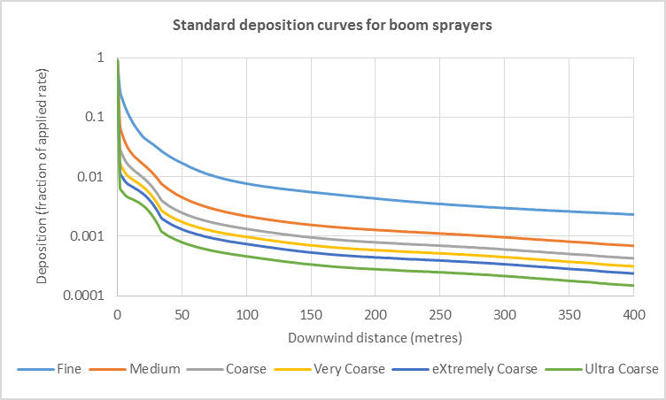
Figure 6: Chart of standard deposition curves for boom sprayers

Vertical sprayers
As no validated predictive models are currently available for vertical sprayers, the ‘basic drift values’ are used as standard deposition curves for the use of vertical sprayers. These were generated from field trials conducted in Germany in the 1990s and have a long history of effective regulatory use in Germany and other countries, including Canada. There are also significant numbers of drift reduction technologies recognised in Germany based on these curves, which may be useful for industry for the development of custom deposition curves (see section 4.3).
As previously-used terminology of orchards and vineyards does not capture all situations where this equipment may be used (eg banana plantations, forestry plantations, asparagus crops and trellis tomatoes), the general term of ‘vertical sprayers’ has been adopted. Within the category of vertical sprayers, terminology has been aligned with the nature of the canopy that the ‘basic drift values’ are based on to ensure all situations are captured (see table 8).
Table 8: Terminology equivalence between German ‘basic drift values’ and APVMA vertical sprayer standard deposition curves
German ‘basic drift values’ | APVMA vertical sprayer standard deposition curves
Fruit crops—early | Canopies taller than 2 metres (non-fully foliated)
Fruit crops—late | Canopies taller than 2 metres (fully foliated)
Grapevine—late | Canopies 2 metres and shorter
Figure 7 shows the standard deposition curves for vertical sprayers on a log-log chart. The validated range of these deposition curves is 250 metres.
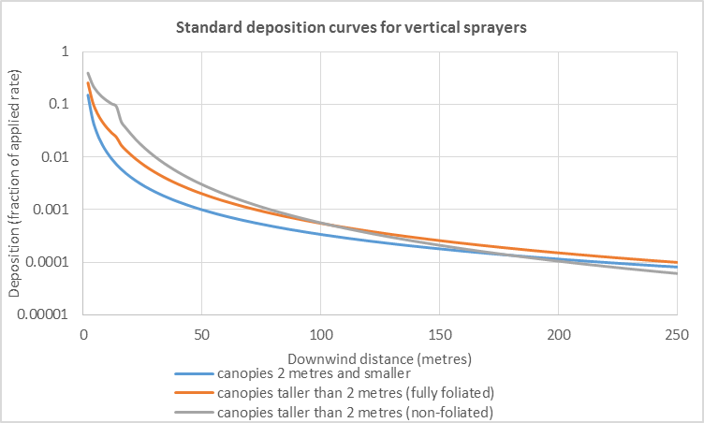
Figure 7: Chart of standard deposition curves for vertical sprayers

Aircraft
Standard deposition curves for each of the droplet size distributions in Appendix 1 have been established using AGDISPTM version 8.26 for both fixed-wing and helicopter aircraft using the model input variables in the template files below. Input summaries are also provided as text files.
APVMA AGDISP—Aircraft—Fixed-Wing.ag
APVMA AGDISP Input Summary—Aircraft—Fixed-Wing.txt
APVMA AGDISP—Aircraft—Helicopter.ag
APVMA AGDISP Input Summary—Aircraft—Helicopter.txt
Release height is based on 25 per cent wingspan for fixed wing aircraft or 25 per cent rotor diameter for helicopters. For the default AT502 fixed wing aircraft a release height of 4 m above the target canopy is used. For the default Bell 206B JetRanger helicopter a release height of 3 m above the target canopy is used.
These curves are shown in figures 8 and 9 on a log-log chart. The validated range of these curves is 800 metres.
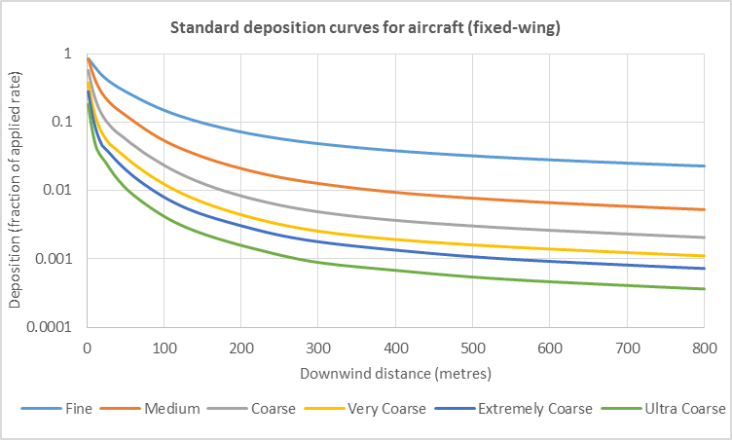
Figure 8: Chart of standard deposition curves for aircraft (fixed-wing)
Note: Reference curves based on threshold nozzles and operating pressures as outlined in ASAE S572.2 have been used to establish the standard deposition curves for aircraft in figures 8 and 9. ASABE S641, Droplet Size Classification of Aerial Application Nozzles, came into effect in May 2018 and the APVMA guidelines will be updated to comply with ASABE S641. In the interim, applications can proceed with the standard curves outlined in this section or sufficient information will need to be provided with applications to enable custom curves based on S641 to be established as outlined in section 4.2.
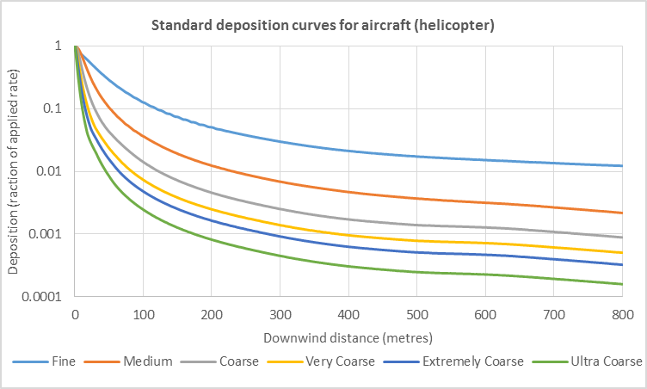
Figure 9: Chart of standard deposition curves for aircraft (helicopter)

Custom deposition curves
Custom deposition curves can be generated from information submitted with an application. The spray drift data guideline contains detailed guidance about the sorts of information that may be relevant.
Typically, custom deposition curves will be generated from information that relates to drift-reducing practices, technologies or innovations, including:
- specific low-drift nozzles
- improved equipment designs
- equipment modifications
- adjuvants (additives and/or components of formulations)
- improved equipment operating practices.

Field trials
Spray drift field trials are inherently variable and therefore need to be assessed with a degree of flexibility rather than a standardised approach, which may not be applicable to certain datasets. Although this means that full details cannot be presented, every assessment will involve two main steps:
- regression analysis
- rather than limit assessments to a single regression model for the entire downwind distance, the ultimate goal is to establish a deposition curve, which has the best possible fit to field data
- the 90th percentile of field data will be used for regression analysis unless a valid scientific argument is presented for the use of an alternative percentile
- results below the limit of detection of the study will not be considered when determining field data percentiles
- quality assurance
- when a field trial includes a reference sprayer, a regression analysis of the test data is compared to the relevant standard deposition curve. If there are significant differences between these curves, the field trial reference sprayer curve may be normalised to the relevant standard deposition curve and the same method applied to correct the candidate curve, in order to ensure consistency
- when a field trial does not include a reference sprayer, quality assurance can only be satisfied with valid scientific argument.

Modelling
As there is no currently validated predictive model for vertical sprayers, modelling can only be conducted for boom sprayers and aircraft using AGDISPTM. Generally, modelling will be conducted using the relevant AGDISPTM template file (see section 4.1) as a basis and either doing one of, or a combination of, the following steps:
- modelling the effect of a candidate (ie the nozzle or equipment being tested under certain conditions) droplet size distribution (DSD) after it has been converted to reduce inter-laboratory variability (see section 4.2)
- modelling the effect of specific use instructions that would support varying the input settings in the relevant AGDISPTM input template.
Unless the information submitted requires otherwise, modelling will be conducted at different wind speeds (7, 14 and 20 km/hr). The deposition curve for 20 km/hr will be used in the spray drift risk assessment tool (see section 6) and all three wind speeds are added to the spray drift management tool. The same approach will be used to model release height.
Currently accepted versions of AGDISP include version 8.26 (the US EPA regulatory version can be downloaded from their website) and version 8.28. The use of later research versions of AGDISP may be considered with argument that changes in newer version do not compromise the validity of the output deposition data.

Conversion of droplet size distributions (DSDs)
To ensure that DSDs from different testing facilities can be compared and be consistent relative to APVMA DSDs (see Appendix 1), a DSD converter tool has been developed. This tool applies a distribution model, originally published by Rosin and Rammler (1933) and used in this context by Teske and Thistle (2000), to both the DSD of the candidate being tested and the two nearest reference nozzles. These two modelled reference nozzle DSDs are then compared to their equivalent APVMA DSDs and a correction factor is applied to the modelled candidate DSD. The DSD of the candidate nozzle and the two nearest reference nozzles must be measured from the same facility with the same experimental setup.
APVMA DSD Converter—V1.0.xls

Averaged deposition curves
As deposition curves are established in terms of point deposition, they must be averaged to reflect the sensitive area being protected before being used to calculate buffer zones. Levels of deposition are averaged across the following distances for each sensitive area:
- bystander areas—20 metres
- natural aquatic areas—3 metres
- pollinator areas—3 metres
- vegetation areas—3 metres
- livestock areas—100 metres.

Use instructions
The following instructions will be required as relevant particulars for approved labels, or as conditions on permits, where a relevant assessment has been conducted in accordance with this manual. Two different approaches are supported for the determination of buffer zones:
- use of standard deposition curves (section 5.1)
- use of customised deposition curves from submission of spray drift data (section 5.2).
The location of these instructions on product labels is described in section 9.5 of the Agricultural Labelling Code.
It is essential that these use instructions are interpreted with the definitions provided in the glossary.

Standard instructions
Standard instructions contain four discrete sections:
- general instructions (section 5.1)—includes instructions applying to the use of any product that requires a spray drift risk assessment regardless of the application equipment
- boom sprayers (section 5.1.)—provides options for instructions specifically related to application by boom sprayer. The first option can be varied by including buffer zones calculated from the maximum label rate and a significantly lower application rate (included on the approved label for use in a different crop/situation or to control a different pest/disease/weed). Additional options for DRTs may be added to the table
- vertical sprayers (section 5.1.)—provides options for instructions specifically related to application by vertical sprayer, including buffer zones for three different canopy types. Additional options for DRTs may be added to the table
- aircraft (section 5.1)—provides three options for instructions specifically related to application by aircraft, including buffer zones for fixed-wing and helicopter aircraft. The first option can be varied by refining the instructions to account for approved labels where only one aircraft type is supported or different droplet sizes are required for different aircraft types. Additional options for lower rates and DRTs may be added to the table.
The selection of application equipment is at the discretion of the applicant, provided that they are within the limits of the Agvet Code (ie they must align with the outcomes of the safety, trade and efficacy assessments). For example, if an application was not supported on the grounds that vertical sprayer application presented an un-mitigatable occupational health and safety exposure risk to users, then this section of the label must include the instruction ‘DO NOT apply with vertical sprayers’.

General instructions
SPRAY DRIFT RESTRAINTS
Specific definitions for terms used in this section of the label can be found at apvma.gov.au/spraydrift.
DO NOT allow bystanders to come into contact with the spray cloud.
DO NOT apply in a manner that may cause an unacceptable impact to native vegetation, agricultural crops, landscaped gardens and aquaculture production, or cause contamination of plant or livestock commodities, outside the application site from spray drift. The buffer zones in the relevant buffer zone table/s below provide guidance but may not be sufficient in all situations. Wherever possible, correctly use application equipment designed to reduce spray drift and apply when the wind direction is away from these sensitive areas.
DO NOT apply unless the wind speed is between 3 and 20 kilometres per hour at the application site during the time of application.
DO NOT apply if there are hazardous surface temperature inversion conditions present at the application site during the time of application. Surface temperature inversion conditions exist most evenings one to two hours before sunset and persist until one to two hours after sunrise.

Boom sprayers
DO NOT apply by a boom sprayer unless the following requirements are met:
- spray droplets not smaller than a [ZAA] spray droplet size category
- minimum distances between the application site and downwind sensitive areas (see ‘Mandatory buffer zones’ section of the following table titled ‘Buffer zones for boom sprayers’) are observed.
Buffer zones for boom sprayers
Application rate | Boom height above the target canopy | Mandatory downwind buffer zones
Application rate | Boom height above the target canopy | Bystander areas | Natural aquatic areas | Pollinator areas | Vegetation areas | Livestock areas
Up to maximum label rate | 0.5 m or lower | [ZBB] m | [ZCC] m | [ZDD] m | [ZEE] m | [ZFF] m
Up to maximum label rate | 1.0 m or lower | [ZLL] m | [ZMM] m | [ZNN] m | [ZOO] m | [ZPP] m
A rate lower than the maximum label rate (if relevant for the product label) | 0.5 m or lower | [ZGG] m | [ZHH] m | [ZII] m | [ZJJ] m | [ZKK] m
 | 1.0 m or lower | [ZQQ] m | [ZRR] m | [ZSS] m | [ZTT] m | [ZUU] m

OR (if an assessment required any buffer zone distance to be greater than the validated distance)
DO NOT apply by a boom sprayer.
OR (if the use of boom sprayers is not supported under any circumstance)
DO NOT apply by a boom sprayer.

Vertical sprayers
DO NOT apply by a vertical sprayer unless the following requirements are met:
- spray is not directed above the target canopy
- the outside of the sprayer is turned off when turning at the end of rows and when spraying the outer row on each side of the application site
- for dilute water rates up to the maximum listed for each type of canopy specified, minimum distances between the application site and downwind sensitive areas (see ‘Mandatory buffer zones’ section of the following table titled ‘Buffer zones for vertical sprayers’) are observed.
Buffer zones for vertical sprayers
Type of target canopy and dilute water rate | Mandatory downwind buffer zones
Type of target canopy and dilute water rate | Bystander areas | Natural aquatic areas | Pollinator areas | Vegetation areas | Livestock areas
2 metres tall and shorter, maximum dilute water rate of [YPP] L/ha | [YAA] m | [YBB] m | [YCC] m | [YDD] m | [YEE] m
taller than 2 metres (not fully-foliated), maximum dilute water rate of [YQQ] L/ha | [YFF] m | [YGG] m | [YHH] m | [YII] m | [YJJ] m
taller than 2 metres (fully-foliated), maximum dilute water rate of [YRR] L/ha | [YKK] m | [YLL] m | [YMM] m | [YNN] m | [YOO] m

OR (if an assessment required any buffer zone distance to be greater than the validated distance)
DO NOT apply by a vertical sprayer.
OR (if the use of vertical sprayers is not supported under any circumstance)
DO NOT apply by a vertical sprayer.

Aircraft
DO NOT apply by aircraft unless the following requirements are met:
- spray droplets not smaller than a [XAA] spray droplet size category
- for maximum release heights above the target canopy of 3m or 25% of wingspan or 25% of rotor diameter whichever is the greatest, minimum distances between the application site and downwind sensitive areas (see ‘Mandatory buffer zones’ section of the following table titled ‘Buffer zones for aircraft’) are observed.
Buffer zones for aircraft
Type of aircraft | Mandatory downwind buffer zones
Type of aircraft | Bystander areas | Natural aquatic areas | Pollinator areas | Vegetation areas | Livestock areas
Fixed-wing | [XBB] m | [XCC] m | [XDD] m | [XEE] m | [XFF] m
Helicopter | [XGG] m | [XHH] m | [XII] m | [XJJ] m | [XKK] m

OR (if an assessment required any buffer zone distance to be greater than the validated distance)
DO NOT apply by aircraft.
OR (if the use of aircraft is not supported under any circumstance)
DO NOT apply by aircraft.

Different application equipment types for different crop/situation use patterns
When the range of crop/situation use patterns on a product label are intended to be treated with the same type/s of application equipment, no further use instructions are required. However, if different application equipment types are intended for different crop/situation use patterns, specific instructions must be incorporated onto the label in order to provide clarity to users.
For example, if boom and aerial application was supported for wheat and only vertical sprayer application was supported for apples on efficacy grounds, then the use instructions would need to clarify this.
These clarifying instructions are required in order to indicate which application type/s are intended for use with which crop/situation; they may appear in different sections of the label at the discretion of the registrant. The complexity of a label (ie the number and range of different crop/situations approved) will dictate the most efficient and effective way of providing this clarification. Some suggested locations for these statements are in the following sections of a label:
- SPRAY DRIFT RESTRAINTS
- GENERAL INSTRUCTIONS
- DIRECTIONS FOR USE (CROP/SITUATION or CRITICAL COMMENTS)
The DIRECTIONS FOR USE table could also be split into sections for each application equipment type (eg a label could have four DIRECTIONS FOR USE sections with only the relevant use pattern(s) in each: a boom sprayer section, a vertical sprayer section, an aircraft section, and a miscellaneous application equipment section for use patterns that do not require a spray drift risk assessment as detailed in section 1.4 above).

Custom instructions
When information relating to spray drift (see spray drift data guideline) is submitted as part of an application, the standard instructions outlined in section 5.1 will be used as a basis for establishing label instructions; the standard instructions will be refined, reduced or expanded in accordance with the nature of that application.
When an application proposes to only allow use with certain equipment, examples of potential additional instructions are:
- ‘only to be applied with a make A model B nozzle up to a maximum pressure of C bar’ (for boom sprayer application)
- ‘only to be applied with a make A model B tower sprayer’ (for vertical sprayer application)
- ‘only to be applied with a make A model B orifice C nozzle at a maximum airspeed of D with a minimum pressure of E bar and a maximum angle of Fº from the horizontal (where 0º is directly opposite from the direction of flight and 90º is directly downwards)’ (for aircraft application).
When an application proposes the addition of a drift-reducing adjuvant, examples of potential additional instructions are:
- ‘only to be applied when [adjuvant product name and number] is used in a tank mix at label rates’
- ‘minimum distances between the application site and downwind sensitive areas that appear in the ‘Mandatory buffer zones’ section of the table below titled ‘Buffer zones for boom sprayers (with or without using adjuvant) must be observed’ (where the first row of the table lists buffer zones established by a risk assessment using standard deposition curves and the second lists buffer zones established by a risk assessment using custom deposition curves).
More generally, applicants may wish to provide additional risk management use instructions in relation to spray drift. For example, as buffer zones may not always be completely protective of agricultural crops or aquacultural production (see section 3.1), applicants may wish to include specific statements about these areas through custom use instructions. This may be particularly useful when there are known risks posed to certain crops or aquacultural species (including at certain development stages) by a certain product.

Spray drift risk assessment tool (SDRAT)
To ensure consistency and evaluation efficiency, a spray drift risk assessment tool has been developed to automate the spray drift risk assessment process described in this manual as much as possible. This tool includes the generation of complete standard instructions (see section 5.1) based on the outcome of a risk assessment. Applicants are able to conduct self-assessments using this tool prior to making an application.
An Excel-based tool will be used in the interim until a permanent web based tool is established:
SDRAT APVMA Assessments v1.0.xlsx.

Buffer zone rounding
For simplicity, when the SDRAT is used to determine use instructions on product labels or permits (see section 5), buffer zones will be rounded up to the nearest interval in accordance with table 9. When a product label references the spray drift management tool, users are able to access the actual calculated buffer zone as no rounding is used in the SDMT.
Table 9: Buffer zone rounding
Distance range (m) | Interval (m) | Boom sprayer | Vertical sprayer | Aircraft
0–100 | 5 | Yes | Yes | Yes
100–250 | 10 | Yes | Yes | Yes
250–400 | 25 | Yes | Outside validated standard deposition curve range | Yes
400–800 | 25 | Outside validated standard deposition curve range | Outside validated standard deposition curve range | Yes

Mandatory tank mixes
NOTE: This function is not available in the current SDRAT.
When an instruction for a mandatory tank-mix instruction is considered, a set of RALs for each combination in a particular ratio (ie the product used by itself and with mandatory tank mix partner/s—see section 3.3) will be entered into the SDRAT. As RALs are expressed as a fraction of applied rate (see section 3.2), each set of RALs will also have an active application rate relative to the product being assessed, but adjusted to the tank mix.
The SDRAT will then calculate the required buffer zones for the use pattern of each combination. For simplicity only the worst case will be used for label/permit instructions, however the buffer zone table may be expanded to cover the additional combinations if required.
The formula used to calculate the adjusted active rate for tank mixes is shown in equation 13 and an example is provided in table 10. An example of determining the worst case buffer zones for label/permit instructions is shown in table 11.
Equation 13: Formula for calculating adjusted active rates for tank mixes
$$ActiveRate(tank mix)=Conc(product)× Rate(product)+Conc(tank mix partner)×Rate(tank mix partner)$$
Table 10: Example calculation of an adjusted active concentration for a tank mix
 | Product used by itself | Product used with mandatory tank mix partner
Active concentration of product | 250 g ac/L | 250 g ac/L
Active concentration of tank mix partner | - | 500 g ac/L
Maximum application rate of product | 1,000 mL/ha | 500 mL/ha
Maximum application rate of tank mix partner | - | 2,000 mL/ha
Active applied rate | 250 g/ha | 1,125 g/ha
Table 11: Example calculation of worst-case buffer zones for a tank mix
Sensitive area | Product used by itself | Product used with mandatory tank mix partner | Label/permit use instructions
Bystander areas | 10 metres | Not required | 10 metres
Natural aquatic areas | Not required | 100 metres | 100 metres
Pollinator areas | 20 metres | 20 metres | 20 metres
Vegetation areas | Not required | Not required | Not required
Livestock areas | 250 metres | Not required | 250 metres

Spray drift management tool (SDMT)
To allow application by techniques other than those covered by the standard risk assessments in the spray drift risk assessment tool, a spray drift management tool will be used by regulatory risk assessment specialists.
The SDRAT has been developed, based on conservative assumptions, to account for a variety of factors which contribute to the distance that spray drifts. This is to ensure that the risk of spray drift can be managed with any spray application in accordance with a broad set of use instructions. By contrast, the SDMT allows buffer zones to be recalculated by considering specific factors and specific use instructions.
As a trade-off for increasing flexibility in the way the product can be applied (compared to the use instructions and the risk assessment), the SDMT can recalculate larger buffer zone distances in certain situations (eg with a finer droplet size when using a product in a tank-mix and higher release heights for application by aircraft).
An Excel-based SDMT will be used by regulatory risk assessment specialists to establish buffers for additional application techniques on a label or permit while a permanent web based tool is established:
SDMT—Chemical user refinement—v1.0.xlsx.

SDMT overview
The SDMT allows more targeted risk assessments with a wider range of application techniques. This information is then used to establish additional buffer zones and conditions through two methods:
- fraction of applied rate factors
- alternative deposition curves.
These methods are explained in more detail in sections 7.2 and 7.3. They can be applied separately, or in combination, depending on the options selected in the SDMT. Visual representations of how buffer zones can be recalculated by applying these methods are shown in figures 10, 11 and 12. In these examples, the solid black arrows show the buffer zone that was established through the use of the SDRAT and the hashed black arrows show the buffer zone recalculated by the SDMT.
Section 7.4 explains the conditions that apply to the use of the SDMT and section 7.5 outlines how information is managed and updates to the SDMT occur.
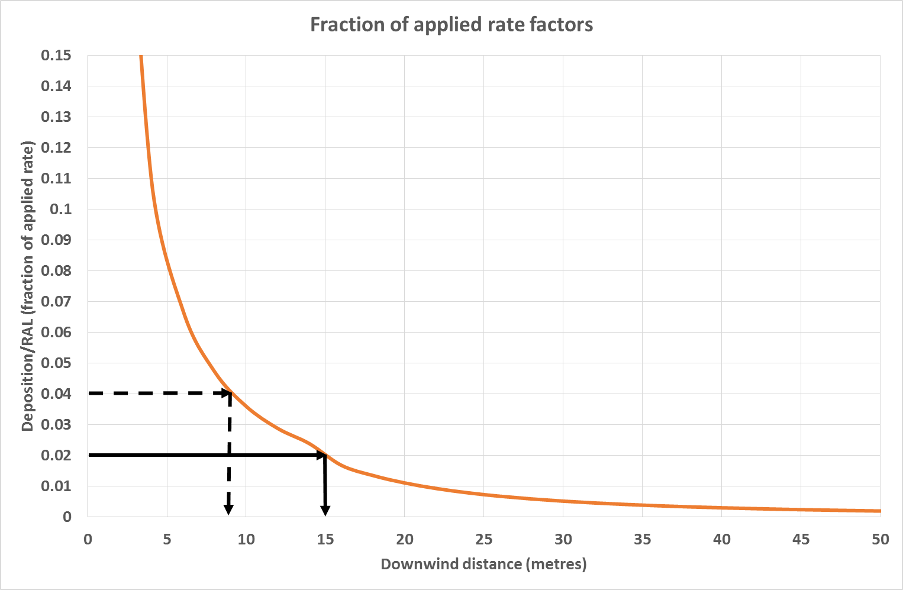
Figure 10: Buffer zone recalculation by applying fraction of applied rate factors
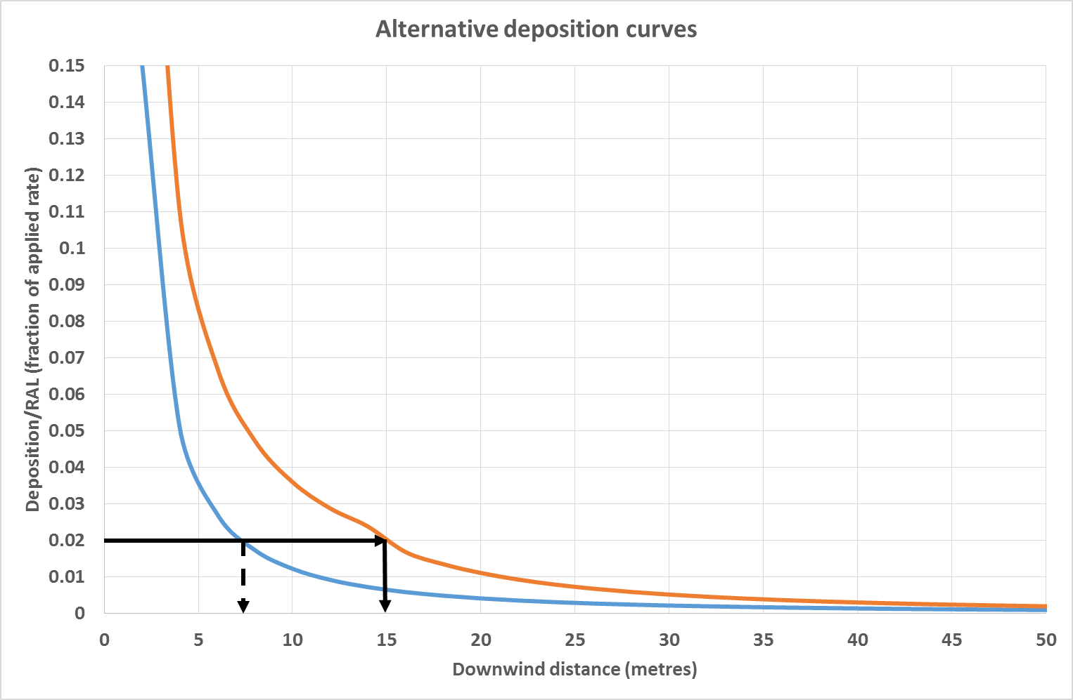
Figure 11: Buffer zone recalculation by selecting alternative deposition curves

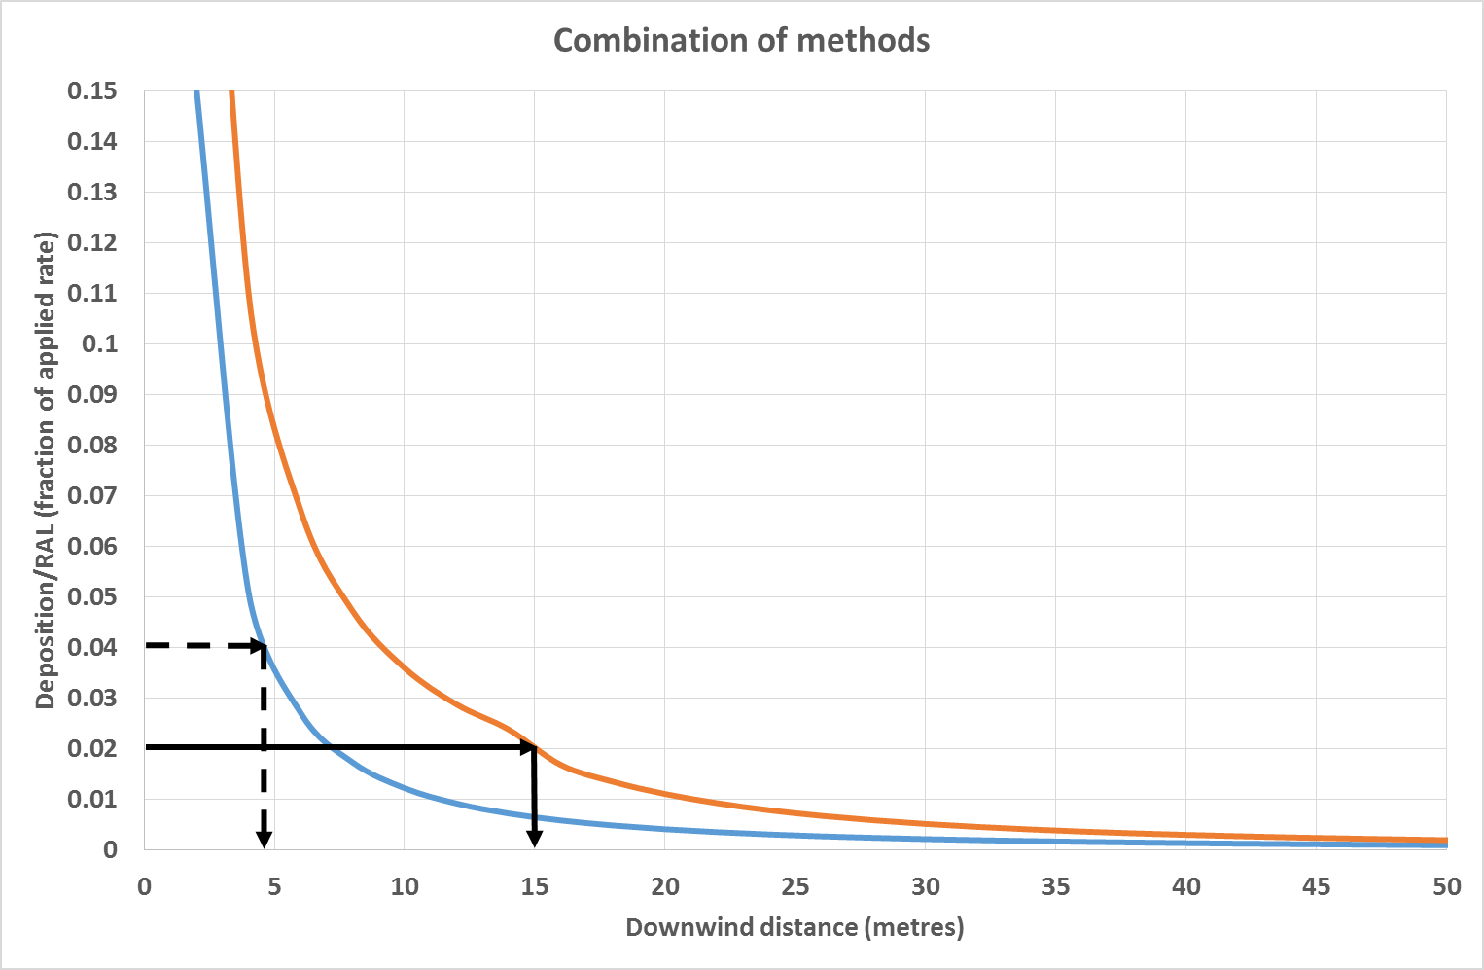
Figure 12: Buffer zone recalculation by applying both methods in combination

Tank-mixing
When users mix products in the tank, they must always follow the most restrictive use instruction (for the particular purpose of application) on the labels of the products used in that tank-mix. For example, if one label includes a statement that a half-face respirator must be worn by the applicator but the tank mix partner label does not, the applicator must wear the half-face respirator to apply the tank mix.
Buffer zones are no different. If a buffer zone was 10 metres for one product in a tank-mix and 50 metres for another, the buffer zone for that tank-mix would be 50 metres. The SDMT allows the risk assessor to select all the products used in a tank-mix and determine the most restrictive for each sensitive area.
An exception arises when a tank mix is on the registered label as mandatory. The SDMT can accommodate this by including different sets of RALs for products used alone and in combination with mandatory tank-mix partners (see section 6.2).

Fraction of applied rate factors
Several different adjustment factors are available in the SDMT which allow the fraction of applied rate, with respect to RALs, to be adjusted. These factors do not change the hazard determination of spray drift risk assessments, only how RALs are converted to relevant units (ie grams per hectare) or how they are expressed as a fraction of the applied rate (see section 3). Once RALs are adjusted, buffer zone distances are recalculated by the SDMT.

Application rate
Instead of the maximum label use for the relevant equipment type (realistic worst-case), the SDMT adjusts each RAL (fraction of applied rate) with the application rate specified by the user (equations 8 and 9 in section 3.2).

Water depth
The natural aquatic area RAL (Aquatic RAL) is calculated for a water body that is 0.15 metres (15 centimetres) deep to allow deposition on the surface of water to be converted to a concentration in water. As this (concentration in water) is the driver for protecting natural aquatic areas, not deposition on the surface of the water, a deeper water body has a greater tolerance to spray drift because of the increased dilution of the chemical.
Equation 14 shows how the aquatic RAL is calculated based on a 15 cm water depth.
Equation 14: Accounting for increased water depth
$$SDMT Adjusted Aquatic RAL=Aquatic RAL \left(fraction of applied rate\right)×\frac{User input water depth (cm)}{15 cm}$$
Water depth is inputted in 15 cm (0.15 m) intervals; a maximum water depth of 0.60 m is accepted to allow for poor mixing from the surface to the bottom in deeper water bodies (which prevents dilution).

Optical spot spraying technologies
When optical spot spraying technologies are used on a boom sprayer, application rates can be significantly reduced. Specific directions for the use of this technology on product labels commonly specify a dilution rate (ie amount of product per 100 litres of water) and a calibration rate (ie number of litres of spray mixture per hectare the equipment is set up to apply, if the optical spot spraying technology was not in use). As this is not consistent with typical boom sprayer directions for use (ie amount of product per hectare), the reduction in application rate from the use of this technology is best accounted for as a factor.
The SDMT allows the risk assessor, once they input their application rate by providing dilution rate and calibration rate, to input the percentage cover of their target (eg weed cover). Each RAL is then adjusted as shown in equation 15.
Equation 15: Accounting for optical spot spraying technologies
$$SDMT Adjusted RAL=RAL \left(fraction of applied rate\right)×\frac{100\%}{User input percentage cover of target}$$

Vegetative and artificial spray drift barriers
The National Working Party on Pesticide Applications conducted a project in relation to vegetative and artificial spray drift barriers. A draft implementation of barriers has been incorporated into the SDMT to demonstrate how this may be incorporated. Further work is required to finalise and validate the proposed analysis.

Alternative deposition curves
Different deposition curves can be selected, within their equipment type, in order to recalculate buffer zones. The SDMT is pre-loaded with the standard deposition curves (see section 4.1) and additional SDMT deposition curves (see section 7.3). After applications are made to the APVMA to assess information (see spray drift data guideline), custom deposition curves will be added to the SDMT (see section 7.3).

Addition of custom deposition curves
Applications to the APVMA that include submission of information (see spray drift data guideline) to establish custom deposition curve/s can be made as follows:
- holders of a product registration (or applicants registering a product for the first time), who own (or have consent to access) information that is product specific can submit information as part of an application for registration or variation
- information provided through this pathway has limits on use of information (see also the guideline) applied, so custom deposition curve/s are only ever available to users of that product. Underlying information used to establish custom deposition curves is not included in the SDMT to ensure confidential commercial information requirements are observed
- third parties (eg equipment/nozzle manufacturers and industry representative groups) can apply to the APVMA for technical assessment of information. This information may either be product specific or applicable to any product
- the third party can then seek consent of a relevant holder of a registration to make an application to vary the relevant particulars of the registration of a product (section 27(2) of the Agvet Code), in order to recognise custom deposition curve/s established from this information
- alternatively, when making an application for technical assessment, written consent can be given by the third party to allow custom deposition curve/s established from this information to be available to any holder of a product registration (or applicant registering a product for the first time).
Third parties and holders of a product registration (or applicants registering a product for the first time) also have the ability to form a partnership and have information submitted as part of an application for registration or variation by the holder/applicant. If this information is intended to be applicable to any product (ie not specific to product the application relates to), the third party can provide written consent to allow custom deposition curve/s established from this information to be available to any holder of a product registration (or applicant registering a product for the first time).

Additional SDMT deposition curves
Additional SDMT deposition curves have been established to provide flexibility during the assessment of applications for registration or variation. These additional deposition curves are included in the ‘Deposition Curves’ tab of the spray drift management tool.

Boom sprayers
For boom sprayers, the AGDISPTM template in section 4.1 was used to model two lower wind speeds (14 km/hr and 7 km/hr) for each droplet size distribution to establish additional SDMT deposition curves.
For simplicity, the standard use instructions (see section 5.1) align to the standard deposition curves and limit application to a maximum boom height of 0.50 metres above the target. To account for this and provide flexibility to users, additional SDMT deposition curves (for each droplet size distribution at each wind speed) have been established for boom heights between 0.50 metres and 1.20 metres (using the AGDISPTM templates in section 4.1 without varying other input values).
At higher release heights, the canopy being treated, and the release height in relation to the canopy, should be considered with specific AGDISPTM model inputs rather than the approach above. Because of the considerable number of combinations, this can only practically be performed through the submission of information to develop custom deposition curves (see section 4.2) rather than including additional SDMT deposition curves.
To account for narrow treatment areas, ‘rights-of-way’ and other small scale applications in turf and horticulture, modelling was also conducted (for each droplet size distribution at each boom height at each wind speeds) for application site widths of three metres (narrow), 20 metres (rights of way) and 60 metres (small fields).

Vertical sprayers
For vertical sprayers, the additional ‘basic drift values’ for ‘grapevine—early’ (canopies two metres and shorter with air assistance turned off) and ‘hops’ have been used to establish additional SDMT deposition curves.

Aircraft
For aircraft, the AGDISPTM templates in section 4.1 were used to model two lower wind speeds (14 km/hr and
7 km/hr) for each droplet size distribution and for each aircraft type to establish additional SDMT deposition curves.
For simplicity, the standard use instructions (see section 5.1) align to the standard deposition curves and limit application to a maximum release height above the target canopy of three metres or 25 per cent of wingspan or 25 per cent of rotor diameter, whichever is greater. To account for this and to provide flexibility to users, additional SDMT deposition curves (for each droplet size distribution for each aircraft type at wind speeds of 20, 14 and 7 km/hr) have been established for heights between three metres and six metres at 1.0 metre increments (using the AGDISPTM templates in section 4.1 without varying other input values).
At higher release heights, the canopy being treated, and the release height in relation to the canopy should be considered with specific AGDISPTM model inputs rather than the approach above. Because of the considerable number of combinations, this can only practically be performed through the submission of information to develop custom deposition curves (see section 4.2) rather than additional SDMT deposition curves.

Case studies
To demonstrate the principles outlined in this manual and the effect it has on the pesticide label, two case study examples for hypothetical pesticide products are set out below. The first is for a herbicide that can be applied by fixed wing aircraft, helicopter or ground boom sprayer (section 8.1). The second is for an insecticide that can be applied using a vertical sprayer or ground boom sprayer (section 8.2).

Case study one: Herbicide applied by air and ground boom
Herbicide One contains an active constituent of 500 g/L active-one. It can be applied by either ground boom or aircraft. It can be applied to cereals with a maximum rate of 2.1 L/ha or pastures, right of way or fallow with a maximum rate of 4 L/ha as shown on the product label (figure 13).
Figure 13: Extract from Herbicide One label
Product Name: Herbicide One
Active constituent: 500 g/L active-one
Product Number: 1001
DIRECTIONS FOR USE
Situation and crop | Weeds | Rate
Wheat Barley Oats | Wild radish (Raphanus raphanistrum)  Fat hen (Chenopodium album)  Turnip weed (Rapistrum rugosum) | 0.7–2.1 L/ha
Pastures  Rights of Way Fallow | Noogora burr (Xanthium occidentale)  Variegated thistle (Silybum marianum) | 0.7–4 L/ha

Table 12: Regulatory acceptable levels for Herbicide One
Sensitive area | Regulator acceptable level (RAL) | Fraction of applied rate¹
Bystander | 31 g/ha | 0.01550
Aquatic | 10 µg/L | 0.01500
Pollinators | 900 g/ha | 0.45000
Vegetation | 7.5 g/ha | 0.00375
Livestock | 500 mg/kg | 0.75000
¹Maximum label active constituent application rate is 2000 g ac/ha (= 4 L/ha * 500 g ac/L)
An extract from the label using the framework given in this manual is shown in figure 14.
Figure 14: Extract from product label with framework described in this manual
SPRAY DRIFT RESTRAINTS
Specific definitions for terms used in this section of the label can be found at apvma.gov.au/spraydrift.
DO NOT allow bystanders to come into contact with the spray cloud.
DO NOT apply in a manner that may cause an unacceptable impact to native vegetation, agricultural crops, landscaped gardens and aquaculture production, or cause contamination of plant or livestock commodities, outside the application site from spray drift. The buffer zones in the relevant buffer zone table/s below provide guidance, but may not be sufficient in all situations. Wherever possible, correctly use application equipment designed to reduce spray drift and apply when the wind direction is away from these sensitive areas.
DO NOT apply unless the wind speed is between 3 and 20 kilometres per hour at the application site during the time of application.
DO NOT apply if there are hazardous surface temperature inversion conditions present at the application site during the time of application. Surface temperature inversion conditions exist most evenings one to two hours before sunset and persist until one to two hours after sunrise.
DO NOT apply by a boom sprayer unless the following requirements are met:
- spray droplets not smaller than a COARSE spray droplet size category
- minimum distances between the application site and downwind sensitive areas (see ‘Mandatory buffer zones’ section of the following table titled ‘Buffer zones for boom sprayers’) are observed.
Buffer zones for boom sprayers
Application rate | Boom height above the target canopy | Mandatory downwind buffer zones
Application rate | Boom height above the target canopy | Bystander areas | Natural aquatic areas | Pollinator areas | Vegetation areas | Livestock areas
Up to maximum label rate | 0.5 m or lower | 5 metres | 25 metres | Not required | 40 metres | Not required
Up to maximum label rate | 1.0 m or lower | 30 metres | 65 metres | Not required | 110 metres | Not required
2100 mL/ha or lower | 0.5 m or lower | Not required | 10 metres | Not required | 30 metres | Not required
2100 mL/ha or lower | 1.0 m or lower | 20 metres | 40 metres | Not required | 65 metres | Not required
DO NOT apply by a vertical sprayer.
DO NOT apply by aircraft unless the following requirements are met:
- spray droplets not smaller than a COARSE spray droplet size category
- for maximum release heights above the target canopy of 3m or 25% of wingspan or 25% of rotor diameter whichever is the greatest, minimum distances between the application site and downwind sensitive areas (see ‘Buffer zones’ section of the following table titled ‘Buffer zones for aircraft’) are observed.
Buffer zones for aircraft
Type of aircraft | Mandatory downwind buffer zones
Type of aircraft | Bystander areas | Natural aquatic areas | Pollinator areas | Vegetation areas | Livestock areas
Fixed-wing | 130 metres | 220 metres | Not required | 400 metres | Not required
Helicopter | 90 metres | 150 metres | 10 metres | 230 metres | Not required

Case study two: Insecticide applied by vertical sprayer and ground boom
Insecticide One contains an active constituent of 500 g/L active-two. It can be applied by either ground boom or vertical sprayers. It can be applied to orchards with a maximum rate of 200 mL/100 L or potatoes with a maximum rate of 2.2 L/ha as shown on the product label (figure 15).
Figure 15: Extract from Insecticide One label
Product Name: Insecticide One
Active constituent: 500 g/L active-two
Product Number: 1002
DIRECTIONS FOR USE
Situation and crop | Pest | Rate
Pecans  Macadamias | Yellow peach moth | 200 mL/100L
Apples  Pears | Lightbrown apple moth  Codling moth | 100 to 200 mL/100L
Potatoes | Potato moth  Heliothis (budworms) | 2.2 L/ha

It is assumed that the RAL as established by the APVMA assessment areas for Insecticide One is given in table 13 for each of the sensitive areas. The RAL is also shown as a fraction of the maximum label active constituent rate (fraction of applied rate).
Table 13: Regulatory acceptable levels for Insecticide One
Sensitive area | Regulator acceptable level (RAL) | Fraction of applied rate¹
Bystander | 450 g/ha | 0.4090
Aquatic | 6.6 µg/L | 0.0090
Pollinators | 22 g/ha | 0.0200
Vegetation | 2000 g/ha | 1.8200
Livestock | 400 mg/kg | 1.0900
¹Maximum label active constituent application rate is 1100 g ac/ha
An extract from the label using the proposed framework given in this manual is shown in figure 16.
Figure 16: Extract from product label with the framework described in this manual
SPRAY DRIFT RESTRAINTS
Specific definitions for terms used in this section of the label can be found at apvma.gov.au/spraydrift.
DO NOT allow bystanders to come into contact with the spray cloud.
DO NOT apply in a manner that may cause an unacceptable impact to native vegetation, agricultural crops, landscaped gardens and aquaculture production, or cause contamination of plant or livestock commodities, outside the application site from spray drift. The buffer zones in the relevant buffer zone table/s below provide guidance but may not be sufficient in all situations. Wherever possible, correctly use application equipment designed to reduce spray drift and apply when the wind direction is away from these sensitive areas.
DO NOT apply unless the wind speed is between 3 and 20 kilometres per hour at the application site during the time of application.
DO NOT apply if there are hazardous surface temperature inversion conditions present at the application site during the time of application. Surface temperature inversion conditions exist most evenings one to two hours before sunset and persist until one to two hours after sunrise.
DO NOT apply by a boom sprayer unless the following requirements are met:
- spray droplets not smaller than a MEDIUM spray droplet size category
- minimum distances between the application site and downwind sensitive areas (see ‘Mandatory buffer zones’ section of the following table titled ‘Buffer zones for boom sprayers’) are observed.
Buffer zones for boom sprayers
Application rate | Boom height above the target canopy | Mandatory downwind buffer zones
Application rate | Boom height above the target canopy | Bystander areas | Natural aquatic areas | Pollinator areas | Vegetation areas | Livestock areas
Up to maximum label rate | 0.5 m or lower | Not required | 20 metres | 5 metres | Not required | Not required
Up to maximum label rate | 1.0 m or lower | Not required | 55 metres | 30 metres | Not required | Not required
DO NOT apply by a vertical sprayer unless the following requirements are met:
- spray is not directed above the target canopy
- the outside of the sprayer is turned off when turning at the end of rows and when spraying the outer row on each side of the application site
- for dilute water rates up to the maximum listed for each type of canopy specified, minimum distances between the application site and downwind sensitive areas (see ‘Buffer zones’ section of the following table titled ‘Buffer zones for vertical sprayers’) are observed.
Buffer zones for vertical sprayers
Type of target canopy | Mandatory downwind buffer zones
Type of target canopy | Bystander areas | Natural aquatic areas | Pollinator areas | Vegetation areas | Livestock areas
2 metres tall and smaller, maximum dilute water rate of 1000 L/ha | Not required | 10 metres | 10 metres | Not required | Not required
Taller than 2 metres (not fully foliated), maximum dilute water rate of 4000 L/ha | Not required | 55 metres | 40 metres | Not required | Not required
Taller than 2 metres (fully foliated), maximum dilute water rate of 4000 L/ha | Not required | 45 metres | 30 metres | Not required | Not required
DO NOT apply by aircraft.

Appendix

Appendix A: Droplet size distributions (DSDS)
The cumulative volume distributions for the ASAE/ANSI S572.2 reference nozzles used to establish standard deposition curves are shown in figure 17 and in the files below which can be imported directly into AGDISPTM. The summary statistics are given in table 14.
APVMA VF-F DSD.txt
APVMA F-M DSD.txt
APVMA M-C DSD.txt
APVMA C-VC DSD.txt
APVMA VC-XC DSD.txt
APVMA XC-UC DSD.txt
These DSDs represent the boundary of each droplet size classification. For example, a DSD finer than VF-F would be VERY FINE and a DSD coarser would be FINE, so VF-F is used for risk assessments for a FINE droplet size.
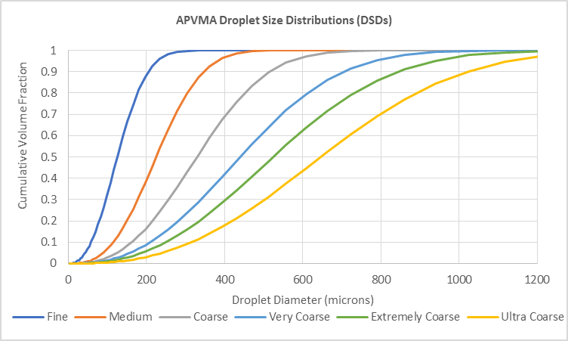
Figure 17: Chart of cumulative volume distributions for the reference nozzles used to establish standard deposition curves
NOTE: These DSDs are used for both boom sprayers and aircraft. ASABE S641, Droplet Size Classification of Aerial Application Nozzles, came into effect in May 2018 and the use of aircraft specific DSDs will be reviewed. In the interim, applications will proceed as outlined in this manual or sufficient information will need to be provided with an application to enable custom curves based on S641 to be established.
Table 14: Summary droplet size statistics for the reference nozzles used to establish standard deposition curves
Standard reference curve | Dv0.1  (µm) | Dv0.5 or VMD  (µm) | Dv0.9  (µm)
Fine | 58 | 126 | 206
Medium | 115 | 225 | 347
Coarse | 163 | 329 | 516
Very coarse | 210 | 440 | 708
Extremely coarse | 249 | 524 | 844
Ultra coarse | 315 | 646 | 1021

Appendix B: Evaluation of AGDISP ground model
The Technical Working Group, (TWG) of the National Working Party on Pesticide Applications (NWPPA) evaluated the suitability of AGDISP ground for establishing buffers for ground boom application. Raw field data from the US Spray Drift Task Force (SDTF) as well as spray drift deposit data from Australian studies was sourced to form a benchmark against which the model outputs could be compared.
Deposition data from 46 trial from the SDTF and 24 trial from the University of Queensland were modelled. It was found that Air Injection (AI) setting was more appropriate for the fine sprays and that the Flat Fan (FF) setting was more appropriate for ultra-coarse scenarios. Figure 18 shows that across all data sets, model predictions with the FF setting (red points) tended to over predict deposit compared to the measured field deposition and the AI setting (green points) tended to under predict deposition. When the modelled downwind curves were weighted between the AI and FF model outputs (graduated AGDISP, blue points) there was a much closer correlation between model prediction and measured deposit (figure 19).
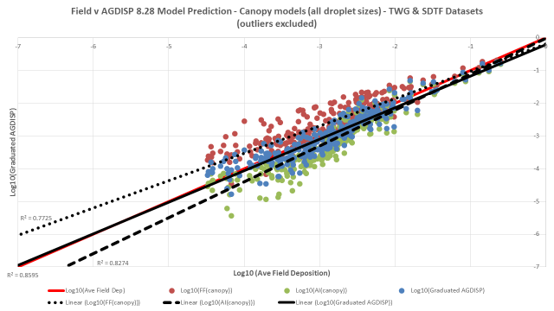
Figure 18: Field versus AGDISP 8.28 model predictions for Flat Fan (FF), Air Injection (AI) and a graduated approach between FF and AI

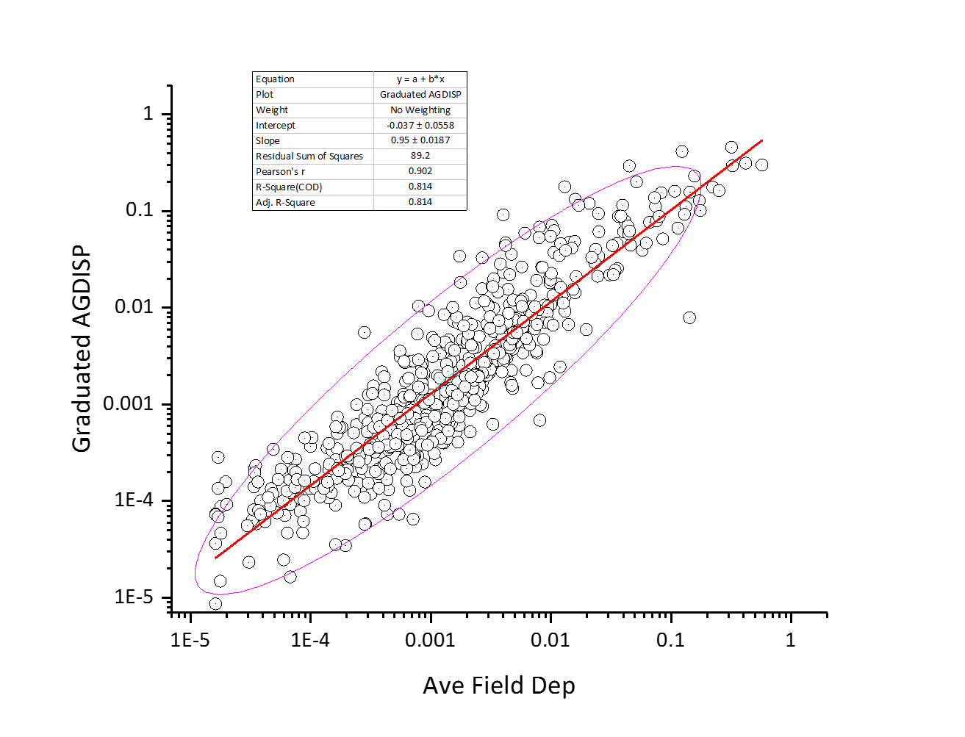
Figure 19: Regression analysis of the graduated AGDISP model prediction and field deposition

Abbreviations
DSD | Droplet size distribution
RAL | Regulatory acceptable level
SDMT | Spray drift management tool
SDRAM | Spray drift risk assessment manual
SDRAT | Spray drift risk assessment tool

Glossary
Agricultural crops | ‘Agricultural crops’ means any terrestrial plant species grown commercially for food, fibre, foliage, fuel or medicinal production, with the following exception:  - plants that are not part of a crop under management at the time of pesticide application (eg blackberries or volunteer grain plants that have escaped from a cropped area and become weeds in another area).
Aircraft | An ‘aircraft’ is a fixed-wing or rotary aircraft that applies spray in-flight. This includes unmanned aerial vehicles (UAVs). This excludes application equipment defined as a ‘boom sprayer’ or ‘vertical sprayer’ or when the product is used for any use pattern not requiring a spray drift risk assessment (see section 2.2).
Application site | The ‘application site’ refers to the area or field where it is intended for the spray to be applied.
Aquacultural production | ‘Aquacultural production’ means commercial production of any aquatic plant or aquatic animal species for food or ornamental purposes. This does not include those which are not part of an area of aquacultural production under management at the time of pesticide application (eg fish that have escaped into natural watercourses).
Boom sprayer | A ‘boom sprayer’ is one that applies spray downward from a ground-based horizontal boom. This excludes application equipment defined as a ‘vertical sprayer’ or ‘aircraft’ or when the product is used for any use pattern not requiring a spray drift risk assessment (see section 2.2). This includes nozzles known as boomless jets, which are mounted to a vehicle and used to produce a swath significantly wider than the vehicle itself.
Boom height | For the purposes of ground boom sprayer, ‘boom height’ is the distance between the top of the ‘target canopy’ and the nozzle tip. If no canopy is present the boom height is the height above the ground. Boom height is only considered as being typical across the application site, not a maximum height. Increases in release height for short periods during application are not considered as being non-compliant with the boom height in a use instruction. These increases are expected and are adequately managed through principles of good agricultural practice.
Buffer zone | A ‘buffer zone’ is an area where pesticide application does not occur between the application site and an identified sensitive area which is downwind from the application site. For boom and aerial spraying, a buffer zone is measured from the edge of the sprayer swath closest to the downwind sensitive area; for vertical spraying, a buffer zone is measured from half a row width (ie trees, vines, other plants) outside the application site closest to the downwind sensitive area.
Bystander areas | ‘Bystander areas’ are locations where it is reasonably likely that ‘bystanders’ will be exposed to residues deposited on the ground from spray drift on a regular basis and for an extended period of time (ie several hours per day over a period of a month). Examples of these areas include: residential properties, schools, kindergartens, day care facilities, hospitals, aged care facilities, public or private parks or recreational areas, and areas where manual handling of soil or plants is required.
Bystanders | ‘Bystanders’ means people not involved in mixing, loading or applying the pesticide and are without the personal protective equipment (PPE) required by the product label.
Contamination | ‘Contamination’ means a failure of plant or livestock commodities to comply with the APVMA Maximum Residue Limit Standard.
Droplet size distribution (DSD) | As defined by ASTM E2798, Standard Test Method for Characterization of Performance of Pesticide Spray Drift Reduction Adjuvants for Ground Application:  - ‘mathematical or graphical representation of droplet sizes of a given spray frequently shown as a volume fraction, number fraction, or cumulative fraction distributions.’  Note that only the volume fraction (or cumulative volume fraction) is relevant for this manual.
Dilute water rate | For ‘vertical sprayers’, ‘dilute water rate’ means the amount of water applied per hectare to reach the point of run-off (ie where the target plant is thoroughly wet).
Hazardous surface temperature inversions | ‘Surface temperature inversions’ occur when air temperature increases with height from the ground surface, which is the opposite of what normally happens (ie the temperature profile is 'inverted'). This results in a layer of cool, still air being trapped below warmer air. In surface temperature inversion conditions airborne pesticides can concentrate near the surface and unpredictable winds can move droplets away from the target area. The direction and distance which the droplets will move becomes unpredictable.  A surface temperature inversion is likely to be present if:  - mist, fog, dew or a frost have occurred  - smoke or dust hangs in the air and moves sideways, just above the ground surface  - cumulus clouds that have built up during the day collapse towards evening  - wind speed is constantly less than 11 km/hr in the evening and overnight  - cool off-slope breezes develop during the evening and overnight  - distant sounds become clearer and easier to hear  - aromas become more distinct during the evening than during the day.  When application occurs in an area not covered by recognised inversion monitoring weather stations, all the surface temperature inversion conditions are regarded as hazardous and the above definition will always apply.
Landscaped gardens | ‘Landscaped gardens’ means any terrestrial plant species grown for ornamental purposes on private or public land, or for domestic food production on private land, with the following exceptions:  - species that are declared noxious or invasive to the area of application by local, state or commonwealth legislation  - plants that are not part of a garden under management at the time of pesticide application (eg flowering plants that have escaped from a home garden and have become weeds in another area).
Livestock areas | ‘Livestock areas’ are those where livestock are grazing. ‘Buffer zones’ for ‘livestock areas’ have been established to protect international trade. These buffer zones are based on the Maximum Residue Limit (MRL) Standards of significant export markets for livestock commodities.
Native vegetation | ‘Native vegetation’ means any terrestrial plant species native to Australia as defined under local, state or commonwealth legislation with the following exceptions:  - species that are declared noxious or invasive to the area of application by local, state or commonwealth legislation  - plants that the chemical user, or the person the chemical user is applying agricultural chemical product/s on behalf of, is legally allowed to remove under local, state or commonwealth legislation.  ‘Buffer zones’ for the purpose of ‘native vegetation’ may also be used as the basis for the protection of ‘agricultural crops’ and ‘landscaped gardens’. However, ‘buffer zones’ for ‘native vegetation’ are based on survival at a population or ecosystem level and they may not be sufficient if yield loss or replacement cost is the issue.
Natural aquatic areas | ‘Natural aquatic areas’ are where a ‘watercourse’ (as defined by the Commonwealth Water Act 2007) is present, with the following exceptions:  - artificial ‘watercourses’ used exclusively for agricultural or ornamental purposes, such as irrigation channels, flood irrigation areas, farm dams, ornamental ponds, golf course dams and those used for aquacultural production  - ‘watercourses’ that are dry at the time of pesticide application  - ‘watercourses’ that are commonly identified as ‘puddles’.  ‘Buffer zones’ established for the purpose of the ‘natural aquatic area’ may also be used as the basis for the protection of ‘aquacultural production’ but as the buffer zones for ‘natural aquatic areas’ are based on survival at a population or ecosystem level, they may not be sufficient if yield loss or replacement cost within an aquaculture operation is the issue.
Pollinator areas | ‘Pollinator areas’ means managed bee hives. This only applies when the manager of those bee hives has provided notification regarding their location to the chemical user, or the person the chemical user is applying agricultural chemical product/s on behalf of, at least 48 hours prior to application of the agricultural chemical product/s. While notification can be made directly (in writing or verbally), the use of the BeeConnected website or smartphone app is acceptable and recommended.
Release height | For the purposes of aircraft, ‘release height’ is the distance between the top of the ‘target canopy’ and the nozzles on the aircraft. Pilot safety is paramount, so the release height is only considered as being typical across the application site, not a maximum flying height. Increases in release height for short periods during application to avoid obstacles, or turn at the end of runs, are not considered as being non-compliant with the release height in a use instruction. These increases are expected and are adequately managed through principles of good agricultural practice by the aerial agricultural industry.
Relevant output of the spray drift management tool | For the purposes of use instructions (see section 5), a ‘relevant output of the spray drift management tool’ refers to the output from the spray drift management tool following the input of information relevant to the proposed application of a specific product (or products). The specific product may be identified by the APVMA approval number printed on the product label or the product name recorded on the APVMA register.
Rotor diameter | Diameter of the rotating blades of a helicopter which generates lift.
Sensitive areas | For the purpose of spray drift management, five different type of sensitive areas are considered in establishing relevant buffer zones. These are ‘Bystander areas’, ‘Natural aquatic areas’, ‘Pollinator areas’, ‘Vegetation areas’ and ‘Livestock areas’.
Spray cloud | ‘Spray cloud’ means the volume of air that is directly adjacent to operating application equipment which contains large numbers of spray droplets in close proximity to each other. The area which the spray cloud covers will vary between types of application equipment and use practices, but is generally defined as the cloud of droplets that is visible by the naked eye shortly after being released into the atmosphere and excludes isolated droplets that are carried downwind from the application area by the wind.
Spray drift | Spray drift is defined by the APVMA as the movement of spray droplets of a pesticide outside of the application site during, or shortly after, application. It does not encompass off-target movement of a pesticide caused by runoff, volatilisation, erosion, or any other mechanism that occurs after spray droplets reach their intended target.
Spray droplet size category | The characteristics of spray droplets produced by a certain nozzle operating at a certain pressure are described in several standards. Specifically, these standards are used by the APVMA for application by ‘boom sprayer’ or ‘aircraft’ only (ie they are not currently relevant for a ‘vertical sprayer’) and describe the following droplet size categories:  - FINE (F)  - MEDIUM (M)  - COARSE (C)  - VERY COARSE (VC)  - EXTREMELY COARSE (XC)  - ULTRA COARSE (UC)  Standards also may refer to VERY FINE (VF) or smaller spray droplet sizes but because they pose significant spray drift risk potential, these categories will only be assessed in rare circumstances, based on the submission of spray drift data rather than standard assumptions.  Different nozzle standards are used because no undisputed international standard currently exists. Nozzle manufacturers commonly rely on the standard, which is used in the jurisdiction in which they are based.  The APVMA currently recognises the following standards for the classification of nozzles used on a ‘boom sprayer’:  - American Society of Agricultural and Biological Engineers (ASABE)  - ANSI/ASAE S572.1 MAR2009: Spray Nozzle Classification by Droplet Spectra  - ANSI/ASAE S572.2 JUL2018: Spray Nozzle Classification by Droplet Spectra  - ISO 25358: Crop protection equipment—Droplet-size spectra from atomizers—Measurement and classification  ASABE S641, Droplet Size Classification of Aerial Application Nozzles, came into effect in May 2018 and the APVMA guidelines may in the future be updated to comply with ASABE S641 for aerial applications.  Droplet size categories are currently based on ASAE S572.2 and categories from non-recognised standards will not be used unless sufficient information is provided with an application to enable custom droplet size distributions to be established or the APVMA recognises the standard.
Surface temperature inversions | See ‘Hazardous surface temperature inversions’.
Target canopy | ‘Target canopy’ refers to vegetation within the ‘application site’. The ‘target canopy’ can refer to the crop, weeds or any other vegetation within the target area, whichever is the highest.
Unacceptable impact | For the purposes of native vegetation, ‘unacceptable impact’ means a loss of native vegetation that has an impact at a population or ecosystem level. For example, damage to leaves on a small percentage of plants in an area that does not cause a change in the diversity of plants in that area is not an ‘unacceptable impact’ but damage that causes a species of plant in an area to be replaced by another species is an ‘unacceptable impact’. However, it is important to note that this ultimately depends on relevant local, state or commonwealth legislation, which varies between jurisdictions.  For the purposes of ‘agricultural crops’, ‘landscaped gardens’ or ‘aquacultural production’, unacceptable impact will be determined by the policies of the relevant Control-of-Use jurisdiction.
Vegetation areas | ‘Vegetation areas’ are where ‘native vegetation’, ‘agricultural crops’ or ‘landscaped gardens’ are present. It does not include vegetation that has been planted explicitly for purpose of a drift buffer.
Vertical sprayer | A ‘vertical sprayer’ is one that applies spray in a direction other than directly towards the ground. This excludes application equipment defined as a ‘boom sprayer’ or ‘aircraft’ or when the product is used for any use pattern not requiring a spray drift risk assessment (section 2.2).
Watercourse | For the purpose of ‘natural aquatic areas’, the current definition of ‘watercourse’ under the Commonwealth Water Act 2007 is a river, creek or other natural watercourse (whether modified or not) in which water is contained or flows (whether permanently or from time to time); and includes:  - a dam or reservoir that collects water flowing in a watercourse  - a lake or ‘wetland’ through which water flows  - a channel into which the water of a watercourse has been diverted  - part of a watercourse  - an estuary through which water flows.  A ‘wetland’ is an area of land where water covers the soil—all year or just at certain times of the year. They include:  - swamps, marshes  - billabongs, lakes, lagoons  - saltmarshes, mudflats  - mangroves, coral reefs  - bogs, fens, and peatlands.  A ‘wetland’ may be natural or artificial and its water may be static or flowing, fresh, brackish or saline.
Wind speed | The average wind speed at the application site during the time of application must not exceed the maximum given on the product label. The maximum wind speed (gusts) should not be more than one-third of the average wind speed above the average wind speed.  Wind speed should be measured two metres above the ground at the application site. The point where the wind speed is measure should be representative of the application area and should be free of obstructions that may impact the measurement.
Wing span | The maximum extent across the wings of an aircraft measured from tip to tip.

Reference
Altenburger, RA, Arrhenius, ÅA, Backhaus, TA, Coors, AA, Faust, MA & Zitzkat, DA 2014, Ecotoxicological combined effects from chemical mixtures Part 1: Relevance and adequate consideration in environmental risk assessment of plant protection products and biocides, Umweltbundesamt, vol. 92/2013, xiii + 203 pp., available at umweltbundesamt.de/publikationen/ecotoxicological-combined-effects-from-chemical.
American Society of Agricultural and Biological Engineers (ASABE) 2018, ANSI/ASAE S572.2: Spray Nozzle Classification by Droplet Spectra, available at elibrary.asabe.org/abstract.asp?aid=49050&t=3&redir=aid=49050&redir=%5bconfid=s2000%5d&redirType=standards.asp&redirType=standards.asp.
ASTM 2011 E2798-11, Standard Test Method for Characterization of Performance of Pesticide Spray Drift Reduction Adjuvants for Ground Application, available at astm.org/Standards/E2798.htm.
EnHealth 2012, Australian Exposure Factor Guide (2012), Environmental Health Standing Committee (enHealth) of the Department of Health, Canberra, available at health.gov.au/internet/main/publishing.nsf/Content/health-pubhlth-publicat-environ.htm.
Hewitt, AJ 2008, Droplet size spectra classification categories in aerial application scenarios, Crop Protection, vol. 27, pp. 1284–8, available at sciencedirect.com/science/article/pii/S0261219408000689?via%3Dihub.
OECD 1998, Test No. 214: Honeybees, Acute Contact Toxicity Test, OECD Guidelines for the Testing of Chemicals, Section 2, OECD Publishing, Paris, available at doi.org/10.1787/9789264070189-en.
OECD 2003, Descriptions of selected key generic terms used in a chemical hazard/risk assessment, Series on Testing and Assessment, No. 44, Organisation for Economic Co-operation and Development, Paris, France, available at oecd.org/chemicalsafety/pesticides-biocides/seriesontestingandassessment.htm.Rosin, P & Rammler, E 1933, ‘The laws governing the fineness of powdered coal’, Journal of the Institute of Fuel, vol. 7, pp. 29–36.
Southcombe, ESE, Miller, PCH, Ganzelmeier, H, Van De Zande, JC, Miralles, A, Hewitt, AJ 1997, The International (BCPC) Spray Classification System Including a Drift Potential Factor. Proc. BCPC Conf.—Weeds, pp. 371–80, available at dropdata.net/bcpc_ewg/ESES_noz.pdf.
Teske, ME, Miller, PCH, Thistle, HW & Birchfield, NB 2009, ‘Initial development and validation of a mechanistic spray drift model for ground boom sprayers’, Transactions of the ASABE, vol. 52, pp. 1089–97.
Teske, ME & Thistle, HW 2000, ‘Droplet size scaling of agricultural spray material by dimensional analysis’, Atomisation and Sprays, vol. 10, pp. 147–58.
US EPA 1997, Standard Operating Procedure (SOPs) for Residential Exposure Assessments, United States Environmental Protection Agency, Washington D.C., United States, available at epa.gov/pesticides/trac/science/index.htm.
US EPA 2014, Residential Exposure Assessment Standard Operating Procedures Addenda 1: Consideration of Spray Drift, United States Environmental Protection Agency, Washington D.C., United States, available at regulations.gov/#!documentDetail;D=EPA-HQ-OPP-2013-0676-0003.
US EPA, Health Canada PMRA & California Department of Pesticide Regulation 2014, Guidance for Assessing Pesticide Risks to Bees, United States Environmental Protection Agency, Washington D.C., United States, available at epa.gov/pollinator-protection/pollinator-risk-assessment-guidance.
Victorian Government 2012, Water rates used in horticulture, former Department of Primary Industries, Melbourne, available at agriculture.vic.gov.au/agriculture/farm-management/chemical-use/publications/water-rates-used-in-horticulture.
WHO 2009, Principles and Methods for the Risk Assessment of Chemicals in Food, Environmental Health Criteria 240, available at who.int/foodsafety/publications/chemical-food/en/.

