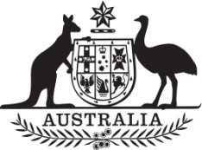

Commonwealth of Australia

Gazette

Agricultural and veterinary chemicals

APVMA Special Gazette, 20 December 2022
Published by the Australian Pesticides and Veterinary Medicines Authority
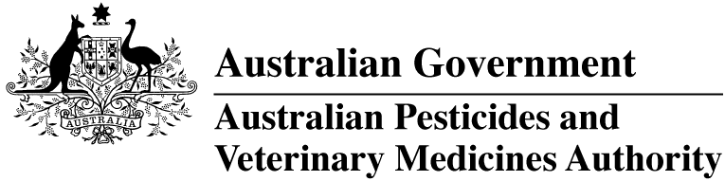
The Agricultural and Veterinary Chemical Code Act 1994 (the Act) commenced on 15 March 1995. The Agricultural and Veterinary Chemicals Code (the Agvet Code) scheduled to the Act requires notices to be published in the Gazette containing details of the registration of agricultural and veterinary chemical products and other approvals granted by the Australian Pesticides and Veterinary Medicines Authority. The Agvet Code and related legislation also requires certain other notices to be published in the Gazette. A reference to Agvet Codes in this publication is a reference to the Agvet Code in each state and territory jurisdiction.
ISSN 1837-7629
© Commonwealth of Australia 2022
This work is copyright. Apart from any use as permitted under the Copyright Act 1968, no part may be reproduced by any process without prior written permission from the Australian Pesticides and Veterinary Medicines Authority (APVMA). Requests and inquiries concerning reproduction and rights should be addressed to:
Assistant Director, Communications
Australian Pesticides and Veterinary Medicines Authority
GPO Box 3262
Sydney NSW 2001
Email: communications@apvma.gov.au
Website: apvma.gov.au
General information
The APVMA Gazette is published fortnightly and contains details of the registration of agricultural and veterinary chemicals products and other approvals granted by the APVMA, notices as required by the Agricultural and Veterinary Chemicals Code (the Agvet Code) and related legislation and a range of regulatory material issued by the APVMA.
Pursuant to section 8J(1) of the Agvet Code, the APVMA has decided that it is unnecessary to publish details of applications made for the purpose of notifying minor variations to registration details. The APVMA will however report notifications activity in quarterly statistical reports.
Distribution and subscription
The APVMA Gazette is published in electronic format only and is available from the APVMA website.
If you would like to subscribe to receive email notification when a new edition is published, please complete a subscription form.
APVMA contacts
For enquiries regarding the publishing and distribution of the APVMA Gazette: Telephone: +61 2 6770 2300.
For enquiries on APVMA Gazette content, please refer to the individual APVMA contacts listed under each notice.
Privacy
For information on how the APVMA manages personal information when you contact us, see our Privacy Policy.
Contents
Agvet chemical voluntary recall: ILIUM MELOXICAM ANTI-INFLAMMATORY ORAL SUSPENSION FOR DOGS 1

Agvet chemical voluntary recall: ILIUM MELOXICAM ANTI-INFLAMMATORY ORAL SUSPENSION FOR DOGS
Product name: ILIUM MELOXICAM ANTI-INFLAMMATORY ORAL SUSPENSION FOR DOGS
APVMA registration number: 60023
APVMA approved label number: 127421
Batch number(s): 220935B
Sold by: Troy Laboratories Pty Ltd in all States and Territories between 7 October 2022 and 14 December 2022
On 16 December 2022, Troy Laboratories Pty Ltd (ACN: 000283769) initiated a voluntary recall under section 106 of the Agricultural and Veterinary Chemicals Code scheduled to the Agricultural and Veterinary Chemicals Code Act 1994 (Cth) in relation to the chemical product described above.

Reason for voluntary recall
This batch recall has been initiated due to the incorrect syringe being included with the product.
This product should include a syringe with “kg” markings (i.e., measuring in mg/kg body weight), but instead includes the syringe with normal “mL” markings.

Hazard
Use of the incorrect syringe may result in dosing errors.

What to do if in possession of this chemical product
If you are in possession of the affected product and you are a veterinarian, please contact the holder to arrange replacement of stock.
If you are an animal owner who has been prescribed this product and have it in your possession, please contact your veterinarian to arrange a replacement and to discuss your pet’s treatment as required.
Troy sincerely regrets any inconvenience this product recall may cause to your business or customers.

More information
Visit the APVMA website to view the notice of voluntary recall for the chemical product described above.
The APVMA publishes a list of agvet chemical recall notices on its website and provides a subscription option to be notified by email when a new recall notice is published.

Contact
Questions about this voluntary recall should be directed to Troy Laboratories Customer Service on 02 8808 3611.

