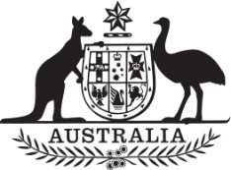

Commonwealth of Australia

Gazette

Agricultural and veterinary chemicals

APVMA Special Gazette, 14 July 2022
Published by the Australian Pesticides and Veterinary Medicines Authority
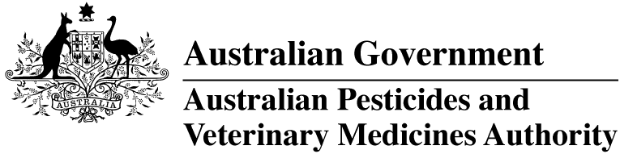
The Agricultural and Veterinary Chemical Code Act 1994 (the Act) commenced on 15 March 1995. The Agricultural and Veterinary Chemicals Code (the Agvet Code) scheduled to the Act requires notices to be published in the Gazette containing details of the registration of agricultural and veterinary chemical products and other approvals granted by the Australian Pesticides and Veterinary Medicines Authority. The Agvet Code and related legislation also requires certain other notices to be published in the Gazette. A reference to Agvet Codes in this publication is a reference to the Agvet Code in each state and territory jurisdiction.
ISSN 1837-7629
© Commonwealth of Australia 2022
This work is copyright. Apart from any use as permitted under the Copyright Act 1968, no part may be reproduced by any process without prior written permission from the Australian Pesticides and Veterinary Medicines Authority (APVMA). Requests and inquiries concerning reproduction and rights should be addressed to:
Assistant Director, Communications
Australian Pesticides and Veterinary Medicines Authority
GPO Box 3262
Sydney NSW 2001
Email: communications@apvma.gov.au
Website: apvma.gov.au
General information
The APVMA Gazette is published fortnightly and contains details of the registration of agricultural and veterinary chemicals products and other approvals granted by the APVMA, notices as required by the Agricultural and Veterinary Chemicals Code (the Agvet Code) and related legislation and a range of regulatory material issued by the APVMA.
Pursuant to section 8J(1) of the Agvet Code, the APVMA has decided that it is unnecessary to publish details of applications made for the purpose of notifying minor variations to registration details. The APVMA will however report notifications activity in quarterly statistical reports.
Distribution and subscription
The APVMA Gazette is published in electronic format only and is available from the APVMA website.
If you would like to subscribe to receive email notification when a new edition is published, please complete a subscription form.
APVMA contacts
For enquiries regarding the publishing and distribution of the APVMA Gazette: Telephone: +61 2 6770 2300.
For enquiries on APVMA Gazette content, please refer to the individual APVMA contacts listed under each notice.
Privacy
For information on how the APVMA manages personal information when you contact us, see our Privacy Policy.
Contents
Agvet chemical voluntary recall: Coopers® Revalor®-H growth promotant and finishing implants 1

Agvet chemical voluntary recall: Coopers® Revalor®-H growth promotant and finishing implants
Product name: Coopers® Revalor®-H growth promotant and finishing implants
APVMA registration number: 47248
APVMA approved label number: 51459
Batch number(s): A767A01, A752A02, A744A02, A727A01, A715T01, A722T01, A707A01, A697A01, A677A01, A672A01, A666A01, A649A01, A643A01
Sold by: Intervet Australia Pty Limited in nationally between 1 June 2019 and 30 June 2022.
On 8 June 2022, Intervet Australia Pty Limited (ABN: 79 008 467 034) initiated a voluntary recall under section 106 of the Agricultural and Veterinary Chemicals Code scheduled to the Agricultural and Veterinary Chemicals Code Act 1994 (Cth) in relation to the chemical product described above.

Reason for voluntary recall
This is not a product nor a batch recall.
This is a notification to customers of a label misprint. Customers are not required to return affected units.
The label on the outer packaging of the affected batch shows the incorrect APVMA registration number 47258 has been printed in place of 47248.

Hazard
None.

What to do if in possession of this chemical product
No specific actions are required other than to note the correct APVMA registration number is 47248.

More information
Visit the APVMA website to view the notice of voluntary recall for the chemical product described above.
The APVMA publishes a list of agvet chemical recall notices on its website and provides a subscription option to be notified by email when a new recall notice is published.

Contact
Questions about this voluntary recall should be directed to:
Intervet Australia Pty Limited (trading as MSD Animal Health)
Level 1, Building A
26 Talavera Road
Macquarie Park
NSW 2113
Australia
Phone: 1800 033 461

