

Commonwealth of Australia

Commonwealth of Australia

Commonwealth of Australia

Commonwealth of Australia

Gazette

Agricultural and veterinary chemicals

APVMA Special Gazette, 24 December 2025
Published by the Australian Pesticides and Veterinary Medicines Authority
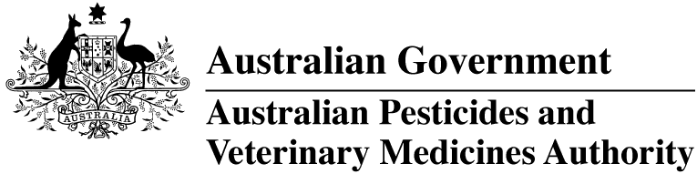
The Agricultural and Veterinary Chemical Code Act 1994 (the Act) commenced on 15 March 1995. The Agricultural and Veterinary Chemicals Code (the Agvet Code) scheduled to the Act requires notices to be published in the Gazette containing details of the registration of agricultural and veterinary chemical products and other approvals granted by the Australian Pesticides and Veterinary Medicines Authority. The Agvet Code and related legislation also requires certain other notices to be published in the Gazette. A reference to Agvet Codes in this publication is a reference to the Agvet Code in each state and territory jurisdiction.
ISSN 1837-7629
© Commonwealth of Australia 2025
This work is copyright. Apart from any use as permitted under the Copyright Act 1968, no part may be reproduced by any process without prior written permission from the Australian Pesticides and Veterinary Medicines Authority (APVMA). Requests and inquiries concerning reproduction and rights should be addressed to:
Assistant Director, Communications
Australian Pesticides and Veterinary Medicines Authority
GPO Box 574
Canberra ACT 2601, Australia
Email: communications@apvma.gov.au
Website: apvma.gov.au
General information
The APVMA Gazette is published fortnightly and contains details of the registration of agricultural and veterinary chemicals products and other approvals granted by the APVMA, notices as required by the Agricultural and Veterinary Chemicals Code (the Agvet Code) and related legislation and a range of regulatory material issued by the APVMA.
Pursuant to section 8J(1) of the Agvet Code, the APVMA has decided that it is unnecessary to publish details of applications made for the purpose of notifying minor variations to registration details. The APVMA will however report notifications activity in quarterly statistical reports.
Distribution and subscription
The APVMA Gazette is published in electronic format only and is available from the APVMA website.
If you would like to subscribe to receive email notification when a new edition is published, please complete a subscription form.
APVMA contacts
For enquiries regarding the publishing and distribution of the APVMA Gazette: Telephone: +61 2 6770 2300.
For enquiries on APVMA Gazette content, please refer to the individual APVMA contacts listed under each notice.
Privacy
For information on how the APVMA manages personal information when you contact us, see our Privacy Policy.
Contents
Agvet chemical voluntary recall: Bloat-Drench Oral Bloat Control 1

Agvet chemical voluntary recall: Bloat-Drench Oral Bloat Control
Product name: Bloat-Drench Oral Bloat Control
APVMA registration number: 38823
APVMA approved label number: 60429
Batch numbers: N2510059 (20 L), N2509031 (200 L), N2509032 (200 L), N2510155 (200 L), N2510156 (200 L), N2509039 (200 L), N2509038 (200 L), N2509037 (1000 L)
Sold by: Victorian Chemical Company Pty Ltd nationwide between 19 September 2025 to 23 December 2025.
On 23 December 2025, Victorian Chemical Company Pty Ltd (ACN 004 188 863) initiated a voluntary recall under section 106 of the Agricultural and Veterinary Chemicals Code scheduled to the Agricultural and Veterinary Chemicals Code Act 1994 (Cth) in relation to the chemical product described above.

Reason for voluntary recall
Due to detection of microbial contamination in the product.

Hazard
Due to presence of microbial contaminant, the potency and safety of the product could be compromised. Using a product with compromised potency and safety may:
- result in reduced effectiveness of the treatment
- pose a safety hazard to handlers and to the animals.

What to do if in possession of this chemical product
- DO NOT use any containers of the above-mentioned batches.
- Please return the product to the place of purchase for a full refund.

More information
Visit the APVMA website to view the notice of voluntary recall for the chemical product described above.
The APVMA publishes a list of agvet chemical recall notices on its website and provides a subscription option to be notified by email when a new recall notice is published.

Contact
Questions about this voluntary recall should be directed to:
Victorian Chemical Company Pty Ltd
Phone: 03 9301 7000
Email: agsales@vicchem.com

