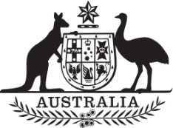

Commonwealth of Australia

Commonwealth of Australia

Commonwealth of Australia

Commonwealth of Australia

Gazette

Agricultural and veterinary chemicals

APVMA Special Gazette, 12 August 2025
Published by the Australian Pesticides and Veterinary Medicines Authority
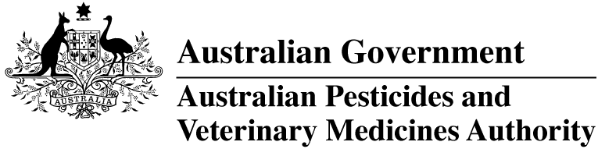
The Agricultural and Veterinary Chemical Code Act 1994 (the Act) commenced on 15 March 1995. The Agricultural and Veterinary Chemicals Code (the Agvet Code) scheduled to the Act requires notices to be published in the Gazette containing details of the registration of agricultural and veterinary chemical products and other approvals granted by the Australian Pesticides and Veterinary Medicines Authority. The Agvet Code and related legislation also requires certain other notices to be published in the Gazette. A reference to Agvet Codes in this publication is a reference to the Agvet Code in each state and territory jurisdiction.
ISSN 1837-7629
© Commonwealth of Australia 2025
This work is copyright. Apart from any use as permitted under the Copyright Act 1968, no part may be reproduced by any process without prior written permission from the Australian Pesticides and Veterinary Medicines Authority (APVMA). Requests and inquiries concerning reproduction and rights should be addressed to:
Assistant Director, Communications
Australian Pesticides and Veterinary Medicines Authority
GPO Box 574
Canberra ACT 2601
Email: communications@apvma.gov.au
Website: apvma.gov.au
General information
The APVMA Gazette is published fortnightly and contains details of the registration of agricultural and veterinary chemicals products and other approvals granted by the APVMA, notices as required by the Agricultural and Veterinary Chemicals Code (the Agvet Code) and related legislation and a range of regulatory material issued by the APVMA.
Pursuant to section 8J(1) of the Agvet Code, the APVMA has decided that it is unnecessary to publish details of applications made for the purpose of notifying minor variations to registration details. The APVMA will however report notifications activity in quarterly statistical reports.
Distribution and subscription
The APVMA Gazette is published in electronic format only and is available from the APVMA website.
If you would like to subscribe to receive email notification when a new edition is published, please complete a subscription form.
APVMA contacts
For enquiries regarding the publishing and distribution of the APVMA Gazette: Telephone: +61 2 6770 2300.
For enquiries on APVMA Gazette content, please refer to the individual APVMA contacts listed under each notice.
Privacy
For information on how the APVMA manages personal information when you contact us, see our Privacy Policy.

Contents
Agvet chemical voluntary recall: Pharmachem Nuheart Monthly Heartworm Tablets for Large Dogs 23kg-45kg 1

Agvet chemical voluntary recall: Pharmachem Nuheart Monthly Heartworm Tablets for Large Dogs 23kg-45kg
Product name: Pharmachem Nuheart Monthly Heartworm Tablets for Large Dogs 23kg-45kg
APVMA registration number: 91999
APVMA approved label number: 135093
Batch numbers: 6102629 and 6102835
Sold by: Veterinary wholesalers and retailers nationwide between 24 October 2024 to 4 August 2025
On 4 August 2025, Pharmachem Australia Pty Ltd (ABN 664 014 644) initiated a voluntary recall under section 106 of the Agricultural and Veterinary Chemicals Code scheduled to the Agricultural and Veterinary Chemicals Code Act 1994 (Cth) in relation to the chemical product described above.

Reason for voluntary recall
A typographic error on the sides of the retail carton. The printed text reads 'for small dogs' when it should read 'for large dogs'. All other information on the label is correct.

Hazard
Due to typographic error, the product may be incorrectly used for small dogs.

What to do if in possession of this chemical product
Quarantine stock which has the incorrect label and contact Pharmachem Australia Pty Ltd Customer Service for return and replacement stock.

More information
Visit the APVMA website to view the notice of voluntary recall for the chemical product described above.
The APVMA publishes a list of agvet chemical recall notices on its website and provides a subscription option to be notified by email when a new recall notice is published.

Contact
Please direct all calls and any queries concerning this voluntary recall to:
Pharmachem Australia Pty Ltd
Phone: 07 3868 0333

