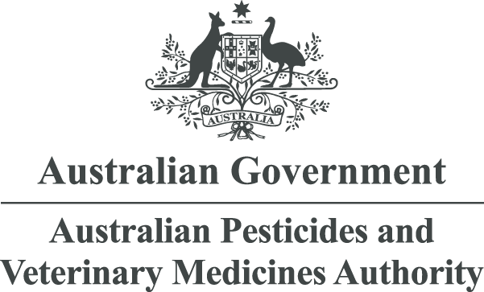

APVMA Online Services Portal: Credit and debit card payment processing guide
July 2025
Contents
Getting started – Updates to credit and debit card payment processing 1
Using the old payment gateway 1
Using the new payment gateway 1
Pay in 3 simple steps 2
Contact 3

Getting started – Updates to credit and debit card payment processing
The Australian Pesticides and Veterinary Medicines Authority (APVMA) has updated the Online Services Portal to use the Reserve Bank of Australia’s new Government Easy Pay service for credit and debit card (card) payments. You will now benefit from a modern card processing system implementing strong standards for authentication and up-to-date fraud prevention tools.
The Online Services Portal will retain the pre-existing payment journey where you are redirected to an external website to make your card payments. Your card details are securely processed on the ANZ Worldline system and are not handled directly lor stored by the APVMA.
One thing that will change from the pre-existing payment journey is the look and feel of the payment gateway. There will be a modernised and functional user interface, and you will navigate through 3 steps to pay rather than paying on a single screen.
Table 1 - Summary of changes to credit card payment processing on the Online Services Portal
 | Legacy payment system (Bambora) | New payment system  (ANZ Worldline)
Payment journey | Transfer to Bambora checkout page | Transfer to ANZ Worldline checkout page
Payment workflow | Single page flow:  - Enter card details. Automatically returned to Online Services Portal following successful payment. | Three-page flow:  - Click to select payment type  - Enter card details and pay  - Wait, or click to continue back to Online Services Portal
Look and feel | Legacy | Modern

Using the old payment gateway
The legacy system processed your payments using the Bambora payment gateway. It is a single-step process to enter your card details and pay. Once you hit ‘Pay Now’ a successful payment will redirect you back to the Online Services Portal automatically.
Figure 1: Legacy payment gateway system provided by Worldline Bambora
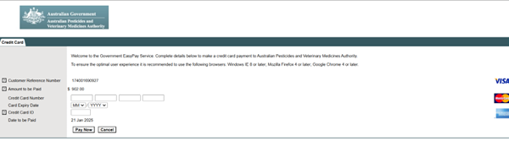

Using the new payment gateway
The new card payment system uses the ANZ Worldline payment gateway. This includes substantial improvements in payment processing and security. It has a three-step process to enter your details and pay. Once you have completed your payment you will need to click ‘continue’ to return to the Online Services Portal.

Pay in 3 simple steps
Step one – select how you would like to pay
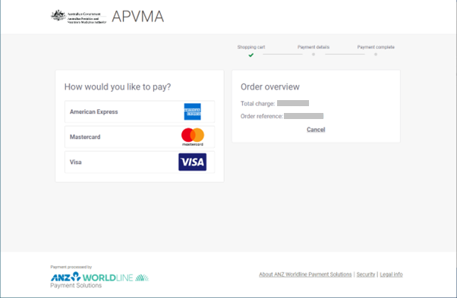
Step 2 – enter card details
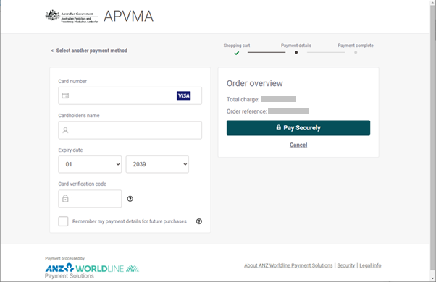
Step 3 – wait, or click 'Continue' to be returned to the Online Services Portal
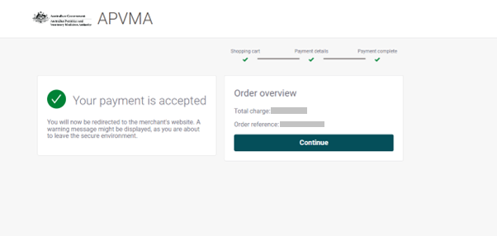

Contact
If you have any questions about the payment gateway or need assistance, please email enquiries@apvma.gov.au.

