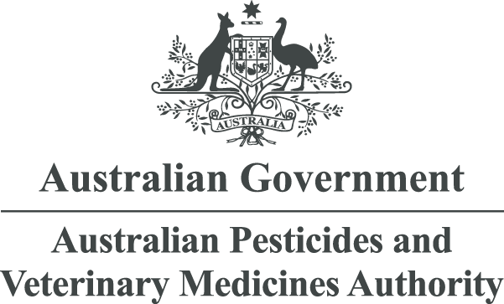

Consultation summary:
Renewing the APVMA’s engagement model
February 2025

Overview
The Australian Pesticides and Veterinary Medicines Authority (APVMA) consulted on a renewed stakeholder engagement model between 12 December 2024 and 7 February 2025. The proposed model was informed by the recommendations of independent reviews of the APVMA, the findings of the 2024 stakeholder and public survey, and a review of the engagement practices used by comparable organisations.
The consultation proposed establishing groups across 3 levels:
- Strategic – the APVMA proposed establishing a formal Advisory Group of registrants, product users, suppliers, and non-government organisations with an interest in the Agvet Code’s statutory criteria (safety, efficacy, labelling, and trade).
- Operational – the APVMA proposed establishing 2 working groups for agricultural and veterinary chemicals. Members were to be directly regulated entities, or their representatives. These working groups would focus on operational aspects of the APVMA relevant to fee payers.
- Informational – the APVMA proposed establishing an annual registrants information update targeted to registrants, but open to all members of the public. This would provide a one-way informational update, with the option for attendees to converse with APVMA subject matter experts afterwards.
The proposed model was intended to deliver a material shift in:
- The level of transparency that regulated industry, consumers, and other stakeholders can access regarding the APVMA’s understanding of current and emerging challenges.
- A collaborative experience for stakeholders, offering two-way communication, defining problems and identifying solutions.
The APVMA received 20 submissions in response to this consultation from organisations representing a range of perspectives. Submissions consistently expressed support for the model, with no objections to the proposal. Questions raised by submissions sought further detail on how the groups would operate, the selection criteria, and other mechanisms for engagement with the APVMA.
Feedback within the scope of this consultation was incorporated where feasible. Out of scope commentary may be considered in future processes if appropriate.
Commentary in submissions broadly fell into 4 themes:
- Selection criteria
- Terms of reference
- Communication with other stakeholders
- Out-of-scope commentary

Selection criteria

APVMA Advisory Group
A number of submissions identified the importance of ensuring that members of the Advisory Group are well equipped to discuss strategic matters and the statutory criteria. Several submissions raised concerns about the inclusion of Non-Government Organisations (NGOs) whose primary objectives were at odds with the legislated purpose of the APVMA.
The APVMA will address any concerns regarding non-constructive conduct via clear terms of reference, appointment, and removal criteria which will apply to all members.
A number of submission asked that we ensure there is allocation of positions necessary to unsure the statutory criteria, specific comments were made regarding public health and with trade criteria, are represented.
Advisory Group will need a diverse range of perspectives to ensure that it is equipped to discuss all aspects of the statutory criteria To achieve this objective the APVMA will ensure there are the following dedicated positions for specific expertise and interest relating to the statutory criteria:
- Public/human health
- Occupational Health and Safety
- Environment
- Animal safety (veterinary medicines perspective)
- Animal safety (for non-target species)
- Trade impacts
- Seller/point of sale
- Efficacy (veterinary chemicals)
- Efficacy (agricultural chemicals)
A few submissions promoted the importance of allowing the Advisory Group to form time bound and topic specific working groups as needed. The APVMA agrees the formation of these types of working groups would be a valuable tool for the Advisory Group.

Working Groups
Several submissions suggested that the 2 Working Groups should include representatives across all types of entities regulated by the APVMA (including permit holders, and international registrants) and their representatives.
The APVMA accepts that all regulated, fee-paying entities are affected by the APVMA’s processes, and that many organisations use third parties to engage with the APVMA on their behalf. The selection criteria for the Working Groups will include:
- permit holders and other entities and individuals which are directly regulated by the APVMA
- third parties representing directly regulated entities that have engaged their services.

Terms of reference

General
Several submissions identified the need for clear terms of reference, and suggested they include clauses to manage non-constructive discussions between organisations representing conflicting perspectives. The APVMA accepts the need for clear operating conditions that manage and address non-constructive debates.
The terms of reference will:
- Clearly identify the operational scope for the Advisory and Working Groups.
- Outline the obligations accepted by appointed organisations.
- Permit the APVMA to terminate appointments where members fail to meet the conditions of their appointment.
A submission identified that the proposed groups should include the perspectives of small organisations, and noted that a 4-year term may deter small organisations from participating. Applicants will be permitted to nominate for shorter term lengths in their expression of interest, up to a maximum of 4 years. Appointments may conclude early if participants resign by writing to the Chair.

Working groups
Submissions did not recommend specific changes to the Working Groups; however a number recommend that a mechanism be established to allow the Working Groups to establish targeted sub-groups and the option to non-members.
While the majority of operational issues can be addressed by the proposed working groups, the APVMA accepts that time bound sub-groups may provide value for specific matters which have a defined outcome and require a high level of involvement or subject matter expertise.
The terms of reference will:
- permit the APVMA to invite relevant third parties to attend meetings at the Chair’s discretion.
- will allow for the APVMA to convene issue specific, time-limited sub-groups at the Chair’s discretion. These groups will include relevant members of the Working Groups, and may include members of the Advisory Group or non-members with relevant expertise.

Communication with other stakeholders
A number of submissions suggested that the model be revised to include the APVMA’s communications with product users and the wider community. The APVMA recognises that our regulatory decisions affect a wide range of stakeholders who we do not directly regulate, including product users and the wider community, and that they have an interest in meaningfully contributing to our consultations.
The APVMA will establish:
 | Registrants Information Update | Farm to Family – your agvet news
Scope | To provide updates on matters affecting registrants and regulated entities. This will be aligned to topics discussed by the 2 working groups and public consultations. | To share information on changes or consultations of interest to agvet users. This includes but is not limited to chemical reviews, APVMA compliance activities, educational information such as how to recognise and report unregistered products, and the Adverse Experience Reporting Program.
Channels | - Webinars run by APVMA subject matter experts  - Social media (LinkedIn and X)  - News and updates for subscribers
Frequency | As required, minimum of once per year for webinars.

Out of scope
This consultation specifically focused on the proposed engagement model and could not consider commentary regarding other matters. The APVMA will consider out-of-scope submissions in future where appropriate.

