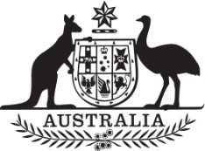

Commonwealth of Australia

Commonwealth of Australia

Commonwealth of Australia

Commonwealth of Australia

Gazette

Agricultural and veterinary chemicals

APVMA Special Gazette, 4 June 2024
Published by the Australian Pesticides and Veterinary Medicines Authority
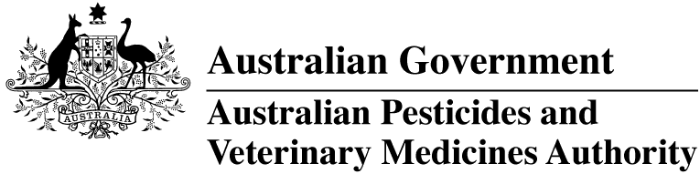
The Agricultural and Veterinary Chemical Code Act 1994 (the Act) commenced on 15 March 1995. The Agricultural and Veterinary Chemicals Code (the Agvet Code) scheduled to the Act requires notices to be published in the Gazette containing details of the registration of agricultural and veterinary chemical products and other approvals granted by the Australian Pesticides and Veterinary Medicines Authority. The Agvet Code and related legislation also requires certain other notices to be published in the Gazette. A reference to Agvet Codes in this publication is a reference to the Agvet Code in each state and territory jurisdiction.
ISSN 1837-7629
© Commonwealth of Australia 2024
This work is copyright. Apart from any use as permitted under the Copyright Act 1968, no part may be reproduced by any process without prior written permission from the Australian Pesticides and Veterinary Medicines Authority (APVMA). Requests and inquiries concerning reproduction and rights should be addressed to:
Assistant Director, Communications
Australian Pesticides and Veterinary Medicines Authority
GPO Box 3262
Sydney NSW 2001
Email: communications@apvma.gov.au
Website: apvma.gov.au
General information
The APVMA Gazette is published fortnightly and contains details of the registration of agricultural and veterinary chemicals products and other approvals granted by the APVMA, notices as required by the Agricultural and Veterinary Chemicals Code (the Agvet Code) and related legislation and a range of regulatory material issued by the APVMA.
Pursuant to section 8J(1) of the Agvet Code, the APVMA has decided that it is unnecessary to publish details of applications made for the purpose of notifying minor variations to registration details. The APVMA will however report notifications activity in quarterly statistical reports.
Distribution and subscription
The APVMA Gazette is published in electronic format only and is available from the APVMA website.
If you would like to subscribe to receive email notification when a new edition is published, please complete a subscription form.
APVMA contacts
For enquiries regarding the publishing and distribution of the APVMA Gazette: Telephone: +61 2 6770 2300.
For enquiries on APVMA Gazette content, please refer to the individual APVMA contacts listed under each notice.
Privacy
For information on how the APVMA manages personal information when you contact us, see our Privacy Policy.
Contents
Agvet chemical voluntary recall: NV GENTAMAX 100 INJECTION 1
Agvet chemical voluntary recall: Ilium Ketamil Injection batch 240130A 2

Agvet chemical voluntary recall: NV GENTAMAX 100 INJECTION
Product name: NV GENTAMAX 100 INJECTION
APVMA registration number: 55873
APVMA approved label number: 134890
Batch numbers: 23259
Sold by: Veterinary wholesalers nationally between 18 January 2024 to 23 May 2024.
On 23 May 2024, Ceva Animal Health Pty Ltd. (ABN: 002 692 426) initiated a voluntary recall under section 106 of the Agricultural and Veterinary Chemicals Code scheduled to the Agricultural and Veterinary Chemicals Code Act 1994 (Cth) in relation to the chemical product described above.

Reason for voluntary recall
Small number of adverse effects in horses involving mild signs such as pawing, sweating and agitation, lasting for 5-10 minutes and self-resolving.

Hazard
Potential adverse effects such as pawing, sweating and agitation, lasting for 5–10 minutes and self-resolving.

What to do if in possession of this chemical product
Cease use of this batch immediately.
Wholesalers should immediately quarantine all the stock on hand of the recalled product and contact Ceva Animal Health to arrange return and replacement. End users are advised to contact Ceva Animal Health Pty Ltd and organise return and replacement.

More information
Visit the APVMA website to view the notice of voluntary recall for the chemical product described above.
The APVMA publishes a list of agvet chemical recall notices on its website and provides a subscription option to be notified by email when a new recall notice is published.

Contact
Questions about this voluntary recall should be directed to:
Ceva Animal Health Pty Ltd
Phone: (02) 9652 7000

Agvet chemical voluntary recall: Ilium Ketamil Injection batch 240130A
Product name: Ilium Ketamil Injection
APVMA registration number: 51188
APVMA approved label number: 138180
Batch number: 240130A
Sold by: Veterinary wholesalers in all states and territories between 14 March 2024 to 27 May 2024.
On 27 May 2024, Troy Laboratories Pty Ltd (ABN: 000 283 769) initiated a voluntary recall under section 106 of the Agricultural and Veterinary Chemicals Code scheduled to the Agricultural and Veterinary Chemicals Code Act 1994 (Cth) in relation to the chemical product described above.

Reason for voluntary recall
Crystallisation has been observed in some vials of batch 240130A.

Hazard
The defect may result in a lack of efficacy and present risks to animal health.

What to do if in possession of this chemical product
Do not use ilium Ketamil Injection from batch 240130A.
Wholesalers should immediately quarantine all the stock on hand of the recalled product. Contact Troy Laboratory
Pty Ltd (details included below) for advice on management of affected units and arrangements for replacement.

More information
Visit the APVMA website to view the notice of voluntary recall for the chemical product described above.
The APVMA publishes a list of agvet chemical recall notices on its website and provides a subscription option to be notified by email when a new recall notice is published.

Contact
Questions about this voluntary recall should be directed to:
Troy Laboratories Customer Service
Phone: (02) 8808 3611

