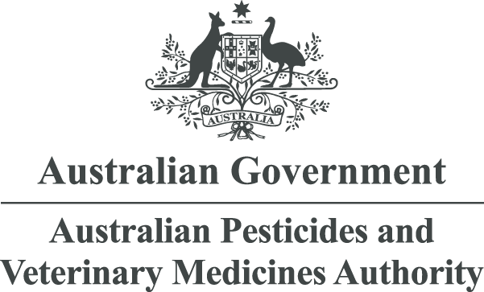

Trade Advice Notice
on the emergency use of spirotetramat on lentils
APVMA product number 93824
August 2023
© Australian Pesticides and Veterinary Medicines Authority 2023
ISSN 2200-3894 (electronic)
Ownership of intellectual property rights in this publication
Unless otherwise noted, copyright (and any other intellectual property rights, if any) in this publication is owned by the Australian Pesticides and Veterinary Medicines Authority (APVMA).
Creative Commons licence
With the exception of the Coat of Arms and other elements specifically identified, this publication is licensed under a Creative Commons Attribution 4.0 Licence. This is a standard form agreement that allows you to copy, distribute, transmit and adapt this publication provided that you attribute the work.

A summary of the licence terms and full licence terms are available from Creative Commons.
The APVMA’s preference is that you attribute this publication (and any approved material sourced from it) using the following wording:
Source: Licensed from the Australian Pesticides and Veterinary Medicines Authority (APVMA) under a Creative Commons Attribution 4.0 Australia Licence.
In referencing this document the Australian Pesticides and Veterinary Medicines Authority should be cited as the author, publisher and copyright owner.
Photographic credits
Cover image: iStockphoto (www.istockphoto.com)
iStockphoto images are not covered by this Creative Commons licence.
Use of the Coat of Arms
The terms under which the Coat of Arms can be used are set out on the Department of the Prime Minister and Cabinet website.
Disclaimer
The material in or linking from this report may contain the views or recommendations of third parties. Third party material does not necessarily reflect the views of the APVMA, or indicate a commitment to a particular course of action. There may be links in this document that will transfer you to external websites. The APVMA does not have responsibility for these websites, nor does linking to or from this document constitute any form of endorsement. The APVMA is not responsible for any errors, omissions or matters of interpretation in any third-party information contained within this document.
Comments and enquiries regarding copyright:
Assistant Director, Communications
Australian Pesticides and Veterinary Medicines Authority
GPO Box 3262
Sydney NSW 2001 Australia
Telephone: +61 2 6770 2300
Email: communications@apvma.gov.au.
This publication is available from the APVMA website.
Contents
Preface 1
About this document 1
Making a submission 1
Further information 2
Introduction 3
Trade considerations 4
Commodities exported 4
Destination and value of exports 4
Proposed Australian use pattern 6
Withholding periods 6
Results from residues trials presented to the APVMA 6
Beans and peas 6
Overseas registration and approved label instructions 7
Codex Alimentarius Commission and overseas MRLs 7
Current and proposed Australian MRLs for spirotetramat 10
Potential risk to trade 11
Conclusion 12
List of tables
Table 1: Proposed use pattern – Movento 240 SC Insecticide (250 g/L spirotetramat) 6
Table 2: Current and proposed Australian and overseas MRLs/tolerances for spirotetramat 8
Table 3: Current MRL Standard – Table 1 10
Table 4: Proposed MRL Standard – Table 1 10
Table 5: Current MRL Standard – Table 4 10

Preface
The Australian Pesticides and Veterinary Medicines Authority (APVMA) is an independent statutory authority with responsibility for assessing and approving agricultural and veterinary chemical products prior to their sale and use in Australia.
The APVMA has a policy of encouraging openness and transparency in its activities and of seeking stakeholder involvement in decision making. Part of that process is the publication of Trade Advice Notices for all proposed extensions of use for existing products where there may be trade implications.
The information and technical data required by the APVMA to assess the safety of new chemical products and the methods of assessment must be undertaken according to accepted scientific principles. Details are outlined in regulatory guidance published on the APVMA website.
- About this document
This Trade Advice Notice indicates that the APVMA is considering an application to vary the use of an existing registered agricultural or veterinary chemical.
It provides a summary of the APVMA’s residue and trade assessment.
Comment is sought from industry groups and stakeholders on the information contained within this document.
- Making a submission
The APVMA invites any person to submit a relevant written submission as to whether the application for an emergency use permit for use of spirotetramat on lentils should be granted. Submissions should relate only to matters that the APVMA is required by legislation to take into account in deciding whether to grant the application. These grounds relate to the trade implications of the extended use of the product. Submissions should state the grounds on which they are based. Comments received outside these grounds cannot be considered by the APVMA.
Submissions must be received by the APVMA by close of business on 17 August 2023 and be directed to the contact listed below. All submissions to the APVMA will be acknowledged in writing via email or by post.
Relevant comments will be taken into account by the APVMA in deciding whether to grant the application and in determining appropriate conditions of registration and product labelling.
When making a submission please include:
- contact name
- company or organisation name (if relevant)
- email or postal address (if available)
- the date you made the submission.
Please note: submissions will be published on the APVMA’s website, unless you have asked for the submission to remain confidential, or if the APVMA chooses at its discretion not to publish any submissions received (refer to the public consultation coversheet).
Please lodge your submission using the public consultation coversheet, which provides options for how your submission will be published.
Note that all APVMA documents are subject to the access provisions of the Freedom of Information Act 1982 and may be required to be released under that Act should a request for access be made.
Unless you request for your submission to remain confidential, the APVMA may release your submission to the applicant for comment.
Written submissions should be addressed to:
Executive Director, Risk Assessment Capability
Australian Pesticides and Veterinary Medicines Authority
GPO Box 3262
Sydney NSW 2001
Phone: +61 2 6770 2300
Email: enquiries@apvma.gov.au
- Further information
Further information can be obtained via the contact details provided above.
Further information on Trade Advice Notices can be found on the APVMA website.

Introduction
The APVMA has before it an application from Pulse Australia Limited for an emergency use permit for the use of Movento 240 SC Insecticide and all similar registered products containing 240 g/L spirotetramat for use in lentils. The use is proposed for South Australia only for a duration of 3 years with an estimated area of use of approximately 250,000 ha.
No changes are required to the current animal commodity MRLs for spirotetramat from the proposed use. The risk to trade in animal commodities remains unchanged and does not require further consideration.

Trade considerations

Commodities exported
Pulses are considered to be export commodities, as are commodities of animal origin, such as meat, offal and dairy products, which may be derived from livestock fed feeds produced from treated pulses. Residues in these commodities resulting from the use of spirotetramat may have the potential to unduly prejudice trade.
Whilst the proposed crop (lentils) is not specifically listed in the APVMA Pesticides: Overseas trade (Part 5B) guidelines, based on the significant value of exports of Australian lentils, particularly in the last few years, they are a major export commodity.

Destination and value of exports
The return of good seasonal conditions in Australia, drought in Canada and the reduced Indian tariffs have contributed to a resurgence in the Australian exports of lentils in recent years.
India and Bangladesh are the most significant markets with other markets in the Middle East and Asia including Sri Lanka, Türkiye, the United Arab Emirates, Egypt and Nepal also significant.
In 2021–22, Australia exported 4,618 kilotonnes (kt) of total pulses (worth $2.32 billion), 605 kt of chickpeas ($476 million), 460 kt of lupins (worth $231 million) and 223 kt of field peas (worth $123 million). Whilst the Australian Bureau of Agricultural and Resource Economics and Sciences (ABARES) does not report individual export data for lentils, the Australian Trade and Investment Commission (Austrade) has reported the values of Australian lentil exports over recent years based on Australian Bureau of Statistics (ABS) data with lentil exports worth approximately $950 million in 2021–22.
A combination of the ABARES and ABS data has been used to generate the following plot shown in Figure 1.
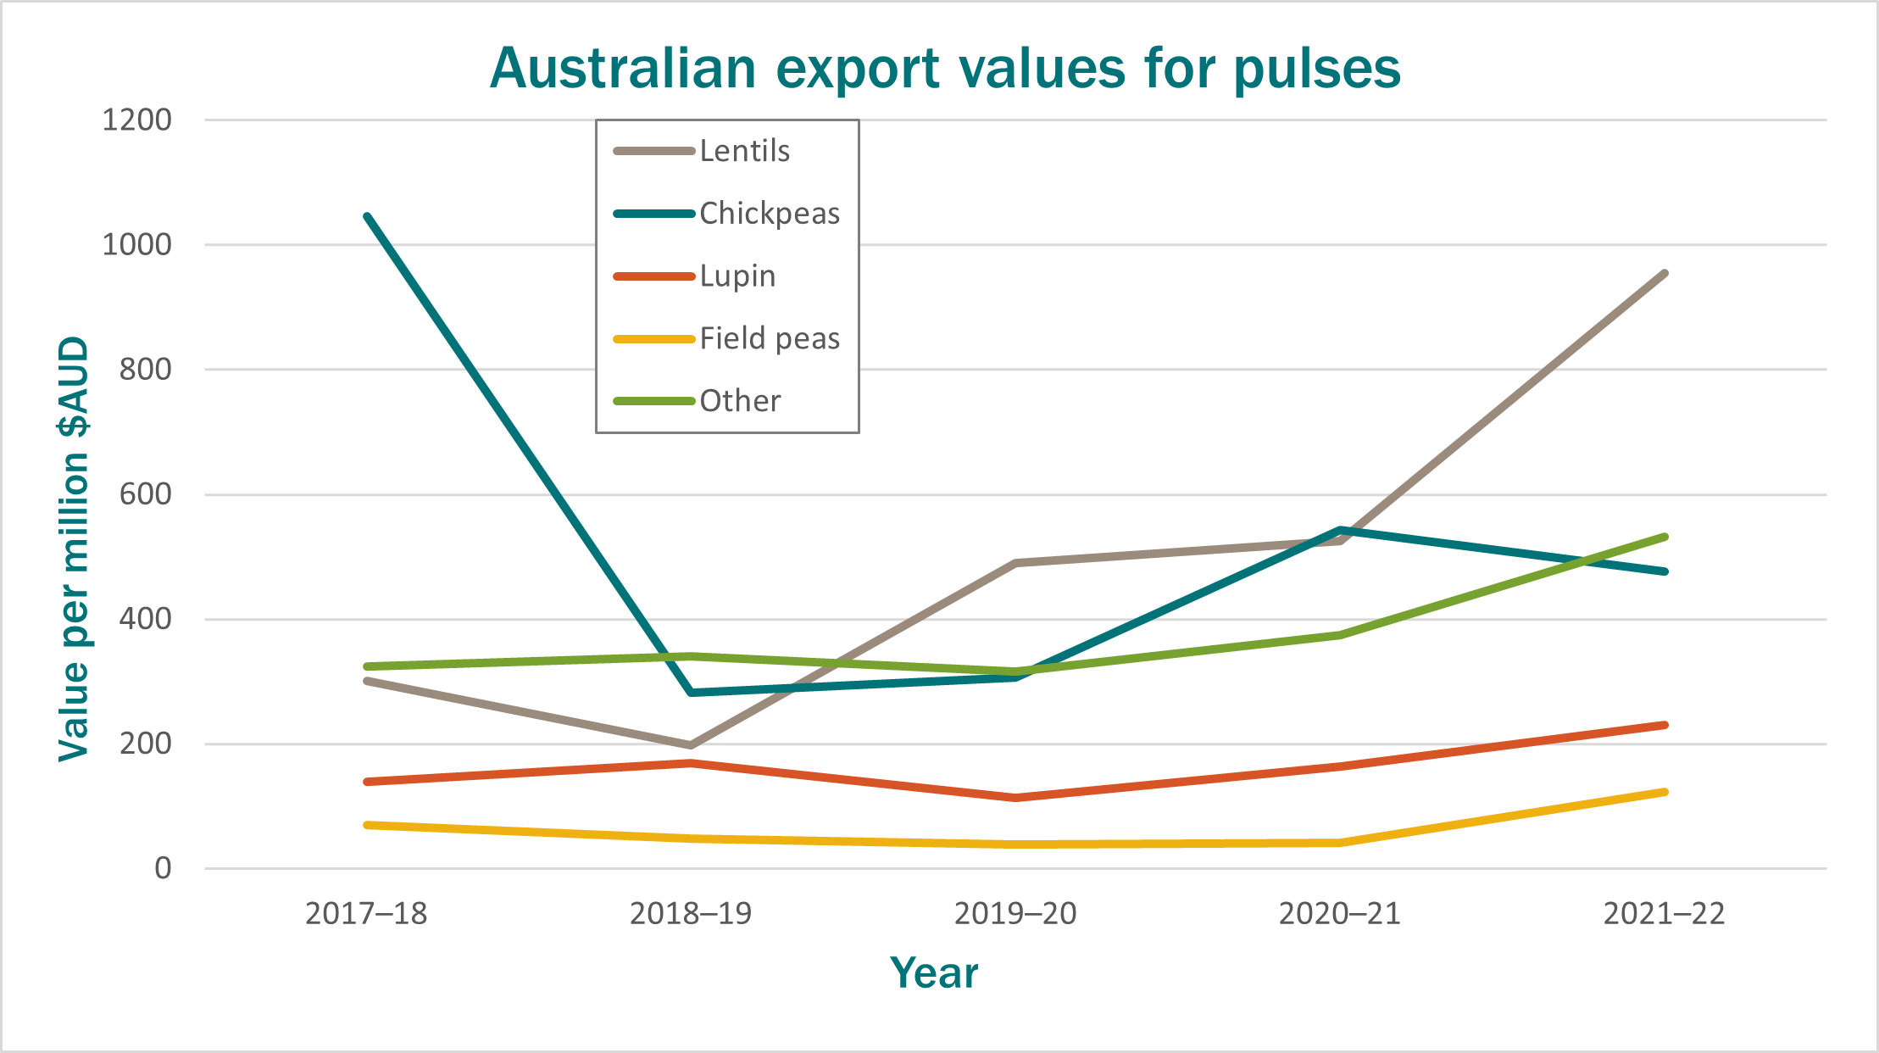
Figure 1: Australian export values for pulses 2017–22
Australian exports of lentils continued at record pace through 2022–23. Between October 2022 and March 2023 Australia shipped 734 kt of lentils with 580 kt shipped between March and May 2023. In May 2023 alone, Australia exported a record 265 kt of lentils with 110 kt exported to India, followed by Türkiye (51 kt) and Nepal (28 kt). Between March and May 2023 the major markets continued to be India (236 kt), followed by Bangladesh (107 kt), Sri Lanka (54 kt), Türkiye (53 kt), the United Arab Emirates (42 kt), Egypt (37 kt) and Nepal (36 kt).

Proposed Australian use pattern
Table 1: Proposed use pattern – Movento 240 SC Insecticide (250 g/L spirotetramat)
Crop | Pest | Rate/concentration | Critical comments
Lentils | Bluegreen aphid (Acyrthosiphon kondoi)  Green peach aphid (Myzus persicae) | 200 mL/ha plus adjuvant (48 g ai/ha) | Monitor crops and commence applications once local thresholds are reached.  Continue to monitor crops and make a subsequent application as necessary.  Do not re-apply within 7 days of a previous spirotetramat spray.  Do not apply more than a total of 2 applications per crop.

Withholding periods

Harvest
DO NOT harvest for 14 days after application.

Grazing
DO NOT graze or cut for stock food for 14 days after application.

Results from residues trials presented to the APVMA
The proposed use in lentils allows a maximum of 2 foliar applications of spirotetramat (7 days apart) per crop, applied once local thresholds are reached at a rate of 48 g ai/ha spirotetramat + Hasten® at 0.5 to 1.0 L/ha in conjunction with a harvest and grazing withholding period of 14 days.
Residue trials on dried beans and peas conducted in the USA and reported by the 2011 Joint Meeting on Pesticide Residues (JMPR) were considered.
In the 14 USA trials on dried beans (9) and peas (5), 2 foliar applications of spirotetramat were made at 88 g ai/ha (~1.8 × proposed rate). Spirotetramat plus enol metabolite (residue definition for enforcement) were determined in dry shelled pea seeds and dry shelled bean seeds taken at a 7-day pre-harvest interval.

Beans and peas
The results of the USA trials on dried beans and peas were scaled to the proposed rate and were combined to estimate a maximum residue limit (MRL). The combined dataset suitable for MRL estimation is, in ranked order: < 0.02 (3), 0.021, 0.034, 0.037, 0.06, 0.11, 0.13, 0.26, 0.29, 0.39, 0.40 and 0.55 mg/kg (n=14). The OECD MRL calculator estimates an MRL of 0.9 mg/kg. The supervised trial median residue (STMR) is 0.09 mg/kg.
A spirotetramat MRL of T1 mg/kg for VD 0533 Lentil (dry) is considered appropriate for the proposed use of spirotetramat on lentils in conjunction with a harvest WHP of 14 days.

Overseas registration and approved label instructions
The applicant indicated that Movento is registered for use on legume vegetables (beans and peas, including dried, except soybean) in the USA. The use pattern involves applications (minimum of 7 days apart) at rates of up to ~90 g ai/ha in conjunction with a pre-harvest interval of one day for edible podded and succulent beans and peas and 7 days for dry shelled beans and peas.

Codex Alimentarius Commission and overseas MRLs
The Codex Alimentarius Commission (Codex) is responsible for establishing Codex Maximum Residue Limits (CXLs) for pesticides and veterinary medicines. Codex CXLs are primarily intended to facilitate international trade and accommodate differences in Good Agricultural Practice (GAP) employed by various countries. Some countries may accept Codex CXLs when importing foods. Spirotetramat has been considered by Codex. The following relevant Codex CXLs have been established for spirotetramat.
Table 2: Current and proposed Australian and overseas MRLs/tolerances for spirotetramat
Commodity | Tolerance for residues arising from the use of spirotetramat (mg/kg)
Commodity | Australia | Codex | Japan | EU | Canada | USA
Residue definition | Sum of spirotetramat, and cis-3-(2,5-dimethylphenyl)-4-hydroxy-8-methoxy-1-azaspiro[4.5]dec-3-en-2-one, expressed as spirotetramat | Spirotetramat and its enol metabolite, 3-(2,5-dimethylphenyl)-4-hydroxy-8-methoxy-1-azaspiro[4.5]dec-3-en-2-one, expressed as spirotetramat | Sum of residues of spirotetramat and its metabolite M1［cis -3-(2,5-dimethylphenyl)-4-hydroxy-8-methoxy-1-azaspiro[4.5]dec-3-en-2-one, calculated as spirotetramat. | Sum of spirotetramat and spirotetramat-enol, expressed as spirotetramat (R) | Sum of spirotetramat and its metabolites, expressed as parent equivalents | Sum of spirotetramat and its metabolites, calculated as the stoichiometric equivalent of spirotetramat
Lentils | T1  (Lentil (dry) – proposed) | 2  (Pulses (group)) except soya bean (dry) | 3  (Other legumes/pulses) | 1.5 | 2.5  (Dry lentils) | 2.5  (Vegetable, legume, group 06, except soybean) (succulent or dried)
Note: There is no established MRL/tolerance for lentils in the Indian Food Safety and Standards (Contaminants, Toxins and Residues) Regulation, 2011. The Regulation states that a tolerance limit of 0.01 mg/kg shall apply in cases of pesticides for which MRL have not been fixed.

Current and proposed Australian MRLs for spirotetramat
Table 3: Current MRL Standard – Table 1
Compound | Food | MRL (mg/kg)
Spirotetramat
MO 0105 | Edible offal (mammalian) | 0.5
PE 0112 | Eggs | *0.02
VP 0060 | Legume vegetables | 2
MM 0095 | Meat (mammalian) | 0.02
ML 0106 | Milks | *0.005
PM 0110 | Poultry meat | *0.02
PO 0111 | Poultry, edible offal of | *0.02
VD 0541 | Soya bean (dry) | T5
Table 4: Proposed MRL Standard – Table 1
Compound | Food | MRL (mg/kg)
Spirotetramat
Add:
VD 0533 | Lentil (dry) | T1
Table 5: Current MRL Standard – Table 4
Compound | Food | MRL (mg/kg)
Spirotetramat
AL 0157 | Legume animal feeds {except Soya bean forage and fodder} | 20
AL 0541 | Soya bean fodder | T50
AL 1265 | Soya bean forage (green) | T50

Potential risk to trade
Export of treated produce containing finite (measurable) residues of spirotetramat may pose a risk to Australian trade in situations where (i) no residue tolerance (import tolerance) is established in the importing country or (ii) where residues in Australian produce are likely to exceed a residue tolerance (import tolerance) established in the importing country.
A finite MRL of T1 mg/kg for spirotetramat on lentil (dry) is proposed and is less than the established MRLs in most international markets. Whilst good MRL coverage exists in the majority of the significant markets (with most significant markets for lentils recognising Codex MRLs), there is no MRL coverage in the Indian Food Safety and Standards (Contaminants, Toxins and Residues) Regulation, 2011.
As finite residues are expected from the proposed use, stakeholders are invited to provide comment on how to mitigate the potential risk to trade in markets without established coverage, such as the Indian market.

Conclusion
Pulse Australia Limited has applied for an emergency use permit for the use of Movento 240 SC Insecticide and all similar registered products in permit containing spirotetramat for use in lentils.
Comment is sought on the potential for the use of Movento 240 SC Insecticide on lentils to prejudice Australian trade when used according to the proposed label instructions.

Australian Pesticides and Veterinary Medicines Authority (APVMA), 2020. Pesticides: Overseas trade (Part 5B) – Major export food commodity groups, APVMA website, accessed 21 July 2023.
Australian Trade and Investment Commission (Austrade), 2022. Insight – First in-transit phosphine fumigated Australian lentils land in India, Austrade website, accessed 21 July 2023.
Department of Agriculture, Fisheries and Forestry (DAFF), 2023. Australian Bureau of Agricultural and Resource Economics and Sciences (ABARES) – Agricultural commodities and trade data – 2022, ABARES website, accessed 21 July 2023.
Australian Bureau of Statistics (ABS), n.d. Australian Bureau of Statistics (ABS), ABS website, accessed 21 July 2023.
Grain Central, 2023. Australia posts solid May chickpea, record lentil exports, Grain Central website, accessed 21 July 2023. ⁵Grain Central, 2023. Australia ships 53,448t chickpeas, 168,650t lentils in March, Grain Central website, accessed 21 July 2023.
Always add a specified spray adjuvant – refer to the Adjuvant section in the product label.
Australian Government Federal Register of Legislation, 2019. Agricultural and Veterinary Chemicals Code (MRL Standard) Instrument 2019, Federal Register of Legislation website, accessed 21 July 2023.
Food and Agriculture Organisation of the United Nations (FAO), 2023. Codex Alimentarius International Food Standards – Pesticide Index, FAO website, accessed 21 July 2023.
Japanese Food Chemistry Research Foundation (JFCRPF), 2023. Maximum Residue Limits (MRLs) List of Agricultural Chemicals in Foods, JFCRPF website, accessed 21 July 2023.
European Commission, 2023. Search Pesticide Residues, European Commission website, accessed 21 July 2023.
Health Canada, 2023. Maximum Residue Limits for Pesticides, Health Canada website, accessed 21 July 2023.
Electronic Code of Federal Regulations (eCFR), 2023. USA Electronic Code of Federal Regulations, eCFR website, accessed 21 July 2023.
Food Safety and Standards Authority of India (FSSAI), 2023. Food Safety and Standards (Contaminants, Toxins and Residues) Regulation, 2011 (see compendium for updates), FSSAI website, accessed 21 July 2023.

