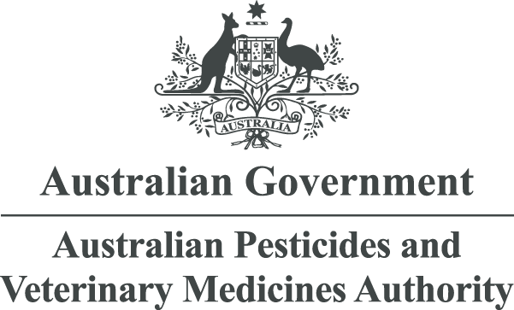

Public Release Summary
on the evaluation of inpyrfluxam in the product Excalia Fungicide
APVMA product number 90901
April 2023
© Australian Pesticides and Veterinary Medicines Authority 2023
ISSN 1443-1335 (electronic)
Ownership of intellectual property rights in this publication
Unless otherwise noted, copyright (and any other intellectual property rights, if any) in this publication is owned by the Australian Pesticides and Veterinary Medicines Authority (APVMA).
Creative Commons licence
With the exception of the Coat of Arms and other elements specifically identified, this publication is licensed under a Creative Commons Attribution 4.0 Licence. This is a standard form agreement that allows you to copy, distribute, transmit and adapt this publication provided that you attribute the work.

A summary of the licence terms and full licence terms are available from Creative Commons.
The APVMA’s preference is that you attribute this publication (and any approved material sourced from it) using the following wording:
Source: Licensed from the Australian Pesticides and Veterinary Medicines Authority (APVMA) under a Creative Commons Attribution 4.0 Australia Licence.
In referencing this document the Australian Pesticides and Veterinary Medicines Authority should be cited as the author, publisher and copyright owner.
Use of the Coat of Arms
The terms under which the Coat of Arms can be used are set out on the Department of the Prime Minister and Cabinet website.
Disclaimer
The material in or linking from this report may contain the views or recommendations of third parties. Third party material does not necessarily reflect the views of the APVMA, or indicate a commitment to a particular course of action. There may be links in this document that will transfer you to external websites. The APVMA does not have responsibility for these websites, nor does linking to or from this document constitute any form of endorsement. The APVMA is not responsible for any errors, omissions or matters of interpretation in any third-party information contained within this document.
Comments and enquiries regarding copyright:
Assistant Director, Communications
Australian Pesticides and Veterinary Medicines Authority
GPO Box 3262
Sydney NSW 2001 Australia
Telephone: +61 2 6770 2300
Email: communications@apvma.gov.au.
This publication is available from the APVMA website.
Contents
Preface 1
About this document 1
Making a submission 1
Further information 2
Introduction 3
Applicant 3
Purpose of application 3
Proposed claims and use pattern 3
Mode of action 3
Overseas registrations 3
Chemistry and manufacture 4
Active constituent 4
Formulated product 6
Recommendations 7
Toxicological assessment 8
Evaluation of toxicology 8
Health-based guidance values and poisons scheduling 12
Recommendations 12
Residues assessment 13
Metabolism 13
Analytical methods and storage stability 15
Residue definition 17
Residues in food and animal feeds 17
Crop rotation 18
Residues in animal commodities 18
Spray drift 18
Dietary risk assessment 19
Recommendations 20
Assessment of overseas trade aspects of residues in food 21
Work health and safety assessment 22
Health hazards 22
Occupational exposure 22
Public exposure 22
Recommendations 23
Environmental assessment 24
Fate and behaviour in the environment 24
Effects and associated risks to non-target species 27
Recommendations 29
Efficacy and safety assessment 30
Proposed product use pattern 30
Efficacy and target crop/animal safety 30
Spray drift assessment 33
Human health 33
Residues and trade 33
Environment 33
Labelling requirements 34
Acronyms and abbreviations 38
Glossary 42
References 43
List of tables
Table 1: Nomenclature and structural formula of the active constituent inpyrfluxam 4
Table 2: Key physicochemical properties of the active constituent inpyrfluxam 5
Table 3: Proposed APVMA active constituent standard for inpyrfluxam 6
Table 4: Key aspects of the formulation of the product Excalia Fungicide 7
Table 5: Physicochemical properties of the product Excalia Fungicide 7
Table 6: Amendments to the APVMA MRL Standard 20
Table 7: Summary of RALs for Excalia Fungicide (400 g/L inpyrfluxam) 33
List of figures
Figure 1: Metabolic pathways of S-2399 in potatoes grown from treated seeds 14
Figure 2: Proposed aerobic soil degradation pathways for inpyrfluxam (S-2399) 25

Preface
The Australian Pesticides and Veterinary Medicines Authority (APVMA) is the Australian Government regulator responsible for assessing and approving agricultural and veterinary chemical products prior to their sale and use in Australia. Before approving an active constituent and/or registering a product, the APVMA must be satisfied that the statutory criteria, including the safety, efficacy, trade, and labelling criteria, have been met. The information and technical data required by the APVMA to assess the statutory criteria of new chemical products, and the methods of assessment, must be consistent with accepted scientific principles and processes. Details are outlined on the APVMA website.
The APVMA has a policy of encouraging transparency in its activities and seeking community involvement in decision making. Part of that process is the publication of Public Release Summaries for products containing new active constituents. This Public Release Summary is intended as a brief overview of the assessment that has been conducted by the APVMA and of the specialist advice received from advisory agencies, including other Australian Government agencies and State departments of primary industries. It has been deliberately presented in a manner that is likely to be informative to the widest possible audience to encourage public comment.
- About this document
This Public Release Summary indicates that the APVMA is considering an application for registration of an agricultural or veterinary chemical. It provides a summary of the APVMA’s assessment, which may include details of:
- the toxicology of both the active constituent and product
- the residues and trade assessment
- occupational exposure aspects
- environmental fate, toxicity, potential exposure and hazard
- efficacy and target crop or animal safety.
Comment is sought from interested stakeholders on the information contained within this document.
- Making a submission
In accordance with sections 12 and 13 of the Agvet Code, the APVMA invites any person to submit a relevant written submission as to whether the application for registration of Excalia Fungicide should be granted. Submissions should relate only to matters that the APVMA is required, by legislation, to take into account in deciding whether to grant the application. These matters include aspects of public health, occupational health and safety, chemistry and manufacture, residues in food, environmental safety, trade, and efficacy and target crop or animal safety. Submissions should state the grounds on which they are based. Comments received that address issues outside the relevant matters cannot be considered by the APVMA.
Submissions must be received by the APVMA by close of business on 16 May 2023 and be directed to the contact listed below. All submissions to the APVMA will be acknowledged in writing via email or by post.
Relevant comments will be taken into account by the APVMA in deciding whether the product should be registered and in determining appropriate conditions of registration and product labelling.
When making a submission please include:
- a contact name
- the company or organisation name (if relevant)
- an email or postal address (if available)
- the date you made the submission.
Please note: submissions will be published on the APVMA website unless you have asked for the submission to remain confidential, or if the APVMA chooses at its discretion not to publish any submissions received (refer to the public consultation coversheet).
Please lodge your submission using the public consultation coversheet, which provides options for how your submission will be published.
Note that all APVMA documents are subject to the access provisions of the Freedom of Information Act 1982 and may be required to be released under that Act should a request for access be made.
Unless you request for your submission to remain confidential, the APVMA may release your submission to the applicant for comment.
Written submissions should be addressed to:
Case Management Team – Pesticides
Australian Pesticides and Veterinary Medicines Authority
GPO Box 3262
Sydney NSW 2001
Phone: +61 2 6770 2300
Email: casemanagement@apvma.gov.au.
- Further information
Further information can be obtained via the contact details provided above.
Copies of technical evaluation reports covering chemistry, efficacy and safety, toxicology, occupational health and safety aspects, residues in food and environmental aspects are available from the APVMA on request.
Further information on Public Release Summaries can be found on the APVMA website.

Introduction
This publication provides a summary of the data reviewed and an outline of the regulatory considerations for the proposed registration of Excalia Fungicide, and approval of the new active constituent, inpyrfluxam.

Applicant
Sumitomo Chemical Australia Pty Ltd is the applicant for the product Excalia Fungicide and for the active, inpyrfluxam.

Purpose of application
Sumitomo Chemical Australia Pty Limited has applied to the APVMA for registration of the new product Excalia Fungicide, containing 400 g/L inpyrfluxam, as a suspension concentrate formulation of the new active constituent inpyrfluxam.

Proposed claims and use pattern
Excalia Fungicide is intended for the control of soil borne Rhizoctonia solani in potatoes and the control of yellow sigatoka in bananas. For potatoes, the application rate is 2 mL/100 m row applied as an in-furrow spray at planting in 1 to 3 L water/100 m row. For bananas, the application rate is 185 mL/ha plus a high-quality water miscible mineral crop oil at 3 to 5 L/ha to be applied either via a vertical sprayer or aircraft. In bananas, Excalia is applied as part of a regular program of fungicide sprays with a 14-to-21-day interval between fungicides and a maximum of three applications of Excalia Fungicide in a 12-month period.

Mode of action
Inpyrfluxam is a broad-spectrum fungicide which belongs to the Fungicide Resistance Action Committee (FRAC) Group 7, the succinate dehydrogenase inhibitors (SDHI) group of fungicides.

Overseas registrations
The product is currently registered in the USA, Japan and Canada, for various uses including apples, peanuts, soybeans and sugar beets (broadcast and banded application) and in Brazil for use in soybeans. In Japan, the product is also registered in potatoes amongst various other uses including citrus, apples, pears, peaches, nectarines, grapes, persimmons, cereals, beans, peas, soybeans, potatoes, onions, sugar beets and leeks. Registration is currently pending in Mexico, the European Union and Korea for similar uses.

Chemistry and manufacture

Active constituent
The active constituent inpyrfluxam is manufactured overseas. Details of the chemical name, structure and physicochemical properties of inpyrfluxam are listed below in Tables 1 to 2.
Table 1: Nomenclature and structural formula of the active constituent inpyrfluxam
Common name (ISO): | Inpyrfluxam
IUPAC name: | 3-(Difluoromethyl)-1-methyl-N-[(3R)-1,1,3-trimethyl-2,3-dihydro-1H-inden-4-yl]-1H-pyrazole-4-carboxamide
CAS registry number: | 1352994-67-2
Molecular formula: | C₁₈H₂₁F₂N₃O
Molecular weight: | 333.38 g mol⁻¹
Structural formula: | 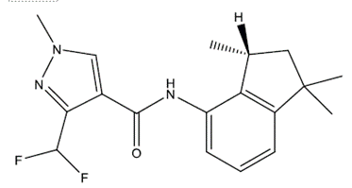

Table 2: Key physicochemical properties of the active constituent inpyrfluxam
Appearance (TGAI): | White powder
Melting point (PAI): | 104 °C
Boiling point (PAI): | 237 °C
Stability: | Stable on storage for 2 weeks at 54 °C, either alone or in the presence of iron or aluminium powder, and iron (II) acetate or aluminium acetate basic hydrate
Safety properties: | Not highly flammable, not explosive or oxidising and no self-ignition below the melting temperature
Solubility in water (PAI): | 16.4 mg/L, 20 °C, pH 5.5 to 5.8
Organic solvent solubility (TGAI): | In g/L, at 20 °C  acetone: 621  dichloromethane: 353  ethyl acetate: 396  n-hexane: 0.982  methanol: 368  n-octanol: 84.6  toluene: 67.9
Surface tension (PAI): | 90% saturated solution: 60.4 mN/m, 21.3 °C
Octanol/water partition coefficient (Log K_{ow} - PAI): | 3.65, pH 7.1 to 7.3
Vapour pressure (PAI): | 3.8×10⁻⁸ Pa at 20 °C  1.2×10⁻⁷ Pa at 25 °C
Henry’s law constant: | 7.74×10⁻⁷ Pa.m³/mole
UV/VIS absorption spectra: | Acidic, neutral and alkaline solution: absorption maxima at 242 and 290 nm
Inpyrfluxam technical active constituent is a white powder. It has good safety properties. It has low volatility and low water solubility. Inpyrfluxam is highly soluble in polar organic solvents, soluble in toluene and ethanol, and slightly soluble in aliphatic hydrocarbon solvents.
Based on the toxicological assessment and Declaration of Composition provided, the following APVMA active constituent standard is proposed for inpyrfluxam:
Table 3: Proposed APVMA active constituent standard for inpyrfluxam
Specification | Parameter | Level
Purity | Inpyrfluxam (R-isomer) | 950 g/kg minimum
Specified impurity | S-enantiomer of inpyrfluxam | 50 g/kg maximum

Formulated product
The product Excalia Fungicide will be manufactured in Australia. Tables 4 and 5 outline some key aspects of the formulation and physicochemical properties of the product.
Excalia Fungicide is a white liquid in the form of a suspension concentrate, with good stability. It has a pH close to neutral and excellent suspensibility, dispersibility and pourability.
Table 4: Key aspects of the formulation of the product Excalia Fungicide
Distinguishing name: | Excalia® Fungicide
Formulation type: | Suspension concentrate
Active constituent concentration: | 400 g/L
Table 5: Physicochemical properties of the product Excalia Fungicide
Physical form: | White suspension with a characteristic odour
PH: | 6.50 to 8.50 (neat formulation)
Density: | 1.07 to 1.10 g/mL (20 °C)
Viscosity: | 350 to 700 cps (20 rpm at 20 °C)
Pourability: | 1.31 to 1.66% residue, 0% rinsed residue
Spontaneity of dispersion: | 98% (Standard Water C at 23 °C)
Suspensibility: | 94 to 97% (Standard Water D at 23 °C)
Safety properties: | Not expected to be flammable or explosive
Storage stability: | Stable for 8 weeks at 40 °C and 7 days at 0 °C in the proposed HDPE packaging

Recommendations
The APVMA Chemistry section has evaluated the chemistry of the active constituent inpyrfluxam and associated product Excalia Fungicide, including the identification, physicochemical properties, manufacturing process, quality control procedures, stability, batch analysis results and analytical methods and has found them to be acceptable. The available storage stability data indicate that both the technical active constituent inpyrfluxam and the formulated product Excalia Fungicide are expected to remain stable for at least 2 years when stored under normal conditions.
Based on a review of the chemistry and manufacturing details, the registration of Excalia Fungicide and approval of the active constituent inpyrfluxam are supported from a chemistry perspective.

Toxicological assessment
The applicant has submitted toxicology data in support of the active constituent and formulated product.

Evaluation of toxicology

Chemical class
Inpyrfluxam belongs to the pyrazole carboxamide group of fungicides. It acts as a succinate dehydrogenase inhibitor (SDHI) at complex II in the mitochondrial electron transport chain, thus inhibiting fungal energy production.

Pharmacokinetics
Following oral administration of either a single or repeated doses of radiolabelled inpyrfluxam to rats by gavage, inpyrfluxam was rapidly and nearly completely absorbed. Plasma concentrations then declined slowly with half-lives ranging between 12 and 17 hours. Most of the absorbed radiolabelled inpyrfluxam was excreted in either urine (up to 59% in females) or bile (up to 74% in males) following all dosing regimens. In biliary excretion studies, less than 3% of the radioactivity was excreted in faeces. At 168 hours after oral administration, the tissue concentrations (including carcass) of radioactivity were about 0.2% of the administered dose (AD).
Inpyrfluxam was extensively metabolised with over 40 metabolites being detected in urine, bile and faeces respectively. The main routes of metabolism were N-demethylation, oxidation of the 1',1'-dimethyl group of the indane ring, followed by further oxidation to the carboxylic acid, and glucuronide conjugation. Major rat metabolites are: 1'-CH₂OH-S-2840, 1'-CH₂OH-S-2840A, 1'-CH₂OH-S-2840B, 1',1'-bis(CH₂OH)-S-2840, 1'-CH₂OH-3'-OH-S-2840, as well as the N-des-Me form of 1’-CH₂OH-S-2840.
Comparative metabolism studies were conducted with human, male and female rat, and male and female dog liver microsomes showed there were no qualitative differences between species (although quantitative differences were apparent) and there were no unique human metabolites.

Acute toxicity (active constituent)
Inpyrfluxam has moderate acute oral toxicity and low dermal and inhalational toxicity. It is a slight eye irritant but not a skin irritant or sensitiser (GPMT).

Acute toxicity (product)
Excalia Fungicide has moderate acute oral toxicity, low dermal and inhalational toxicity and is neither an eye or skin irritant nor a skin sensitiser (Buehler test and LLNA).

Repeat-dose toxicity
In 28-day oral studies performed in rats, mice and dogs, the liver was the main target organ following oral administration. The observed effects were mainly non-adverse adaptive changes (e.g., increased liver weights associated with hepatocyte hypertrophy and endoplasmic reticulum proliferation, renal hypertrophy and tubular vacuolation). Thyroid (follicular cell hypertrophy), adrenals (cortical zona fasciculata cell vacuolation) and ovarian (interstitial gland vacuolation) effects were also observed. The NOAELs in mice, rats and dogs were 54, 44 and 100 mg/kg bw/d, respectively.
A 28-day dermal toxicity study performed in rats found no treatment-related changes in clinical signs, detailed clinical observations, body weight, feed consumption, ophthalmology, urinalysis, haematology, blood biochemistry, organ weight or histopathology at necropsy. The NOAEL was established at 1000 mg/kg bw/d, the highest dose tested (limit dose).
In a 13-week dietary study in mice, the NOAEL was 111 mg/kg bw/d based on changes in liver weight and histopathological changes (fatty change) in the liver at 491 mg/kg bw/d.
In a 13-week dietary study in rats, effects of inpyrfluxam were mainly observed on body weight and on liver, ovary, kidney and adrenal weights and histopathology. The NOAEL was determined to be 37.5 mg/kg bw/d, based on increased adrenocortical zona fasciculata cell vacuolation at 44 mg/kg bw/d.
In a 90-day oral capsule study in dogs, where inpyrfluxam was administered at 0, 40, 160 or 700/500 mg/kg bw/d, mortalities occurred at the high dose. The NOAEL of 40 mg/kg bw/d, was established based on adrenal zona fasciculata cell vacuolation in 2/4 males and optic nerve degeneration in 1/4 females at 160 mg/kg bw/d.

Chronic toxicity and carcinogenicity
Inpyrfluxam is not a potential carcinogen.
In a 12-month oral capsule study in dogs, the NOAEL was determined to be 6 mg/kg bw/d based on histopathological changes (zona fasciculate cell vacuolation) in the adrenal gland at 30 mg/kg bw/d.
In a 78-week dietary (carcinogenicity) study in mice, the NOAEL for toxicity was 69 mg/kg bw/d based on an increased incidence of amyloidosis in cervical lymph nodes and glandular stomach in females at 210 mg/kg bw/d, also seen in the high dose group with amyloidosis in liver, kidneys, thyroid and adrenals. The compound was not carcinogenic up to the highest dose tested 775 mg/kg bw/d.
In a 104-week combined toxicity and carcinogenicity dietary study, the NOAEL at 104 weeks was 19.4 mg/kg bw/d in males based on decreased body weight gain (18% (m)/27% (f)) and feed efficiency (16% (m)/7% (f)), and haematological changes (significantly decreased neutrophil and monocyte count in both sexes and decreased leukocyte count in females) at the highest dose. The compound was not carcinogenic up to the highest dose tested 78.4 mg/kg bw/d. The NOAEL for toxicity at 52 weeks was also 19.4 mg/kg bw/d based on increased GGTP, Glob and A/G ratio in males and increased AST, and ALT in females in the high dose groups. There were no statistically significant changes at necropsy in the 52-week toxicity group.

Reproductive and developmental toxicity
Inpyrfluxam is not a potential reproductive/developmental toxicant.
In a 2-generation reproduction study in rats, the systemic NOAEL for parental toxicity was 31 mg/kg bw/d based on decreased body weight gain (>10%, both sexes) and increased incidence of follicular cell hypertrophy in the thyroid in females at 86 mg/kg bw/d. The NOAEL for reproductive toxicity was 93 mg/kg bw/d), the highest dose level(s) tested, as no reproductive effects were observed at any dose. The NOAEL for offspring toxicity was 22 mg/kg bw/d based on the decreased mean body weight (~10%) at 86 mg/kg bw/d. It was noted that there were no observations of any malformations in pups, including cyclopia.
In a developmental toxicity study in rats, inpyrfluxam was administered orally, via gavage, at doses of 0, 10, 25, or 80 mg/kg bw/d over gestational days 6 to 19. A follow up study was also carried out at 90 mg/kg bw/d to further investigate an effect (cyclopia) seen in one foetus in a single litter in the 80 mg/kg bw/d group in the main study. Necropsy at GD 20 revealed no differences between the treated and control groups for the mean numbers of corpora lutea and implantations, pre-implantation losses, live foetuses, incidence of resorptions or sex ratio. Although some external (e.g., microphthalmia) and skeletal malformations (meningocele and fused ribs) were observed in both the control and/or the treated group pups, there were no test substance-related abnormalities. As cyclopia was not observed in the follow up study in any foetuses, the single incidence observed in the main study was not considered treatment related. The NOAEL was determined as 25 mg/kg bw/d based on the results of the 2 studies for both maternal and foetal effects.
In a teratogenicity study in rabbits, where inpyrfluxam was administered over the gestation dates 6 to 27, the NOAEL for maternal toxicity was 60 mg/kg bw/d based on decreased body weight gain (21%), decreased mean feed consumption and increased incidence of abortions seen at 200 mg/kg bw/d. There were no treatment-related effects in the mean number of live foetuses, percent incidence of resorptions and foetal deaths, sex ratio or foetal weight. The NOAEL for embryo/foetal toxicity was the highest dose tested (200 mg/kg bw/d).

Genotoxicity
Inpyrfluxam was not genotoxic in an appropriately validated battery of in vitro and in vivo assays.

Neurotoxicity
Acute and sub-chronic neurotoxicity studies (i.e., inclusive of neuropathology) were carried out in rats, with functional observation battery (FOB) and motor activity assessments included in the sub-chronic study. The NOAEL for acute neurotoxicity was 30 mg/kg bw, based on reduced motor activity and body temperature at 100 mg/kg bw.
In a sub-chronic (90-day) dietary neurotoxicity study in rats, the NOAEL for systemic toxicity was determined to be 35.2 mg/kg bw/d based on the decreased body weight and feed consumption at higher dose. The NOAEL for neurotoxicity in the 90-day study was 240 mg/kg bw/d.
In dogs, statistically significant effects on the CNS and optic nerve damage were reported in 90-day and 1-year studies at doses ≥160 mg/kg bw/d. In addition, clinical signs consistent with neurotoxicity (staggering gait, convulsions, torticollis and ananastasia; lacked neuropathology correlates) were observed in the 90-day study in dogs at 700/500 mg/kg bw/d and a NOAEL of 40 mg/kg bw/d was established for this effect.
In a 28-day dog study (maximum dose 1000 mg/kg bw/day), optic nerve damage was not observed, although clinical signs indicative of effects on the CNS, such as staggering and ataxic gait and decreased spontaneous activity, were observed in the female dog in the high dose group (1000 mg/kg bw/d).

Mode of action (toxicology)
Inpyrfluxam induced effects on the thyroid gland (increase in weight and follicular cell hypertrophy) in rats, mice, and dogs; adrenal gland (vacuolation of the zona fasciculata cells) in rats and dogs; and changes in ovary weight and vacuolation of the interstitial ovary cells in rats.
Sufficient mechanistic information was presented to conclude that inpyrfluxam likely has a CAR/PXR xenosensor agonist/phenobarbital-like mode of action in both rats and mice. This mode of action, and its effects on the hypothalamic-pituitary-thyroid axis in rodents, is not relevant to humans. The effects in the dog have potential human relevancy until proven otherwise.

Toxicity of metabolites and/or impurities
The major mammalian metabolites in laboratory animals were 1’-CH2OH-S-2840 and N-des-Me-S-2840, which were detected at ≥11% of total radio-chromatogram.
1’-COOH-S-2840 is a major metabolite in laboratory animals. The acute oral LD₅₀ in rats was >2000 mg/kg bw and it was negative for genotoxicity in a range of in vitro tests. Given that 1’-COOH-S-2840 is currently not identified as a major food/feed metabolite no further action is required at this time.
1'-CH2OH-S-2840 is a major metabolite in laboratory animals. The acute oral LD₅₀ in rats was >2000 mg/kg bw. Given that 1'-CH2OH-S-2840 is currently not identified as a major food/feed metabolite no further action is required at this time.
N-des-Me-S-2840, another major metabolite in laboratory animals, did not induce bacterial reverse mutations and is unlikely to present a genotoxic hazard at levels likely to occur in the diet. Given that N-des-Me-S-2840 is currently not identified as a major food/feed metabolite no further action is required at this time.
Minor metabolites found in laboratory animals were at levels unlikely to present acute hazard and did not show genotoxic potential in in vitro genotoxic tests. Given they are not currently identified as major food/feed metabolites, no further action is required at this time.
Based on the limited available data on the impurity, RATM (<0.1%) in the TGAC inpyrfluxam is unlikely present a genotoxic hazard at likely occupational exposure levels. No other data is available. Given that no further data is available human exposure should be limited to less than or equal to the Cramer Class III TTC of 1.5 µg/kg bw/d.

Health-based guidance values and poisons scheduling

Poisons Standard
Inpyrfluxam is included in Schedule 6 of the Standard Uniform Scheduling of Medicines and Poisons with no exemptions.

Health-based guidance values

Acceptable daily intake
An acceptable daily intake (ADI) for inpyrfluxam was established at 0.06 mg/kg bw/d, based on no observed adverse effect level (NOAEL) of 6 mg/kg bw/d in a 1-year dog study based on adrenocortical zona fasciculata vacuolation at the next higher dose. Similar effects were seen in a 90-day dog study (NOAEL 40 mg/kg bw/d).

Acute reference dose
An acute reference dose (ARfD) for inpyrfluxam and gly-CH2OH-S-2840 expressed as inpyrfluxam was established at 0.3 mg/kg bw, based on a NOAEL of 30 mg/kg bw in rats in an acute neurotoxicity study, based on reduced motor activity (no neuropathology correlates) and body temperature at the next higher dose.

Recommendations
There are no objections on human health grounds to the approval of the new TGAC, inpyrfluxam.
There are no objections on human health grounds to the registration of the product, Excalia Fungicide containing 400 g/L of inpyrfluxam, when used in accordance with the directions for use (DFU) and adhering to the recommended safety directions.

Residues assessment
As part of the residues assessment of inpyrfluxam, plant and animal metabolism studies, supervised residue trial data for potato and banana, analytical methodology, fate in storage and processing data, and residues in trade information were considered.

Metabolism
The metabolism and distribution of inpyrfluxam was investigated in plants (apple, potato, corn, sorghum, canola, soybean and rice) and in target animals (lactating goats and laying hens) using either [pyrazolyl-4-14C]-inpyrfluxam or [phenyl-U-14C]-inpyrfluxam.
Inpyrfluxam was applied using either [pyrazolyl-4-14C]-inpyrfluxam or [phenyl-U-14C]-inpyrfluxam.

Plants
Inpyrfluxam was the predominant residue in apple (up to 79% TRR (total radioactive residue); 0.24 mg/kg), mature rice grain (up to 78.6 %TRR; 0.039 mg/kg) and potato tubers (up to 15% TRR; 0.002 mg/kg) but was only found at very low concentrations in mature soya seed (up to 2% TRR; <0.001 mg/kg). In canola, maize and sorghum, residues were typically low, with TRR <0.005 mg/kg. While metabolism study on banana is not available, the parent was detected at significant levels (0.30 mg/kg) in unbagged banana one day after application in field trials. In animal feed commodities, parent was detected in soya bean forage (up to 50.5%TRR; 0.79 mg/kg), soya bean hay (up to 22.1%TRR; 0.5 mg/kg), immature pods (up to 65.2%TRR; 0.41 mg/kg), rice straw (up to 77.8%TRR; 0.72 mg/kg) and rice hulls (up to 52.5%TRR; 0.88 mg/kg). In the confined rotational crops study, inpyrfluxam was detected in mature lettuce (up to 26.9%; 0.027 mg/kg) at 30, 120 and 365 PBI (plant back interval), radish immature and mature tops (up to 15%; 0.025 mg/kg) at 30, 120 and 365 PBI and radish immature and mature roots (up to 58.9%; 0.045 mg/kg) at 30, 120 and 365 PBI.
1′-CH₂OH-S-2840 (free or conjugated), was not found in any food commodities at significant levels in primary crop metabolism studies. In the confined rotational crops study 1′-CH₂OH-S-2840 (free or conjugated) was detected in only in lettuce (24.8% TRR; 0.024 mg/kg). While metabolism study on banana is not available, this metabolite was detected at significant levels (0.094 mg/kg) in unbagged banana one day after application in residue field trials.
3′-OH-S-2840 was not found at significant levels in primary or rotational crop metabolism studies.
1′-COOH-S-2840 (free or conjugated) was not found in any food commodities at overly significant levels in primary crop metabolism studies or field rotation crops studies. In potatoes, 1'-COOH-S-2840 accounted for 14.5 to 22.3% TRR (0.006 to 0.009 mg eq kg). In the confined rotational crops study, 1′-COOH-S-2840 (free or conjugated) was detected in lettuce (14.6% TRR; 0.045 mg/kg) and radish immature or mature tops (22.1% TRR; 0.026 mg/kg).
N-DesMet-pyrazole carboxylic acid (free and conjugated) was found in the metabolism study in soya bean seeds (17.5% TRR; 0.038 mg eq/kg). In the confined rotational crops study, the metabolite was detected in radish tops (13.6% TRR; 0.015 mg/kg) but not detected in the field rotation crop studies. This metabolite is also a metabolite formed after use of other active substances, such as bixafen and fluxapyroxad.
DFPA (free and conjugated) was not found in any food commodities at significant levels in primary crop metabolism studies, residue trials or field rotational crops studies. In the confined rotational crops study, DFPA (free or conjugated) was detected in immature lettuce and mature lettuce (29.1% TRR; 0.028 mg/kg).
Use of inpyrfluxam on potatoes (and bananas) is proposed. The metabolic pathway for inpyrfluxam in potatoes (seed treatment) is presented below.
Figure 1: Metabolic pathways of S-2399 in potatoes grown from treated seeds
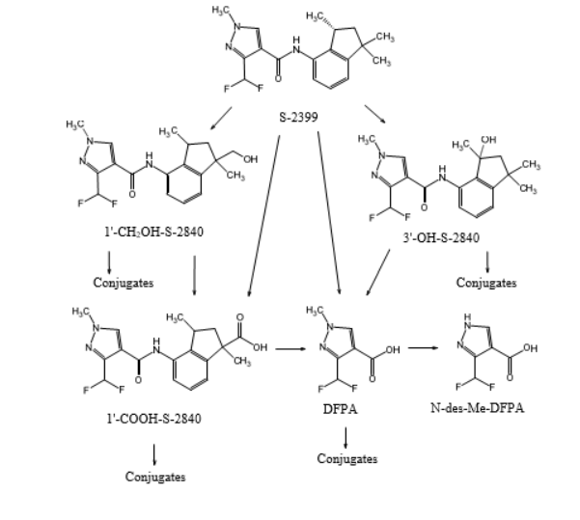

Animals
The metabolism of inpyrfluxam was studied in laying hens and lactating goats.
Parent (inpyrfluxam) was observed in poultry fat (up to 81%TRR; 0.075 mg eq/kg), goat fat (up to 15.8%TRR; 0.004 mg eq/kg) and eggs (up to 11%TRR; 0.002 mg eq/kg). In the feeding studies (at feeding levels of 10 ppm for hens and 20 ppm for cattle), parent was only present at 0.017 mg/kg in poultry fat from the highest dose group but not in any other animal tissue, milk or eggs.
DFPA-CONH2 was observed in poultry muscle (up to 15%TRR; 0.001 mg eq/kg). Residues of DFPA-CONH2 were not found in the feeding studies.
1′-COOH-S-2840 (free and conjugates) was observed in poultry liver (up to 11%TRR; 0.028 mg eq/kg), poultry muscle (up to 14%TRR; 0.003 mg eq/kg), skimmed milk (up to 16%TRR; 0.006 mg eq/kg), goat liver (up to 42%TRR; 0.13 mg eq/kg), goat kidney (up to 50%TRR; 0.08 mg eq/kg), goat muscle (up to 32%TRR; 0.007 mg eq/kg) and goat fat (up to 39.7%TRR; 0.018 mg eq/kg). In the feeding studies, residues were present only at 0.01 mg/kg in poultry liver.
1′-CH2OH-S-2840 (free or conjugated) was observed in poultry liver (up to 52%TRR; 0.164 mg eq/kg), poultry muscle (up to 51%TRR; 0.012 mg eq/kg), fat (up to 17%TRR; 0.014 mg eq/kg), eggs (up to 39%TRR; 0.009 mg eq/kg), goat liver (up to 25%TRR; 0.088 mg eq/kg), goat kidney (up to 37% TRR; 0.063 mg eq/kg) and goat muscle (up to 32%TRR; 0.007 mg eq/kg).
In the feeding studies (at feeding levels of 10 ppm for hens and 20 ppm for cattle), residues were present at 0.012 mg/kg in egg yolk, 0.017 mg/kg in poultry liver, 0.014 mg/kg in cattle liver and at 0.022 mg/kg in kidney.
3′-OH-S-2840 and N-des-Me-S-2840 were not found in any food commodities at significant levels nor residues found in the feeding studies.
Besides parent inpyrfluxam, 1′-CH₂OH-S-2840 (free and conjugated) was a major residue in most animal matrices and the predominant residue found in the livestock feeding studies. Suitable analytical methods for enforcement are available for inpyrfluxam and 1′-CH₂OH-S-2840 (free or conjugated) in animal matrices.

Analytical methods and storage stability

Plant commodities
Various analytical methods were available for the determination of inpyrfluxam and its metabolites in various plant commodities (apple, maize grain, maize stover, maize forage, soya bean, wheat (whole plant), wheat grain, potato tubers, grapes, soya bean seeds, lettuces (without roots), carrot roots and carrots leaves/tops).
All the methods followed a similar methodology with minor modifications. Generally, residues were extracted from homogenized samples with acetonitrile/water. The extracts were further partitioned into hexane/ethyl acetate and purified with SPE (solid phase extraction). To free the conjugates, a fraction of the extract was hydrolysed with HCl before analysis. Residues were determined by HPLC-MS/MS.
The method validation recoveries were satisfactory for inpyrfluxam and its metabolites in all the matrices. In European trials, the limit of quantification (LOQ), was established at 0.01 mg/kg in grapes, potato (tuber), soybean (seeds), wheat (whole plant) and wheat (grain) for S-2399, 3’-OH-S-2840, DFPA-CONH2, N-des-Me-DFPA and DFPA. The LOQ for 1’-COOH-S-2840A&B, 1’-CH2OH-S-2840A&B was determined to be 0.005 mg/kg in all validated matrices.
In Australian trials, for potato and banana, for S-2399 and 3′-OH-S-2840 analytes, the LOQ of the analytical method was 0.01 mg/kg.
For 1′-CH2OH-S-2840A, 1′-CH2OH-S-2840B, 1′-COOH-S-2840A and 1′-COOH-S-2840B analytes in potato, the LOQ was 0.005 mg/kg. For 1′-CH2OH-S-2840A, 1′-CH2OH-S-2840B, 1′-COOH-S-2840A and 1′-COOH-S-2840B analytes in bananas, the LOQ of the analytical method was 0.01 mg/kg.

Animal commodities
Homogenized samples (tissue, milk, or cream) were weighed then extracted using vigorous mechanical shaking with different extraction solvents. Milk/skim/cream were extracted with acetone, liver/kidney/muscle were extracted with acetonitrile/water and fat was extracted with hexane/acetone. The samples were centrifuged after each time to remove and combine supernatants. The “initial extract” was then used to prepare 2 separate final extracts, one for analysis of S-2399, 1’-COOH-S-2840A and B residues, and another for analysis of 1’-CH2OH-S-2840A and B residues.
For the determination of residues of S-2399, 1’-COOH-S-2840A and B in all matrices except fat, an aliquot of the “initial extract” was diluted with methanol/water then filtered. For fat, an aliquot of the “initial extract” was diluted with hexane and partitioned twice with acetonitrile. The acetonitrile layers were combined and concentrated to near dryness before being reconstituted in methanol/water prior to analysis.
For the determination of 1’-CH2OH-S-2840A and B residues in all matrices except fat, an aliquot of the “initial extract” was acidified and hydrolysed for 4 hours at 100 °C to release free forms of 1’-CH2OH-S-2840A and B metabolites from potential conjugates. For fat extracts, an aliquot of the “initial extract” was first concentrated to near dryness, then reconstituted with acetonitrile/water prior to acidification and hydrolysed as above. For all matrices, the resulting hydrolysed extract was cleaned up using a SPE cartridge. The resulting final extract was presented for analysis by high performance liquid chromatography with tandem mass selective detection (HPLC-MS/MS).
The LOQ, defined as the lowest fortification level at which acceptable recovery and repeatability data were obtained, was determined to be 0.01 mg/kg for S-2399 and 0.005 mg/kg for metabolites 1’-COOH-S-2840A&B and 1’-CH2OH-S-2840A&B.

Tissues and eggs of laying hen
The analytical method employed for the detection of inpyrfluxam, and its metabolites were similar to that used for cattle. In brief, analytes were extracted with hexane/acetone from egg/white/yolk, hexane/acetone from fat and with acetonitrile/water from liver/muscle. In muscle and liver, hydrolysis with HCl and clean up with SPE was used to free the conjugates. Residues were determined by HPLC-MS/MS. Final quantification was achieved using HPLC-MS/MS, with LOQs of 0.01 mg/kg for inpyrfluxam and 0.005 mg/kg for metabolites 1′-COOH-S-2840-A and -B and 1′-CH2OH-S-2840 (A and B).

Residue definition
Based on the available metabolism studies, field rotational crop studies and the toxicological profile of the metabolites, the following residue definitions are recommended for enforcement and dietary risk assessment for plant and animal commodities. It is noted that the recommended health-based guidance values cover toxicological aspects of inpyrfluxam and gly-CH₂OH-S-2840.
Residue definition for enforcement for commodities of plant origin: Inpyrfluxam
Residue definition for dietary exposure assessment for commodities of plant origin: the sum of inpyrfluxam and 1′-CH₂OH-S-2840 (free or conjugated) expressed as inpyrfluxam.
Residue definition for enforcement and dietary exposure for animal commodities: the sum of inpyrfluxam and 1′-CH₂OH-S-2840 (free or conjugated) expressed as inpyrfluxam.

Residues in food and animal feeds

Potato
The proposed use involves in-furrow spray application of inpyrfluxam as a directed band spray over potato seed tubers at the rate of 2 mL/100 m row. A harvest WHP of “not required when used as directed” is proposed.
EU trials: In total, eighteen GLP (good laboratory practice) residue trials were conducted in Europe (9 trials each in North and South Europe) in 2016 on potato (tubers).
Residues of inpyrfluxam (parent) observed in potato tubers at early or late commercial maturity following a seed treatment rate addressing the proposed GAP (Good Agriculture Practice) were <0.01 (16) and 0.04 (2) mg/kg. The total residues (i.e., the sum of the parent and 1-CH2OH-S-2840 (free and conjugate) expressed as inpyrfluxam) addressing the proposed GAP were <0.0156 (16) and <0.0476 (2) mg/kg.
Australian trials: Details from 4 Australian GLP trials were provided. Residues of inpyrfluxam at commercial harvest addressing the proposed GAP were <0.01 (4) mg/kg. The total residues in Australian trials were <0.0195 (4) mg/kg.
The OECD MRL calculator estimates, based on the combined results of parent inpyrfluxam from the EU and Australian trials, an MRL (Maximum Residue Limit) of 0.05 mg/kg, highest residue (HR)= 0.04 mg/kg; supervised trials median residue (STMR)= 0.01 mg/kg). Based on the available information, a permanent MRL of 0.05 mg/kg is considered appropriate for potato (VR0589) in conjunction with a harvest WHP of “not required when used as directed”.

Banana
The proposed use involves up to 3 foliar applications of inpyrfluxam with re-treatment intervals of 14 to 21 days at a rate of 185 mL/ha (75 g a.c./ha) in a year. A harvest WHP of 1 day is proposed.
Seven Australian trials conducted in bagged (4) or unbagged (3) bananas were provided but only 4 addressed the proposed 1 day withholding period. The residues of inpyrfluxam (parent) at the proposed WHP of 1 day following three foliar applications at a rate approximately ~1× the proposed (i.e., 75 g a.c./ha) were in rank order: 0.01, 0.023, 0.098 and 0.30 mg/kg.
The OECD MRL calculator estimates, based on the results of the four trials addressing the proposed 1 day withholding period, an MRL of 0.7 mg/kg (HR= 0.30 mg/kg; STMR= 0.01 mg/kg). Based on the available information a permanent MRL of 0.7 mg/kg is considered appropriate for banana (FI0327) in conjunction with a harvest WHP of 1 day.
The total residues of inpyrfluxam (i.e., the sum of the parent and 1-CH2OH-S-2840 (free and conjugate) expressed as inpyrfluxam) were in rank order: 0.029, 0.041, 0.165 and 0.436 mg/kg. (STMR= 0.103 mg/kg).

Crop rotation
The residues of parent and 1′-CH₂OH-S-2840 observed in the field rotational crop study which addressed plant back intervals of 28, 120 and 350 days, when scaled to the proposed rate, are expected to be <0.01 mg/kg in all rotational crops (both food and animal feed commodities). Therefore, plant back intervals for managing residues in succeeding crops are not considered necessary for the proposed uses.

Residues in animal commodities
Animal feeding studies along with appropriately validated analytical methods were provided for quantification of residues in lactating cows and laying hen. Based on these studies, quantifiable residues of inpyrfluxam or any of its metabolites are not expected in cattle or poultry edible commodities or their by-products after the proposed use. For compliance, MRLs for animal commodities are recommended at their respective limit of quantification. For mammalian meat or milk commodities, MRLs at *0.02 mg/kg (derived from LOQs of 0.01 mg/kg for inpyrfluxam and 1′-CH2OH-S-2840 (A and B) for Edible offal (mammalian) (MO 0105); Meat (mammalian) (MO0105); and Milks (ML0106) are recommended for the proposed use. In poultry meat or eggs, the following MRLs at *0.02 mg/kg are recommended for poultry commodities: Eggs (PE0112), Poultry, edible offal of (PO 0111) and Poultry meat (PM 0110).

Spray drift
Animal commodity MRLs for inpyrfluxam in many overseas markets are not currently established. It is therefore considered that residues should be below the limit of quantification (0.01 mg/kg) in animal tissues to mitigate any potential risk to international trade of animal tissues.
In the dairy cattle transfer study feeding at 6 ppm gave a total maximum residue of 0.03 mg/kg in kidney. The feeding level (RAL) for residues to be <LOQ of 0.02 mg/kg is 4 ppm.
If a RAL of 4 ppm is used in the APVMA Spray Drift Risk Assessment Tool, then mandatory downwind buffer zones are not required for vertical sprayer application whereas for aerial application a downwind buffer zone of up to 10 metres is required for the protection of livestock areas for international trade.

Dietary risk assessment
The chronic dietary exposure to inpyrfluxam is estimated by the National Estimated Daily Intake (NEDI) calculation encompassing all registered/temporary uses of the chemical and the mean daily dietary consumption data derived primarily from the 2011–12 National Nutritional and Physical Activity Survey. The NEDI calculation is made in accordance with WHO Guidelines and is a conservative estimate of dietary exposure to chemical residues in food. The NEDI for inpyrfluxam is equivalent to <1% of the ADI. It is concluded that the chronic dietary exposure to inpyrfluxam is acceptable.
The acute dietary exposure is estimated by the National Estimated Short-Term Intake (NESTI) calculation. The NESTI calculations are made in accordance with the deterministic method used by the JMPR with 97.5th percentile food consumption data derived primarily from the 2011–12 National Nutritional and Physical Activity Survey. NESTI calculations are conservative estimates of short-term exposure (24-hour period) to chemical residues in food. The highest acute dietary intake was estimated at <10% of the ARfD. It is concluded that the acute dietary exposure is acceptable.

Recommendations
The following amendments are required to be made to the APVMA MRL Standard (Tables 1 and 3).
Table 6: Amendments to the APVMA MRL Standard
Amendments to Table 1
Compound | Food | MRL (mg/kg)
Add:
Inpyrfluxam
FI 0327 | Banana | 0.7
MO 0105 | Edible offal (mammalian) | *0.02
PE 0112 | Eggs | *0.02
MM 0095 | Meat (mammalian) | *0.02
ML 0106 | Milks | *0.02
PO 0111 | Poultry, Edible offal of | *0.02
PM 0110 | Poultry meat | *0.02
VR 0589 | Potato | 0.05
Amendments to Table 3
Compound | Residue
Add:
Inpyrfluxam | Commodities of plant origin for enforcement: Inpyrfluxam  Commodities of plant origin for dietary exposure assessment: Inpyrfluxam and 1′-CH₂OH-S-2840 (free or conjugated) expressed as inpyrfluxam.  Commodities of animal origin: Inpyrfluxam and 1′-CH₂OH-S-2840 (free or conjugated) expressed as inpyrfluxam.

Assessment of overseas trade aspects of residues in food
Potatoes and bananas are not considered to be major export commodities and quantifiable residues are not expected to arise in animal products as a result of the proposed use. The risk to international trade associated with the proposed use is considered not undue.

Work health and safety assessment

Health hazards
Excalia Fungicide has moderate acute oral toxicity, low dermal and inhalational toxicity and is neither an eye or skin irritant nor a skin sensitiser (Buehler test and LLNA).

Occupational exposure

Exposure during use
Excalia Fungicide containing 400 g/L of inpyrfluxam in a suspension concentrate (SC) formulation is intended for professional use and will be applied as an in-furrow soil drench to control Rhizoctonia solani in potatoes at planting. Spray nozzles will preferably direct the spray in a 15 to 20 cm band onto the seed pieces and surrounding soil as they fall into the planting furrow. Excalia Fungicide will also be applied by aerial and ground (mechanically pressurised handgun) application equipment as a foliar spray to control yellow sigatoka in bananas. The product will be available in 1 to 20 L HDPE containers.
Occupational risk assessment is based on both acute exposure to the product and repeat exposure to the active constituent. Workers may be exposed to the product from dermal and/or inhalation routes during mixing, loading and application (M/L/A) and dermal exposure during post-application activities. Minor or accidental ocular exposure may also occur.
Although no worker exposure data were submitted, the APVMA concluded adequate data were available to undertake an occupational risk assessment for the proposed uses of Excalia Fungicide.

Exposure during re-entry or rehandling
Post-application exposure to the product may occur from dermal contact with foliage for workers undertaking activities associated with potatoes and banana. Based on the exposure assessment, risks were acceptable for relevant maintenance activities with high margins of exposure (MOE >100) on day 0 (day of product application) after application. As there are no acute dermal hazards (eye and skin irritation or sensitisation) associated with the product residues, no re-entry statement is required on the product label.

Public exposure
The product is intended for professional use only. Therefore, risks from use are not relevant for the general public.
Spray drift risk assessment indicated no buffer zones are required for aerial or mechanical ground spraying.

Recommendations
The following first aid instructions, safety directions and precautionary (warning) statements are recommended for the product label.

First aid instructions
If poisoning occurs, contact a doctor or Poisons Information Centre. Phone Australia 131126; New Zealand 0800 764 766.

Safety directions
Harmful if swallowed. When using together with other products, consult their safety directions. When opening the container, preparing, and using the spray, wear cotton overalls buttoned to the neck and wrist (or equivalent clothing). Wash hands after use. After each day’s use, wash contaminated clothing.

Precautionary (warning) statements

Restraints/restrictions
DO NOT allow bystanders to come into contact with the spray cloud.

Re-entry or re-handling statement
A re-entry statement is not required.

Environmental assessment

Fate and behaviour in the environment

Soil
Guideline laboratory studies on inpyrfluxam have been conducted in 4 soils under aerobic conditions using inpyrfluxam radiolabelled in the phenyl- or pyrazolyl- ring. It was confirmed that no isomerisation occurred during the incubation period. Considering both radiolabelling positions, the amounts of bound residues formed were low (≤12% after 120 days incubation) and the amount of CO₂ evolved was insignificant (<1% after 120 days incubation). The major metabolites formed were 1-COOH-S-2840 (max. 30% at final sampling point) and 3-OH-S-2840 (max. 21% at final sampling point). The proposed aerobic degradation pathway for inpyrfluxam is shown in the figure below.
Guideline anaerobic laboratory studies on inpyrfluxam have been conducted in 4 soils (3 of those used for the aerobic incubations) using inpyrfluxam radiolabelled in the phenyl- or pyrazolyl rings. Degradation occurred predominantly in the aerobic phase, and it was concluded there was little degradation under anaerobic conditions and no evidence of any differing metabolism pathway.
A guideline laboratory photodegradation study was conducted on inpyrfluxam on a US soil. Inpyrfluxam was radiolabelled in the phenyl- or pyrazolyl- ring. It was confirmed no isomerisation occurred during the incubation period. Photodegradation of inpyrfluxam was determined to be insignificant. No major photoproducts were formed.
The rate of soil degradation of inpyrfluxam in the laboratory was obtained from the 4 studies where the route was investigated. In general, degradation was slow under aerobic conditions with DT₅₀ values of 121-1720 days (geomean 348 days) in the agricultural soils and DT₅₀ >1000 days in the paddy soil. Under anaerobic conditions, inpyrfluxam was essentially stable in all the agricultural soils and DT₅₀ 813 days was determined in the paddy soil.
The rate of aerobic soil degradation of the main metabolites, 1-COOH-S-2840 and 3-OH-S-2840 was also directly determined in standard laboratory studies in 3 soils. The DT₅₀ values for 3-OH-S-2840 ranged 276-369 days (geomean 314 days) and for 1-COOH-S-2840 ranged 91-266 days (geomean 153 days).
Terrestrial field dissipation studies were conducted at 5 North American sites (no soil incorporation) and 4 European sites (using soil incorporation). DT₅₀ values ranged 45-279 days at the North American sites and 121-381 days at the European sites. The geomean DT₅₀ at all sites was 158 days.
The accumulation of inpyrfluxam and its metabolites 3-OH-S-2840, 1-COOH-S-2840A, and 1-COOH-S-2840B was assessed in soil under field conditions at 4 sites in Europe. There was no evidence of any significant carryover of inpyrfluxam at the end of the first year at 2 of the sites (ca 90% of day 0 value degraded). At the other 2 sites, there was some carryover of residues at the end of the first year (ca 20-30% remaining) and hence these studies are continuing. However, there was no evidence of accumulation of inpyrfluxam based on results 240 days after the second application (i.e., concentrations are similar 240 days after 1st or 2nd applications).
The adsorption behaviour of inpyrfluxam was examined in 4 UK soils, 2 US soils and one Japanese paddy soil. Adsorption K_{Foc} values for inpyrfluxam ranged 500-891 L/kg (geomean 651 L/kg), hence showing a low range of values compared to the KF data (1.6-19 L/kg). The mean 1/n value was 0.96. There was no evidence of any pH dependence. As expected, desorption K_{Foc} values were slightly higher than adsorption values.
The adsorption behaviour of the major soil metabolite 3-OH-S-2840 was examined in three European soils. There was no evidence of pH-dependence of sorption and adsorption K_{Foc} values ranged 349-492 L/kg (geomean 414 L/kg), with a mean 1/n value of 0.94.
The adsorption behaviour of the major soil metabolite 1-COOH-S-2840 was examined in 5 soils (four European, one US). Both the A and B isomers were tested, with adsorption K_{Foc} values ranging 11-45 L/kg (geomean 24 L/kg) and the mean 1/n value was 0.94. Despite the presence of the carboxy group, there was no evidence of pH-dependence of sorption, and this may have been because all values were relatively low.
Figure 2: Proposed aerobic soil degradation pathways for inpyrfluxam (S-2399)

Water
Inpyrfluxam is hydrolytically stable at pH 4, 7 and 9 and no isomerisation occurred. The compound is also photolytically stable in sterile buffer and a quantum yield of 3.8 × 10-4 was determined. However slow photolysis was observed in sterile natural water (DT₅₀ 69-171 days at 30-50°N in summer) and hence an indirect mechanism can be assumed.
Inpyrfluxam is not readily biodegradable but did not inhibit the activity of the microbial inoculum. An aerobic mineralisation study also confirmed very slow degradation, with effectively no decline of inpyrfluxam over the 60-day laboratory incubation at 20°C.
Guideline laboratory studies have been conducted in 5 varying water/sediment aquatic systems under aerobic conditions using inpyrfluxam radiolabelled in the phenyl- or pyrazolyl- ring. All waters and sediments originated from the United States. It was confirmed no isomerisation occurred during the incubation period. Considering both radiolabelling positions, the amounts of bound residues formed in the systems were low (≤12% after 112 days incubation) and the amount of CO₂ evolved was insignificant (<1% after 112 days incubation). The major metabolites formed were 1-COOH-S-2840 (max. 13% in whole system at final sampling point) and 3-OH-S-2840 (max. 6.8% in whole system at 30 day). 1-COOH-S-2840 was found predominantly in the water phase and 3-OH-S-2840 was predominantly in the sediment phase. The proposed aerobic degradation pathway for inpyrfluxam in aerobic aquatic systems is the same as in soil.
A guideline laboratory study on inpyrfluxam has been conducted in 2 varying water/sediment aquatic systems under anaerobic conditions using inpyrfluxam radiolabelled in the phenyl- or pyrazolyl- ring. Both waters and sediments were also used for the aerobic studies. It was confirmed that no isomerisation occurred during incubation period. Considering both radiolabelling positions, the amounts of bound residues formed in the systems were very low (<10% at the final timepoint) and the amount of CO₂ evolved was insignificant (<1%). The major metabolite formed was 3-OH-S-2840 (max. 5.3% in whole system at 30 day). The proposed anaerobic degradation pathway for inpyrfluxam in aquatic systems is therefore the same as in soil and aerobic aquatic systems.
The rate of aerobic and anaerobic aquatic degradation of inpyrfluxam in the laboratory was obtained from the guideline studies where the route was investigated. In general, degradation was slow in aerobic conditions and not significant in anaerobic conditions. Single first order (SFO) DT₅₀ values ranging 225-1616 days (geomean DT₅₀ 540 days) were obtained for aerobic systems whilst inpyrfluxam was essentially stable in anaerobic systems.
An aquatic field dissipation study was conducted to determine the dissipation and degradation of inpyrfluxam in 2 representative small, static (non-flowing) outdoor ponds in Texas following a broadcast application. Two additional aquatic field dissipation studies were conducted in flooded rice fields in Louisiana and California following planting of rice seed treated with inpyrfluxam and a broadcast foliar application of inpyrfluxam. Inpyrfluxam partitioned to sediment relatively fast in both the small ponds and the flooded paddy (geomean DT₅₀ 6.3 and 1.2 days in water phases, respectively).

Air
Inpyrfluxam has a low vapour pressure (3.8 × 10-8 Pa at 20ºC) and a short DT₅₀ in air (0.23 days derived by the Atkinson model). Therefore, transport in air is not expected to be significant.

Effects and associated risks to non-target species

Terrestrial vertebrates
Following gavage administration, inpyrfluxam had moderate toxicity to mammals (LD₅₀ 180 mg ac/kg bw, Rattus norvegicus) and low toxicity to birds (LD₅₀ >1350 mg ac/kg bw, 2 species tested). The SC formulation appeared to enhance toxicity to birds (LD₅₀ 571 mg ac/kg bw, Colinus virginianus). The major soil metabolites 3-OH-S-2840 and 1-COOH-S-2840 and the plant metabolite 1-CH2OH-S-2840 were less toxic to mammals than the parent substance.
Inpyrfluxam had high toxicity to passerine birds following dietary administration (LD₅₀ 48 mg ac/kg bw/d. Taeniopygia guttata). There was feed aversion which resulted in a non-monotonic increase in daily doses. Clinical signs of toxicity were observed at doses as low as 32 mg ac/kg bw/d (NOAEL 19 mg ac/kg bw/d).
Following long-term dietary administration in reproductive toxicity studies, reduced parental and pup body weights were observed at doses as low as 86 mg ac/kg bw/d (NOAEL 22 mg ac/kg bw/d, Rattus norvegicus), while no adverse effects observed in birds at the highest doses tested (lowest NOEL 87 mg ac/kg bw/d, Colinus virginianus).
Risks of Excalia Fungicide to terrestrial vertebrates were determined to be acceptable assuming a realistic worst-case scenario of direct dietary exposure within the treatment area at the maximum seasonal exposure rates. No protection statements are required for terrestrial vertebrates.
The octanol-water partition coefficient for inpyrfluxam indicates a potential for bioaccumulation. A food chain assessment indicates that any accumulated residues in earthworms or fish will not reach levels harmful to predators under the proposed conditions of use. Based on no evidence of accumulation in mammalian tissues, biomagnification is not expected up the food chain.

Aquatic species
Inpyrfluxam has high toxicity to fish (median HC5 0.018 mg ac/L based on a SSD of LC₅₀ values for 8 fish species), and moderate toxicity to aquatic invertebrates (lowest definitive LC₅₀ 1.1 mg a.c./L, Americamysis bahia), algae (lowest E_{r}C₅₀ 1.5 mg a.c./L, E_{r}C₁₀ 11 mg a.c./.L, Skeletonema costatum) and aquatic plants (E_{r}C₅₀ >25 mg a.c./L, E_{r}C₁₀ 11 mg a.c./L, Lemna gibba). The SC formulation did not influence the toxicity to aquatic species. The major soil metabolites 3-OH-S-2840 and 1-COOH-S-2840 were less toxic to fish than the parent substance. Based on high toxicity of inpyrfluxam to fish, a protection statement is required on the label.
Following long-term exposure to inpyrfluxam, decreased survival and growth of fish in the early life stages was observed at concentrations as low as 0.013 mg a.c./L (NOEC 0.0075 mg ac/L, Pimephales promelas), reduced growth of aquatic invertebrates was observed at concentrations as low as 0.36 mg a.c./L (NOEC 0.18 mg a.c./L, Americamysis bahia), and a biologically relevant (15%) reduction of egg masses per mated female was observed in sediment dwellers at concentrations as low as 3.2 mg a.c./kg dry sediment (NOEC 1.3 mg a.c./kg dry sediment, Chironomus riparius).
Risks of Excalia Fungicide to aquatic invertebrates, algae and aquatic plants were determined to be acceptable assuming a worst-case scenario of a direct overspray at the maximum seasonal rates. Spray drift risks to fish and sediment-dwellers were determined to be acceptable provided mandatory downwind buffer zones of 5-20 metres are observed for vertical sprayers and 95 to 130 metres are observed for aircraft. Runoff risks were also determined to be acceptable provided a runoff event does not occur soon after application (i.e., due to storms or heavy irrigation). General runoff restraints are advised to mitigate this risk.

Bees and other non-target arthropods
Inpyrfluxam has low toxicity to adult bees by contact exposure (LD₅₀ >100 μg a.c./bee, 2 species tested) and oral exposure (LD₅₀ >95 μg a.c./bee, 2 species tested), and low toxicity be bee larvae (LD₅₀ 115 μg a.c./bee, Apis mellifera). The SC formulation did not influence the toxicity to bees.
Following long-term dietary exposure to 2 similar SC formulations of inpyrfluxam, no adverse effects were observed in adult bees at the highest concentration tested (NOEL 154 μg a.c./bee/d, Apis mellifera), while pupal mortality and emergence were negatively affected in a dose-dependent manner (LD₁₀ 2.9 μg a.c./bee/d, ED₁₀ 3.5 μg a.c./bee/d, Apis mellifera).
In Tier 1 (glass plate) toxicity tests, fresh dried residues of a representative SC formulation of inpyrfluxam were not toxic to the indicator species of predatory arthropods (LR₅₀ >1000 g a.c./ha, Typhlodromus pyri) and parasitic arthropods (LR₅₀ >1000 g a.c./ha, Aphidius rhopalosiphi). There were no effects on reproduction at these rates for either species.
Risks of Excalia Fungicide to bees and other non-target arthropods were determined to be acceptable under realistic worst-case scenarios of direct dietary and/or contact exposure within the treatment area at the maximum exposure rates. No protection statements are required for bees or other non-target arthropods.

Soil organisms
Inpyrfluxam and its SC formulation have moderate toxicity to earthworms (LC_{50corr} 113 and 64 mg a.c./kg dry soil for Eisenia fetida, respectively). Following long term exposure to inpyrfluxam, earthworm reproduction was reduced in a dose-dependent manner (EC₁₀ 22 mg a.c./kg dry soil, Eisenia fetida). No adverse effects were observed in other species of soil macro-organisms at the highest test concentration (EC₁₀ >100 mg a.c./kg dry soil, 2 species tested). Inpyrfluxam and its SC formulation did not adversely affect soil processes such as nitrogen and carbon mineralisation at exaggerated soil concentrations (NOEC 6.0 mg a.c./kg dry soil). The major soil metabolites 3-OH-S-2840 and 1-COOH-S-2840 were not demonstrably more toxic to soil organisms than the parent substance.
Risks of Excalia Fungicide to soil organisms were determined to be acceptable assuming a realistic worst-case scenario of direct exposure to accumulated soil residues in the top 5 cm after multiple years of use. No protection statements are required for soil organisms.

Non-target terrestrial plants
A representative SC formulation of inpyrfluxam had no effect on a standard suite of 10 test plants following pre-emergent exposure (seedling emergence test) or post-emergent exposure (vegetative vigour test) at the highest rate tested (ER₂₅ >200 g a.c./ha, ER₅₀ >200 g a.c./ha).
Risks of Excalia to non-target terrestrial plants were determined to be acceptable assuming a worst-case scenario of a direct overspray at the maximum application rates. No protection statements are required for non-target terrestrial plants.

Recommendations
In considering the environmental safety of the proposed use of Excalia Fungicide, the APVMA had regard to the toxicity of the active constituent in relation to relevant organisms and ecosystems. Based on the outcome of the risk assessment, the proposed use of the product is unlikely to have an unintended effect that is harmful to animals, plants, or things, or to the environment.

Efficacy and safety assessment

Proposed product use pattern
Excalia Fungicide is proposed for the control of soil borne Rhizoctonia solani in potatoes and for the control of yellow sigatoka in bananas. In potatoes, the proposed use is for an in-furrow spray at planting at 2 mL/100 m row in 1 to 3 L of water/100 m row. In bananas, the proposed use is at 185 mL/ha as part of a regular fungicide spray program alternating with fungicides from different MoA groups with a 14-to-21-day interval between fungicide applications and a maximum of three applications of Excalia Fungicide to any banana block in a 12-month period. When using in bananas, Excalia Fungicide can be applied by vertical sprayer or aircraft and must be used with a high quality miscible mineral crop oil at 3 to 5 L/ha.

Efficacy and target crop/animal safety
For potatoes, efficacy and crop safety was assessed in 16 trials both locally in Tasmania and Queensland and internationally in Germany, New Zealand, and the USA from 2014 to 2020. Although most local trials were conducted in Tasmania, Rhizoctonia is a universal disease and mostly consistent between states and as such, the trials in Tasmania are representative to the rest of Australia. In the USA, the trials were conducted in the potato growing regions of central northern USA where winters are cold, and summers are hot and humid with high rainfall which are similar climatic conditions to New Zealand and Australia. The USA, Germany and New Zealand have colder winters than Australia, however the summer growing temperatures are similar. Furthermore, in regions where rainfall is inadequate, supplementary irrigation is used and therefore soil temperature and moisture, the main environmental drivers of pathogen incidence, are similar in the overseas trials compared to Australia.
For bananas, efficacy was assessed in 4 trials and safety in 6 trials, all conducted in Queensland between 2016 and 2020. Although the trials were all conducted in the same area, Queensland is the major banana producing region and as such, efficacy against yellow sigatoka can be extrapolated to other areas of Australia.
All trials used appropriate trial design, scientific methodology, and assessment parameters, with 4 or 5 replicates, industry standards, and untreated controls. Results were analysed using standard statistical procedures (ANOVA and LSD). Most trials had moderate to high disease pressure whereas 2 trials had very low disease pressure.

Efficacy

Potatoes
Four Australian and 12 overseas trials were conducted to evaluate the efficacy of Excalia Fungicide at 1× the label rate of 2 mL/100 m row and at various other rates including 1.6, 1.7, 1.8, 1.9, 2, 2.03, 3.2 and 3.8 mL/100m row against Rhizoctonia solani in potatoes. The formulation used in the 7 USA trials is a 340 g/L inpyrfluxam SC formulation with slightly lower content of inpyrfluxam (32.1% vs 36.5 % w.w.) at 2 rates including 75 g a.c./ha (0.648 g a.c./100m row) and 100 g a.c./ha (0.86 g a.c./100 m row). The proposed label rate is equivalent to 0.8 g a.c./100 m row, which at the most common row spacing of 0.9 m, is 88.9 g a.c./ha which falls between the 2 US rates. Considering the US trial results showed excellent control at both rates, the US data supports the proposed Australian rate.
Efficacy was determined by assessing various parameters including potato emergence, marketable/unmarketable tuber yield, tuber Rhizoctonia incidence, tuber Rhizoctonia severity, tuber yield, stem Rhizoctonia incidence, stem girdled incidence, stem yield, plant vigour, stolon Rhizoctonia incidence, stem lesion severity, and reduction of radial growth of Rhizoctonia. Excalia Fungicide was applied in-furrow by spraying down into the furrow as the seed pieces fell down the planting chute as per label instructions.
Two local trials had very low pest pressure which explains the non-significant results in the first trial and partial efficacy in the second trial, but Excalia Fungicide performed equivalently to the industry standards. The third local trial applied Excalia Fungicide at 2.4× the proposed label rate and thus could not be used to confirm efficacy at the proposed label rate. Two trials conducted in Germany and one in New Zealand showed partial efficacy with equivalent results to the industry standards. One New Zealand trial showed no significant differences compared to the UTC but performed numerically better than the industry standard. One US trial showed no significant control of Rhizoctonia vs the UTC although there was a numerical reduction in Rhizoctonia severity and incidence. In addition, an agar bioassay showed signification reduction of radial growth of Rhizoctonia compared to the standard product. In the other 9 trials, Excalia Fungicide at label rate provided significant control of Rhizoctonia compared to the untreated control performing equivalently to the industry standards. In summary, Excalia Fungicide performed equivalently and, in some cases, numerically better than the industry standards.

Bananas
Four Australian trials were conducted to evaluate the efficacy of Excalia Fungicide at 1× the label rate of 185 mL/ha against yellow sigatoka in bananas and one other local trial with Excalia Fungicide applied as a 60 g/L EC formulation. In the trial where inpyrfluxam was applied as an EC formulation, the same amount of active was applied as proposed on the Excalia Fungicide label (75 g a.c./ha) and therefore efficacy of inpyrfluxam at the proposed label rate can be confirmed. Efficacy against yellow sigatoka was determined by assessing various parameters including disease severity via leaf area infected and youngest leaf infected.
In all trials, Excalia Fungicide at the proposed label rate provided significant control of yellow sigatoka performing equivalently and, in most cases, numerically better than the industry standard products.

Crop safety
In potatoes, 9 trials showed Excalia Fungicide applied at 0.94× (1 trial), 0.95× (2 trials), 1× (2 trials), 1.25× (2 trials), 2.4× (1 trial), and 3× (1 trial) the label rate, was safe with no phytotoxicity noted throughout the trials.
In bananas, 5 trials showed Excalia Fungicide was safe to apply at 1× the label rate after 4 to 5 applications and one trial at up to 2× the label rate after 5 applications.

Resistance management
Inpyrfluxam is a broad-spectrum fungicide which belongs to the Group 7, succinate dehydrogenase inhibitors (SDHI) group of fungicides as designated by the Fungicide Resistance Action Committee (FRAC). The product label proposed the following resistance management statement:
Excalia Fungicide is a member of the succinate dehydrogenase inhibitors (SDHI) group of fungicides. For fungicide resistance management Excalia Fungicide is a Group 7 fungicide. Some naturally occurring individual fungi resistant to Excalia Fungicide and other Group 7 fungicides may exist through normal genetic variability in any fungal population. The resistant individuals can eventually dominate the fungal population if these fungicides are used repeatedly. These resistant fungi will not be controlled by this product or other Group 7 fungicides, thus resulting in a reduction in efficacy and possible yield loss. Since the occurrence of resistant fungi is difficult to detect prior to use, Sumitomo Chemical Australia Pty Ltd accepts no liability for any losses that result from the failure of Excalia Fungicide to control resistant fungi. Excalia Fungicide may be subject to specific resistance management strategies. For further information refer to the CropLife Australia website.
Trial data indicate Excalia Fungicide will provide acceptable control against soil borne Rhizoctonia solani in potatoes and yellow sigatoka in bananas and is expected to be safe to the target crops potatoes and bananas when used according to label directions. The directions for use are appropriate and consistent with fungicide use in commercial agriculture in Australia.
There are no objections on efficacy or target crop safety grounds to the registration of the product Excalia Fungicide, containing 400 g/L inpyrfluxam.

Spray drift assessment
Regulatory Acceptable Levels (RALs) were established for each risk area to calculate the appropriate spray drift buffer zones for Excalia Fungicide, using the APVMA Spray Drift Assessment Tool (SDRAT).

Human health
Results from the spray drift risk assessment indicated no bystander buffer zones are required for aerial or vertical sprayer.

Residues and trade
The feeding level for residues to be at the LOQ (0.02 mg/kg) is 4 ppm. Mandatory buffer zones are not required for vertical sprayer application whereas for aerial application, mandatory buffer zones of up to 10 m are required for the protection of livestock areas for international trade.

Environment
Inpyrfluxam has low toxicity to adult bees by contact (LD₅₀>100 μg a.c./bee, 2 species tested) and oral (LD₅₀> 95 μg a.c./bee, 2 species tested) exposure and low toxicity be bee larvae (LD₅₀ 115 μg ac/bee, Apis mellifera). Acceptable spray drift risks to bees were concluded and therefore no mandatory buffer zones are needed for pollinators.
Based on the set regulatory acceptable level (RAL) for aquatic species of 2.0 μg a.c./L, mandatory buffer zones of 5 to 20 m for vertical sprayers and 95 to 130 m for aerial applications are required for natural aquatic areas.
Table 7: Summary of RALs for Excalia Fungicide (400 g/L inpyrfluxam)
Sensitive area | Regulatory acceptable level
Sensitive area | Level of active | Units
Bystander | 4060 | g/ha
Livestock | 4 | ppm
Aquatic | 2 | µg/L
Pollinator | 16667 | g/ha
Vegetation | 100 | g/ha
Buffer zones calculated by the SDRAT, using the above RALs, were incorporated into the Excalia Fungicide label spray drift instructions (see Labelling requirements below).

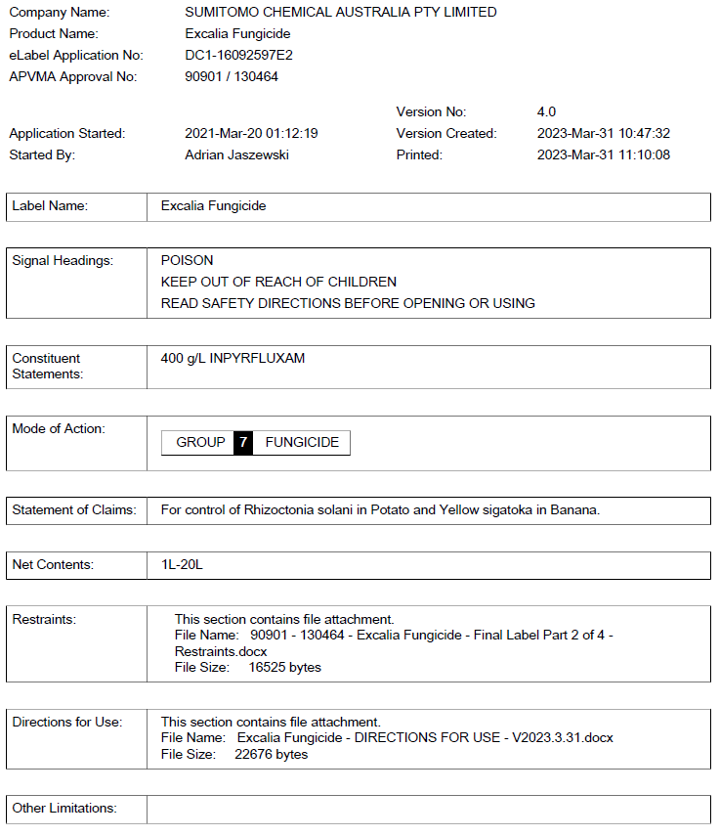
Labelling requirements

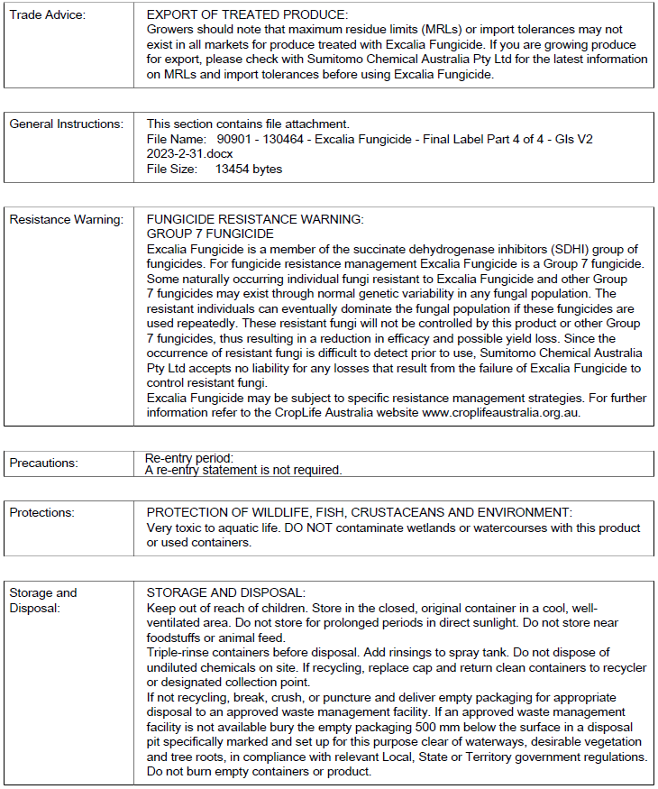

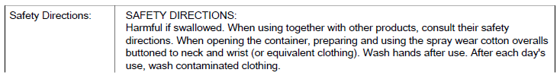
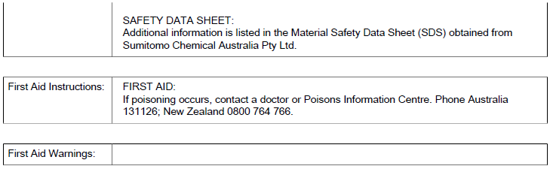
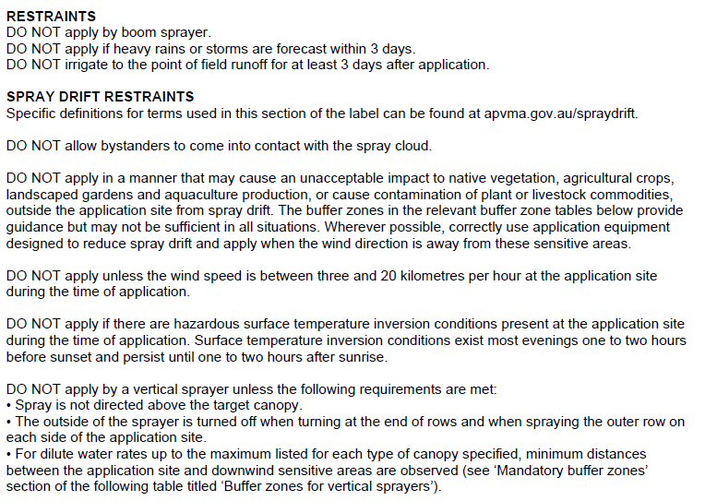
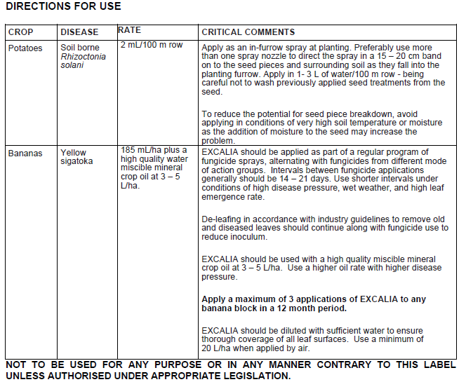
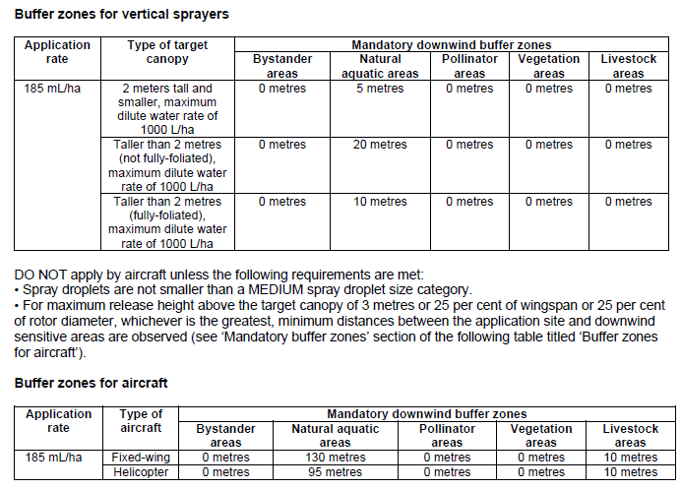
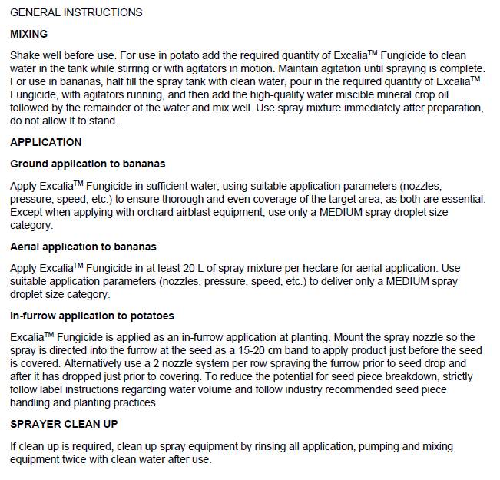

Acronyms and abbreviations
Shortened term | Full term
ACCS/ACMS | Advisory Committee for Chemicals Scheduling/Advisory Committee for Medicines Scheduling
ac | Active constituent
ADI | Acceptable daily intake (for humans)
A/G | Albumin/globulin
AHMAC | Australian Health Ministers Advisory Council
ai | Active ingredient
ALT | Alanine aminotransferase
ARfD | Acute reference dose
AST | Aspartate aminotransferase
BBA | Biologische Bundesanalstalt fur Land – und forstwirschaft
bw | Bodyweight
CNS | Central nervous system
d | Day
DAT | Days after treatment
DT₅₀ | Time taken for 50% of the concentration to dissipate
EA | Environment Australia
E_{b}C₅₀ | Concentration at which the biomass of 50% of the test population is impacted
EC₅₀ | Concentration at which 50% of the test population are immobilised
ED₁₀ | Concentration at which 10% of the population shows an adverse effect
EEC | Estimated environmental concentration
E_{r}C₅₀ | Concentration at which the rate of growth of 50% of the test population is impacted
EI | Export interval
EGI | Export grazing interval
ESI | Export slaughter interval
EUP | End use product
F₀ | Original parent generation
FRAC | Fungicide Resistance Action Committee
g | Gram
GAP | Good agricultural practice
GCP | Good clinical practice
GD | Gestational date
Glob | Globulin
GLP | Good laboratory practice
GPMT | Guinea pig maximization test
GGPT | Gamma-glutamyl transpeptidase
GVP | Good veterinary practice
h | Hour
ha | Hectare
HC₅ | Hazardous concentration to 5% of the species
Hct | Heamatocrit
Hb | Haemoglobin
HPLC | High pressure liquid chromatography or high-performance liquid chromatography
id | Intradermal
im | Intramuscular
ip | Intraperitoneal
IPM | Integrated pest management
iv | Intravenous
in vitro | Outside the living body and in an artificial environment
in vivo | Inside the living body of a plant or animal
kg | Kilogram
K_{OC} | Organic carbon partitioning coefficient
K_{FOC} | Organic carbon normalized Freundlich distribution coefficient
L | Litre
LC₅₀ | Concentration that kills 50% of the test population of organisms
LD₅₀ | Dosage of chemical that kills 50% of the test population of organisms
LLNA | Local lymph node assay
LOD | Limit of Detection – level at which residues can be detected
Log K_{OW} | Log to base 10 of octanol water partitioning co-efficient, synonym P_{OW}
LOQ | Limit of Quantitation – level at which residues can be quantified
mg | Milligram
mL | Millilitre
MRL | Maximum residue limit
MSDS | Material Safety Data Sheet
NEDI | National Estimated Daily Intake
NESTI | National Estimated Short-Term Intake
ng | Nanogram
NHMRC | National Health and Medical Research Council
NOEC/NOEL | No observable effect concentration level
NOAEL | No observed adverse effect level
OC | Organic carbon
OM | Organic matter
PAI | Purified active ingredient
po | Oral
ppb | Parts per billion
PPE | Personal protective equipment
ppm | Parts per million
Q-value | Quotient-value
RAL | Regulatory acceptable level
RBC | Red blood cell count
REI | Re-entry interval
s | Second
sc | Subcutaneous
SC | Suspension concentrate
SDMT | Spray Drift Management Tool
SDRAT | Spray Drift Risk Assessment Tool
SSD | Species specific diversity
SUSMP | Standard for the Uniform Scheduling of Medicines and Poisons
TGA | Therapeutic Goods Administration
TGAC | Technical grade active constituent
TRR | Total radioactive residue
TTC | Threshold of toxicological concern
µg | Microgram
vmd | Volume median diameter
WG | Water dispersible granule
WHP | Withholding period

Glossary
Term | Description
Active constituent | The substance that is primarily responsible for the effect produced by a chemical product
Acute | Having rapid onset and of short duration
Carcinogenicity | The ability to cause cancer
Chronic | Of long duration
Codex MRL | Internationally published standard maximum residue limit
Desorption | Removal of a material from or through a surface
Efficacy | Production of the desired effect
Formulation | A combination of both active and inactive constituents to form the end use product
Genotoxicity | The ability to damage genetic material
Hydrophobic | Repels water
Leaching | Removal of a compound by use of a solvent
Metabolism | The chemical processes that maintain living organisms
Photodegradation | Breakdown of chemicals due to the action of light
Photolysis | Breakdown of chemicals due to the action of light
Subcutaneous | Under the skin
Toxicokinetics | The study of the movement of toxins through the body
Toxicology | The study of the nature and effects of poisons

References
Australian Government Federal Register of Legislation, Agricultural and Veterinary Chemicals Code Act (1994) (Cth), Federal Register of Legislation website
Australian Pesticides and Veterinary Medicines Authority (2018). Spray Drift Risk Assessment Tool (SDRAT) – Version 1.0, APVMA website.
Australian Pesticides and Veterinary Medicines Authority (2021a). Acceptable daily intakes for agricultural and veterinary chemicals, APVMA website.
Australian Pesticides and Veterinary Medicines Authority (2021b). Acute reference doses for agricultural and veterinary chemicals, APVMA website.
Australian Pesticides and Veterinary Medicines Authority (2021c). FAISD Handbook, APVMA website.
European Food Safety Authority (2009). Risk Assessment for Birds and Mammals, EFSA Journal 7(12) 1438, DOI 10.2903/j.efsa.2009.1438, EFSA website.
European Food Safety Authority (2014). EFSA Guidance Document for evaluating laboratory and field dissipation studies to obtain DegT50 values of active substances of plant protection products and transformation products of these active substances in soil, EFSA Journal 12(5):3662, 37 pp. DOI 10.2903/j.efsa.2014.3662, EFSA website.
Health Canada Pest Management Regulatory Agency (2020). Inpyrfluxam, Excalia Fungicide and Zeltera Fungicide, PRD2020-10, 23 June 2020, PMRA website.
Australian Federal Government Department of Health (2021). Standard for the Uniform Scheduling of Medicines and Poisons (SUSMP) – Legislative Instrument – The Poisons Standard, Australian Government Federal Register of Legislation website
United States Environmental Protection Agency Office of Pesticide Programs, Environmental Fate and Effects Division (2017). Residual Time to 25% Bee Mortality (RT25) Data, USEPA website.
United States Environmental Protection Agency (2021a). Occupational Pesticide Handler Exposure Calculator (OPHEC) (version date May 2021), USEPA website.
United States Environmental Protection Agency (2021b). Occupational Pesticide Re-entry Exposure Calculator (OPREC) USEPA website.

Technical grade active constituent (95.0% purity)
Purified active ingredient (99.9% purity)

